

Toilets are cleaned twice daily, at the start of the day and again at lunchtime.
DATE | TIME | PERSON RESPONSIBLE

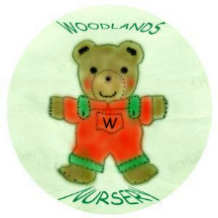 Woodlands Nursery Class – TOILET CLEANING SCHEDULE 

