
DATE | ITEM | PERSON RESPONSIBLE | ACTIONS TAKEN IF ANY

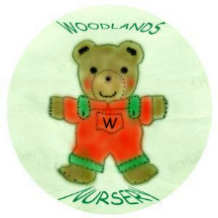 Woodlands Nursery Class – TOY & EQUIPMENT CLEANING LOG 

