

All areas of the nursery are cleaned daily prior to the children arriving.
DATE | TIME | PERSON RESPONSIBLE

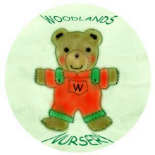 Woodlands Nursery Class – CLEANING SCHEDULE 

