

Cleaning Schedule

Daily
Wipe all kitchen surfaces with Toucan and cloth.
Wash the 2 cloths in the dishwasher.
Check food dates in fridge and throw away any ‘out of date’.
Toilets are checked in the morning and at lunchtime.
Areas are checked each morning.
The nursery is cleaned at the end of each day using a fogging machine and Toucan solution.

Weekly (Friday)
Wipe out fridge with soapy water and Toucan.
Check food dates in fridge and throw away any ‘out of date’.
Wipe down microwave with Toucan.

Toothbrushes rinsed under water and replace if necessary.

On-going (As Required)
Wipe out cupboards with Toucan spray.
Toys should be checked regularly and cleaned where required using hot soapy water, cleaning logs are attached to the door of the toy cupboard. Toys must be cleaned before being put away.

Updated and shared with all staff February 2026 by Nicola Ferguson

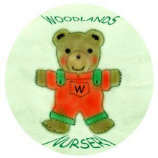 Woodlands Nursery Class – CLEANING SCHEDULE 

