

CHILD PROTECTION POLICY

All staff have a responsibility for child protection and training takes place annually on the first in set day in August to ensure that all staff are aware of the procedures in place. Any new staff are given induction training which includes child protection.

The Head Teacher is the Child Protection Co-Ordinator for the school and all concerns must be reported to Nicola Ferguson. The Head Teacher records concerns using pastoral notes on Seemis to ensure confidentiality and security.

For further details please see Woodlands Primary School Safeguarding Policy.

The school and nursery class adhere to the North Lanarkshire Council Child Protection Policy - Revised Management Circular C5. All policies are available at mynl.co.uk

Updated and shared with all staff February 2026 by Nicola Ferguson

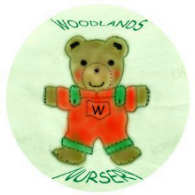 Woodlands Nursery Class – CHILD PROTECTION 

