

Admissions Procedures

Nursery Staff within Woodlands Nursery adhere to North Lanarkshire Council Education and Families Policy on Admissions which is available on mynl.co.uk
See Appendix.

Parental enquiries are dealt with promptly and anyone wishing to may have a guided tour of the establishment.

All applications are made electronically however if required, staff will sit with the parent/carer and complete the application form, ensuring they are able to validate the date of birth and address.

The completed is accessed by the senior clerical assistant and details are uploaded to NAMS.

The Head Teacher and senior clerical assistant work together to ensure that all aspects of the council admissions policy are implemented and that deadlines for applications and submissions are met.

Once the child has gone through the admissions process they are lettered to invite them to take up their place. At this stage parents are also provided with a start date and dates for their child to visit the nursery prior to starting.

Parents inform us of their decision by acceptance slip.

Children who become 3 years old are eligible to start nursery in the term following their birthday.

Updated and shared with all staff February 2026 by Nicola Ferguson

Updated August 2018 by N. Ferguson

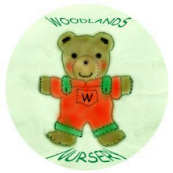 Woodlands Nursery Class – ADMISSIONS PROCEDURES 

