
DATE | CHILD’S NAME | DETAILS OF INCIDENT INCLUDING ACTION TAKEN | PARENT CONTACTED BY

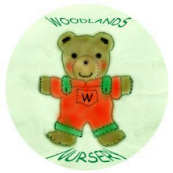 Woodlands Nursery Class – ACCIDENT LOG 

