
DATE | PERSON RESPONSIBLE | ACCIDENTS RECORDED SINCE LAST AUDIT | ACTION TAKEN, IF ANY

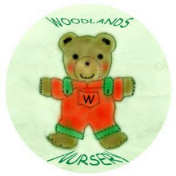 Woodlands Nursery Class – ACCIDENT AUDIT 

