

Addresses & Telephone Numbers

Woodlands Nursery Class Telephone: 01236 632074
Melrose Road
Cumbernauld
G67 4BA

Nicola Ferguson (HT) Telephone: 01236 632074
Melrose Road
Cumbernauld
G67 4BA

Vicki Sherry Telephone: 0345 143 0015

Education & Families Manager
Civic Centre
Motherwell
ML1 1AB

Eileen McGeogh Telephone: 0345 143 0015
ELC Quality Officer
Early Years and Childcare
Civic Centre
Motherwell
ML1 1AB

Updated and shared with all staff February 2026 by Nicola Ferguson
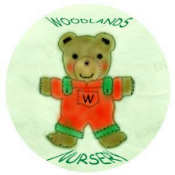 Woodlands Nursery Class – ADDRESSES 

