
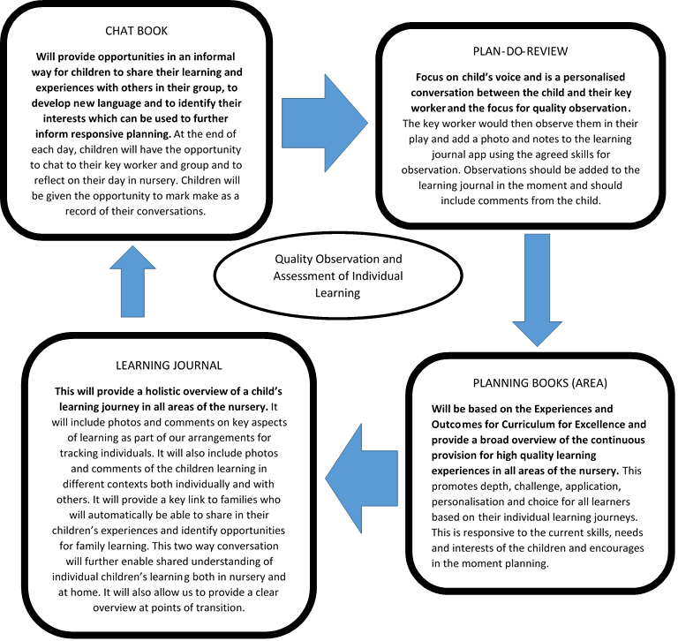
Updated and shared with all staff February 2026 by Nicola Ferguson

Planning is flexible and used as a guide rather than followed slavishly. The most important planning that is done is the short-term daily/weekly planning that arises from discussions with the children at the planning stage of play and is recorded in the chat books. Talk is an important feature of the planning stage as it extends thinking, vocabulary and enriches ideas for play (Moyles, 2013). Ensuring that all children receive equity in their learning is evident in both the way in which the nursery is designed and also in the way in which the adults interact with children to support their play.
Listening and observing children will be the key tools we use to assess children during play and are therefore the main tools for assessment within the nursery. Lancaster and Kirby (2010) point out that listening to children is a respectful act and is concerned with the child’s feelings as well as their thinking. Observation is the practice of looking at children to find out how they are developing, what they like doing and what they are learning through their play and the experiences on offer (Stewart, 2011). The adult’s role when observing is to notice what the child is learning. Donaldson (1978) refers to this as ‘de-centring,’ in other words, seeing what the child is experiencing first over what the teacher’s view of the experience is.
Nursery staff will track specific children throughout the week, will observe children as they play within their areas and during chat time. The focus should be on the skills and concepts that are relevant to that child. Staff have a shared understanding of what skills they are observing and these are incorporated in the planning book. Nursery staff should record observations of children’s learning both within their chat books (informal) and on learning journals (formal).
Observing into Recording

