
Assessment Evidence
Everything that a child does in school is part of their learning and therefore can be used as evidence for assessment. We evidence pupil progress through:
School and class blogs, photographs and videos, learning conversations and discussion in class, work in jotters and on walls, learning logs including pupil targets, chat books and results from summative assessments, tests and benchmarking.
What does this mean for our children?
Children are the most important part of the assessment process. In order to achieve and progress children will work with their teacher to assess their own learning and identify their next steps including what they need to do to achieve success in their learning.

Woodlands Primary School – Assessment Policy
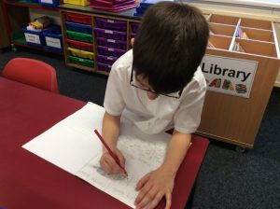


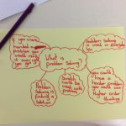
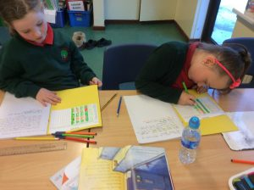
What does this means for our Parents?
As a parents you are key to your child’s progress and school staff will strive to involve you fully in your child’s learning by discussing how you can support your child’s learning at home. Staff will share with you your child’s current progress, the evidence that demonstrates their learning, what their next steps are and how to achieve them.
Approaches to Assessment
There are many ways of assessing children’s learning but the key methods are:
- Sharing learning intentions and what success looks like
- Through discussion and the questions we ask at the start, during and end of lessons
- Through review of pupils daily class work
- Through learner conversations with pupils
- Through self and peer assessments
- Through traffic lighting work to communicate progress with children
- Through observing the children working
- In more formal ways including summative assessments and end of unit/level tests
- Using benchmarks to assess pupil progress
Effective Assessment
Assessment of pupils learning involves teachers and children discussing the learning that will take place and what success will look like. Following the lesson they will discuss the child’s work including how to make it better and together decide the next steps for their learning.
Children will be actively involved in assessment as part of their learning. They will work with their teacher to set their own learning goals, to evaluate their own work and identify evidence of what they have learned and work with other children in class to assess their learning.
Assessment for learning involves all staff working together to track and monitor each child’s progress using a range of evidence. This encourages all staff to plan for ongoing improvements to learning and teaching.
Key Message
Assessment gives a picture of where a child is at in their learning at a specific point in time, it is ongoing and is a key tool in identifying their next steps for learning. Assessment can take many forms and is integral to all aspects of a child’s learning and therefore is a key aspect of planning for learning and teaching.

