Woodlands Primary and Nursery Newsletter January – March 2021

Dear Parents,

Happy New Year! All the staff at Woodlands would like to wish our friends and families a safe and restful 2021. We really miss having the children in school with us. Based on the most up to date guidance from the Scottish Government we will be engaging in remote learning until at least the middle of February. There will be some teething problems as we get used to this so I ask that we can all be patient and I am sure we will get there together.
Please keep an eye on the school app and School blog for updates.

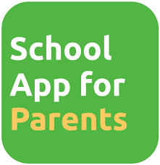

Login Details and Passwords
Microsoft Teams is a platform for pupils to interact with their teacher and each other. Any requests for login details or password should be directed to the school office.

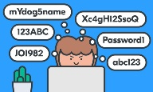

Complete the work that you can
We understand that lockdown brings with it many pressures. Ranging from ICT issues to parents trying to juggle work commitments and home learning. If at any point, you are finding it a tricky task to complete every piece of work then focus on finishing one piece a day to share with the teacher.
Take a break
Children can have very short attention spans. Childhood development experts say that a reasonable attention span to expect of a child is two to three minutes per year of their age and most people can properly manage around 20 - 30minutes at a time. Once they reach that limit, switching to a new task or having a brain break can help.

What work should I prioritise?
There are many views on remote learning, with many parents requesting more tasks for their children to complete and others requesting fewer tasks.
Firstly – Children should complete the daily literacy and numeracy tasks provided daily by their class teachers.
Secondly – Additional learning is available. Children are able to access the Cluster outdoor challenge and the whole school learning topic. This can be accessed through the file section within each class team.

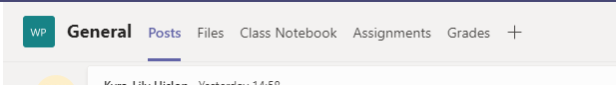

Finally – NLC Virtual School, BBC Bitesize tasks and Woodlands Primary school Home learning packs can be used to supplement the learning already provided for your child. Please remember that children are not expected to complete each task, they are optional.

Teams Platform
The GLOW class Teams page should be used for communication related to schoolwork and check-ins with the class teacher. It is not a social media platform for uploading personal videos or pictures.

Teachers will be online for questions and check-ins throughout the day and will endeavour to support pupils as much as possible during this time. However, teachers will be unable to reply to any messages after normal working hours. Teachers are also in school on a rota basis – this will affect how they can respond and on these days and they will be unavailable for direct communication. Teachers will post on their teams to let children know the days they are unavailable.
Uploading Work
Please upload work it on the same day you complete it, even if you are doing work from the day before or earlier in the week. This will make it easier for teachers to find and comment on.

Team Check-ins
We will eventually incorporate live check-in sessions with teachers. We will expect the same respect shown in school to be present during these times. The check-ins are for pupils and adults should not be on camera during this time. In line with NLC’s Child Protection procedures screenshots and recordings are not permitted of any ‘live’ session.

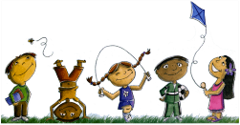
The benefits of being outdoors
Although currently the weather is not great it is worth aiming to get outdoors for at least 20 minutes each day. Spending 20minutes outdoors just 3 times a week has been proven to help reduce stress and help mental health. This is true for children and adults alike.

NLC Virtual Classroom
NLC’s Virtual Classroom has been very popular with many things to explore linked to Literacy and Numeracy. From Monday 25th of January the way in which you access the NLC Virtual Classroom is changing. No code will be required, and instead the classes can be accesses by directly logging into Glow instead of going through Teams. This is to accommodate the numbers of children/parents engaging with the platform.
Each classroom is colour coded.
Red = Primary 1
Orange = Primary 2
Yellow = Primary 3
Green = Primary 4
Blue = Primary 5
Indigo = Primary 6
Violet = Primary 7
If your child is finding a particular colour to tricky or easy then feel free to move to the colour above or below.

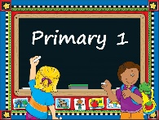
Primary 1 Enrolment
The deadline for Primary 1 enrolment 2021 is this Friday (22nd). Information and links to the forms and documentation has been posted on the School Main blog on December 16th 2020 and on January 18th 2021.

We would like to thank everyone for the effort so far with remote learning – we are fully aware that ICT can be problematic and can cause many of us challenges. Please remember that you are doing your best for your child and you are being asked to do the impossible, keeping life as normal as possible during a global pandemic often where expectations can change often on a weekly basis. The most important thing is that you and your family are healthy and happy. If we can support you and your family in any way then please do not hesitate to contact the school office or email ht@woodlands.n-lanark.sch.uk

We will endeavour to keep everyone up to date via the school app and blog and look forward to when we can all be back in school together.

