WOODLANDS PARENT COUNCIL
HOMEWORK SURVEY RESULTS

Q1: We asked parents what type of homework does your child like? This is the reply’s below

As you can see many parents said that their child/children like Reading the most closely followed by English and Maths.

Q2: What challenges do you face in regard to homework? The reply’s are found below.
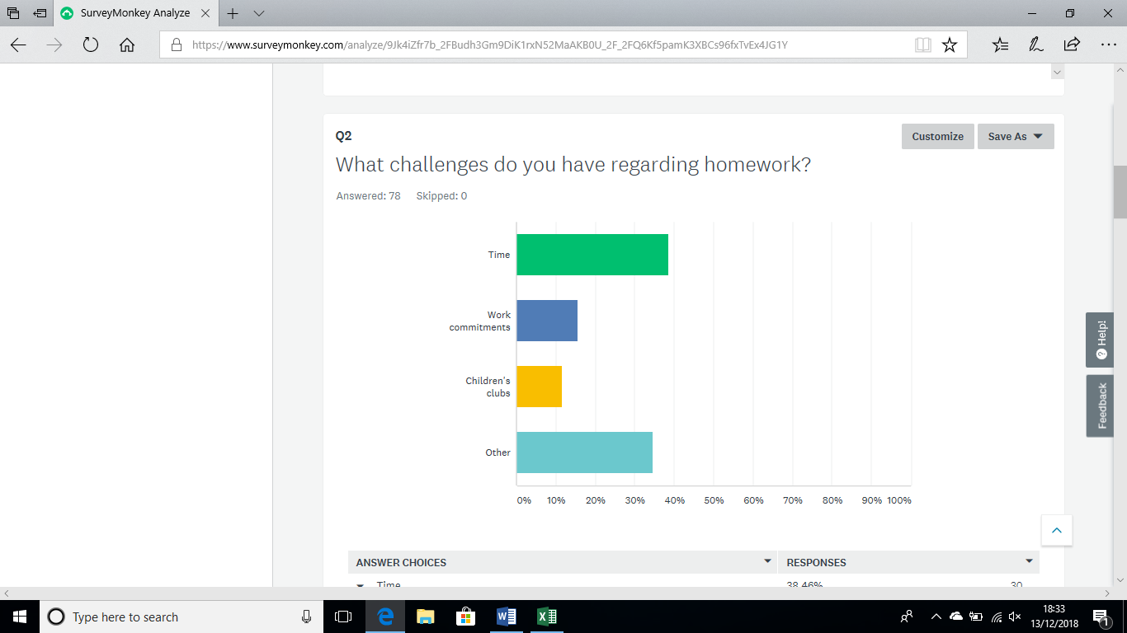
The reply’s show that time is a major issue with parents in regards to their children’s homework.

Q3: How would you like the homework to be set? This is the reply’s below

Parents would like the homework to be set weekly and either in a structured format such as homework jotter or worksheet.
Q4: Have you found Sumdog useful? The results are found below
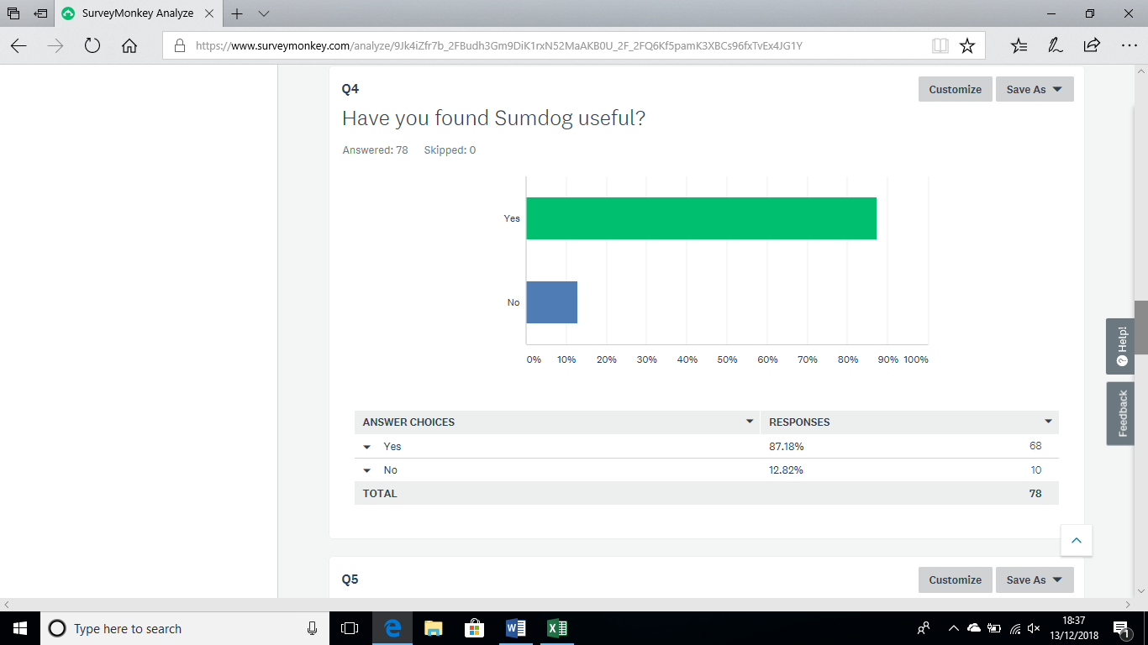
The results show that yes parents are finding Sumdog useful.

Q5: Would you be interested in Sumdog literacy? The results are found below
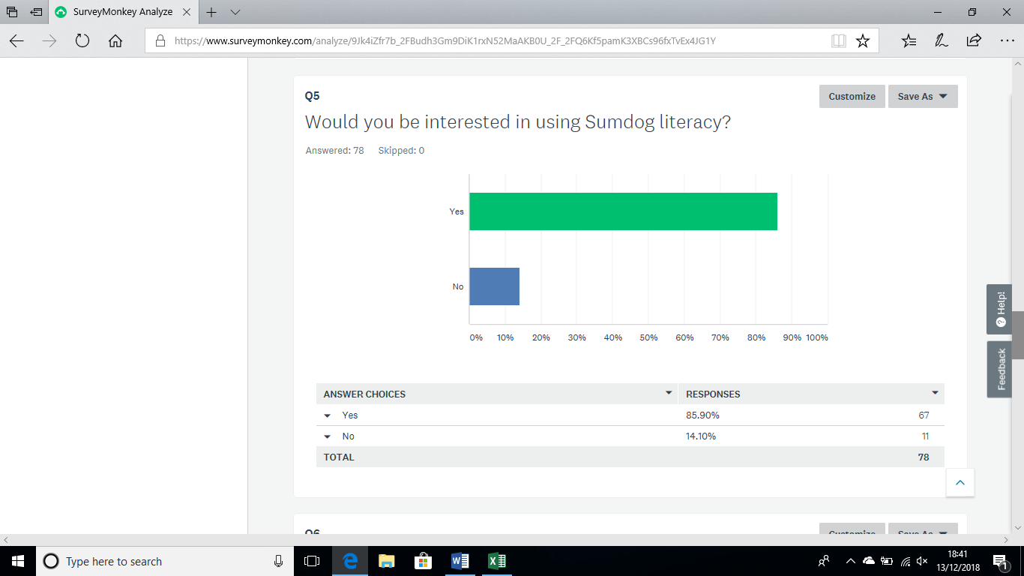
The results show that parents would be interested in using Sumdog literacy.

Q6: We asked parents if they would be interested in parent and child homework sessions? The results are found below.
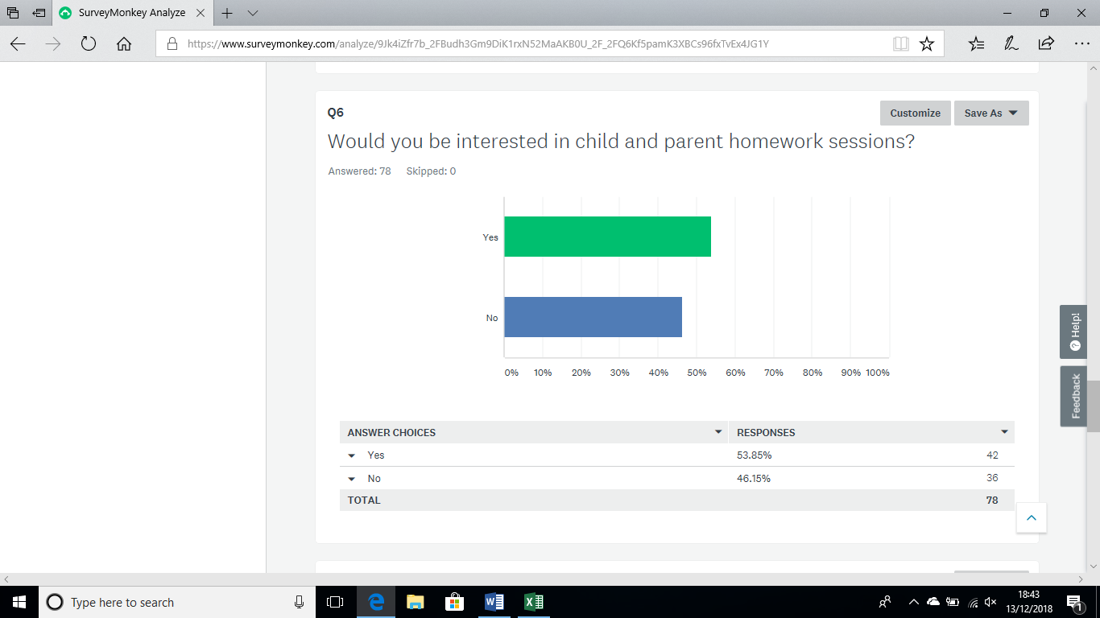
The results are that yes parents would be interested in child and parent homework sessions.

Q7: We asked parents how they feel about the current homework setup? The results are found below.

The results show that yes parents do like the current setup, however the parents that said that they didn’t some of the reasons are;
“disorganised and confusing”
“please send homework out to the child in a structured way there was nothing wrong with the current setup”.
Q8: We asked parents for any other feedback in relation to the homework setup. Many of the comments were similar, some of the comments randomly selected are:
“more structured”
“give sheet homework”
“other schools more advanced”
“not challenging enough”
“children are bored”
“less pressure on parents”
“blog is helpful”
“difficult to encourage children to do the homework"

These results have been discussed with school management at a meeting of the Parent Council in November 2018. Taking on board the feedback from parents the school have suggested amendments to the current approach to homework to better meet the needs and requests of parents.
“While it is impossible to meet the requests of all parents we are keen to find an approach that best suits the majority of our Parent Forum. Understandably there are some parents for whom the more traditional approach to homework is preferred, however this is not reflected by the majority and is not complimentary to current approaches to learning in school. Therefore this is not an option that would best meet the needs of pupils or of most parents.
Many have reported that they are happy with the focus on reading and with Sumdog however issues arising are with deadlines and accountability. Taking this into account our approach will be as follows:
Homework will be issued for a term, this will be a sheet with a range of tasks and will include literacy, numeracy and health and well-being. Children should complete one task per week in any order they choose and return this to school on Monday of each week. Children will be issued with a homework jotter for this.
Children will have access to all areas of Sumdog which includes Maths, Reading, Writing and Spelling, this has involved the school paying for a whole school subscription and the materials have been tried out in school. Undertaking approximately 5-10 minutes on Sumdog every day will allow children to answer the same number of questions as they would in a worksheet. Children are welcome to do more than this but as a guide 5-10 minutes is ample time. Teacher are able to see how the children have got on and set challenges for them which supports their learning in class.
Children in the lower stages will continue to bring home reading books and common words for daily practise. Children in the upper stages will be encouraged to read for enjoyment at home and a range of books are available for them to borrow in school.
Nicola Ferguson

