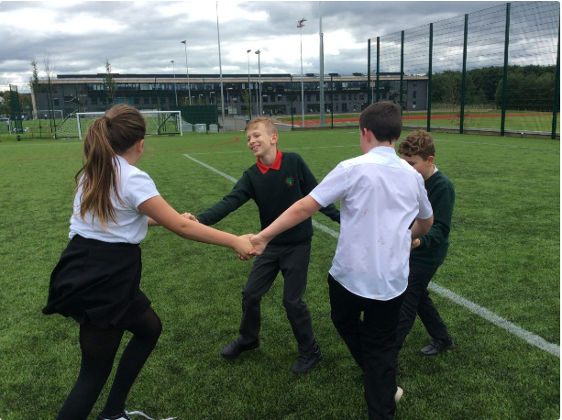



**Whole School Approaches:**

* **Rights Respecting Schools Gold Award including School Charter, Playground Charter, Lunch Charter, Class Charters and Social Media Charter**
* **HEALTHY resource for whole school HWB**
* **Annual staff training for child protection and safeguarding**
* **Child’s Plan in place for all children requiring additional support**
* **Monitoring and tracking of all data to ensure equity for all learners with focus on SIMD 1&2 and those in receipt of free school meals**
* **Playground supervision**
* **Playground buddies**
* **Effective working with partner agencies**

**Monitoring and Tracking**

**Safeguarding children is the responsibility of all however all concerns must be reported immediately to the Head Teacher who will keep a log of concerns using Seemis Pastoral Notes. The Head Teacher is the Child Protection Co-ordinator for all children in school. All files containing confidential information are stored securely.**

**Policies in Place to ensure effective practice:**

* **Child Protection**
* **Adult Protection**
* **School Attendance (B1)**
* **Positive Relationships Policy**
* **Support for Learning**
* **PVG scheme for all volunteers working with children**
* **GTCS and SSSC registration of staff**
* **GIRFEC legislation, procedures and guidelines**
* **Risk Assessments for all areas of school and for outings**
* **Management Circulars C11 (Physical Restraint), J6 (Cyber Bullying), B2 (Indiscipline and Exclusion) and F19 (Violence Against Staff)**
* **NLC Equality and Diversity Policy**
* **NLC Anti-Bullying Policy and Prevention Guidelines**

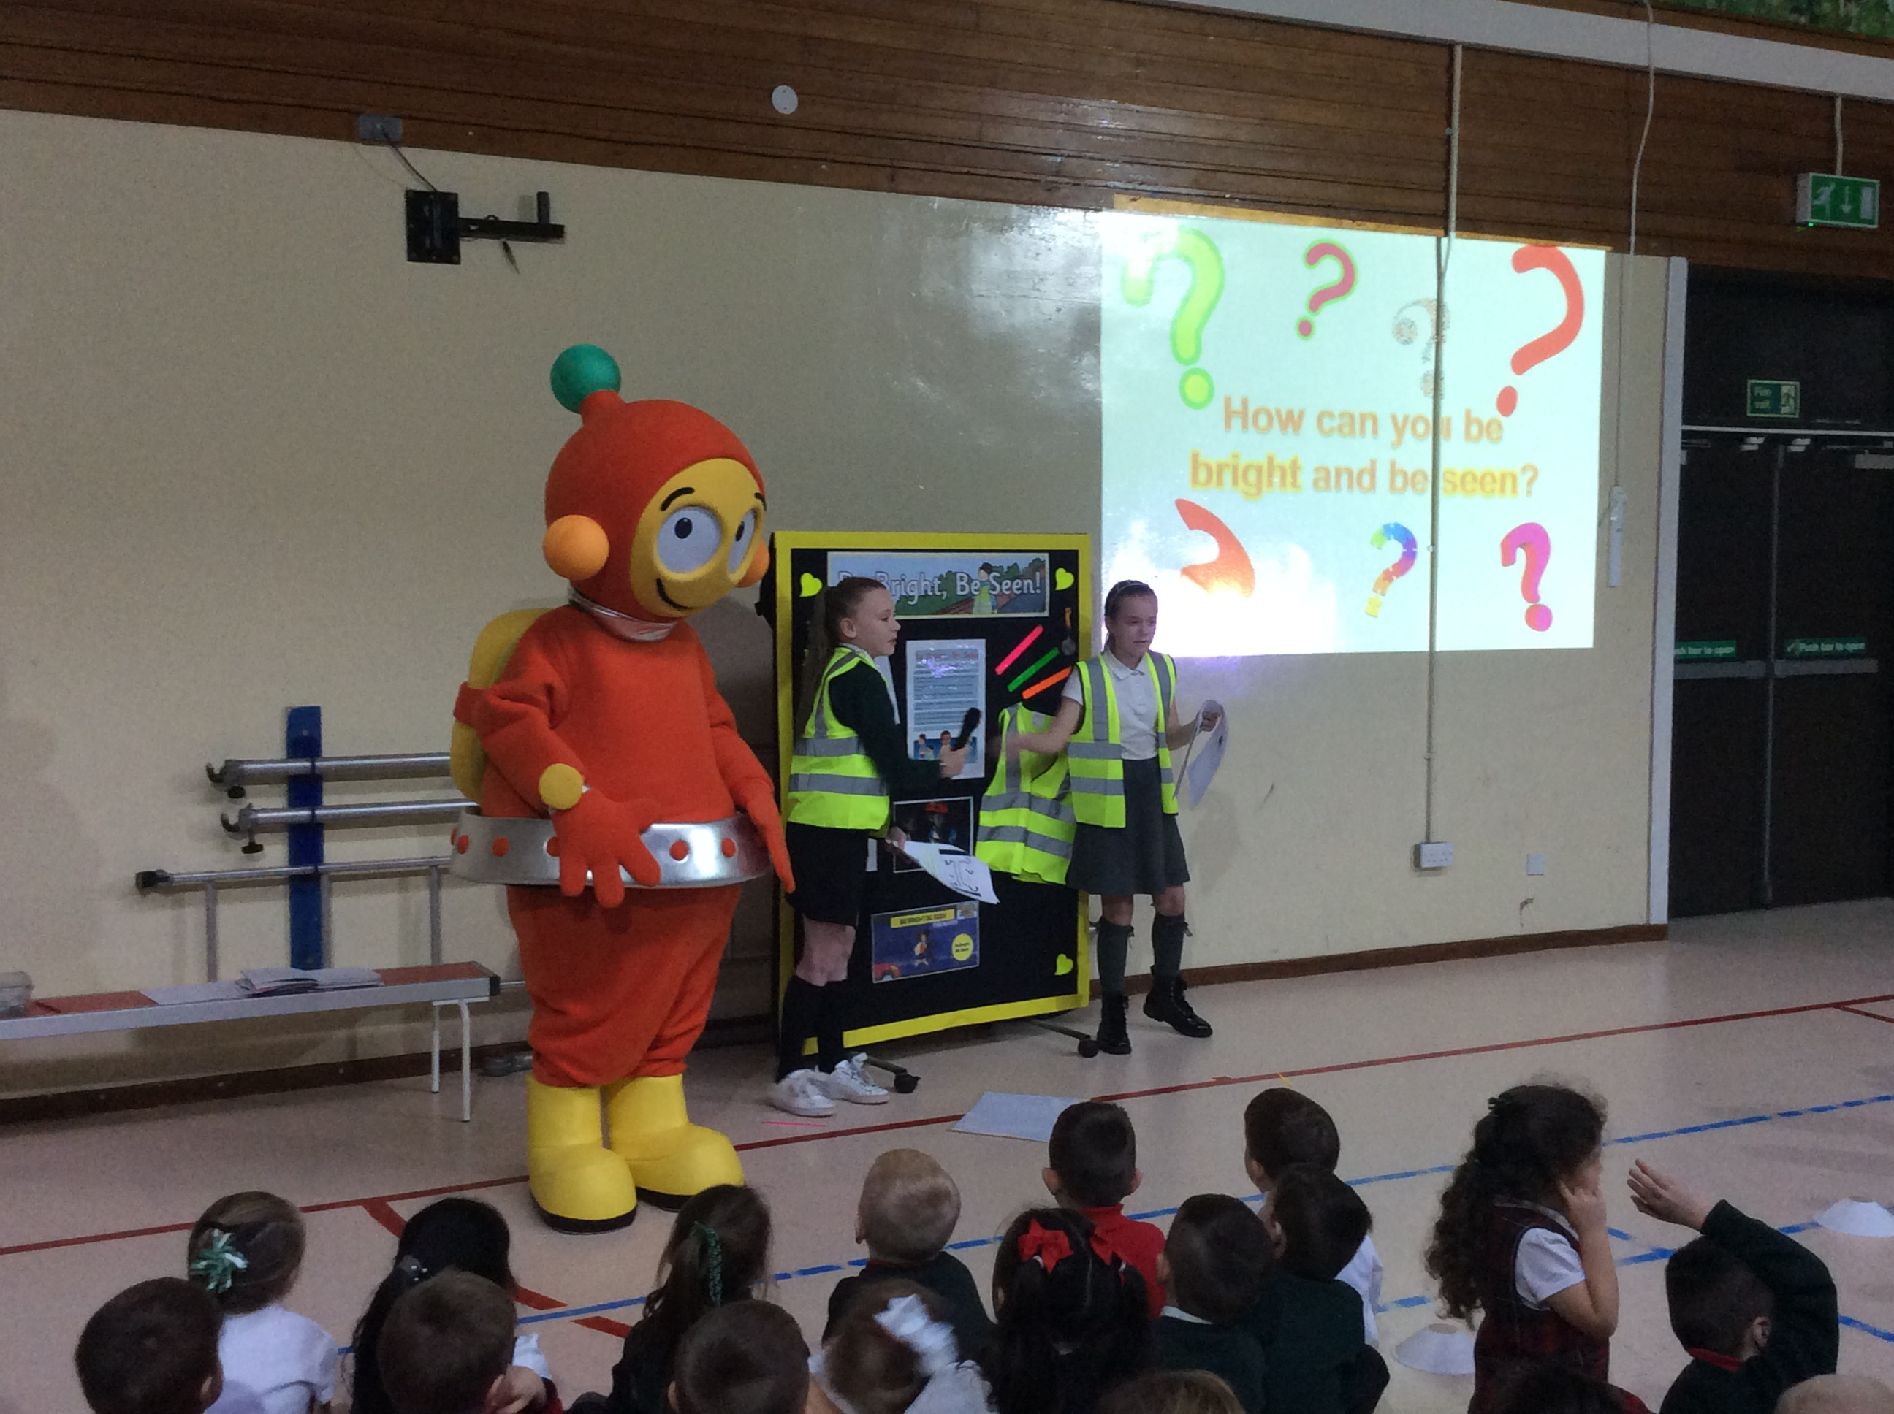

**Woodlands Primary School – Safeguarding Overview**





**Key Message**

**Ensuring the safety and well-being of our pupils is paramount. All staff work together to ensure that the needs of all our pupils and their families are met and that children are supported.**