

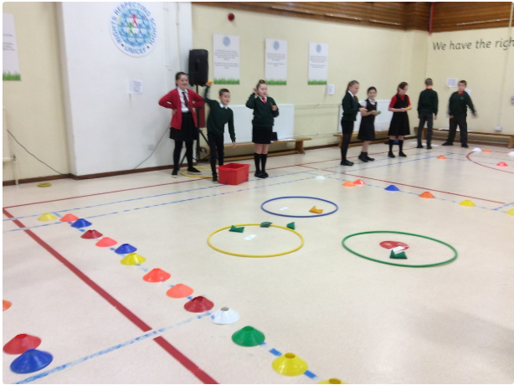



**What does this mean for our Parents?**

**Parents are the key to learning and should be actively involved in all decisions that support their child. High levels of support for families ensures that we work together to meet the needs of all children and are truly inclusive.**

**Targeted Supports**

* **Child’s Plans are in place for all children who require any additional support and are regularly reviewed**
* **Strategies are in place to support children who are distressed and need help to manage their emotions**
* **Classroom layouts and resources are reviewed and revised to meet learner needs regularly**
* **Additional support staff are used strategically to support individuals and groups**
* **Interventions are used to support groups and individuals including Rainbow Reading, Catch Up Numeracy, IDL and Read Write Inc**
* **Lego, art and play therapies are used to support groups and individuals**
* **Flexible programmes of study are used to meet learner needs**
* **Nurture in place to support children in transition from nursery to school**

**What does this mean for our children?**

**Children are at the heart of their own learning and must be involved in the decisions that affect them. Interventions are only effective if they meet learners needs and lead to progress so children’s opinions are most valuable.**

**Key Principles**

* **Inclusion is demonstrated within the ethos of the school and all staff are focussed on meeting the needs of all learners**
* **Relationships within the school are strong and supportive, build on an ethos of trust and respect**
* **Staged intervention is used effectively to ensure that the needs of all learners are met**
* **Support is both universal and targeted to ensure positive impact**
* **Expectations of all learners is high**
* **Progression pathways for children requiring support are highly effective and continually reviewed and revised to ensure they meet individual needs**
* **Robust assessment including where appropriate specialist input is used to identify learning needs and determine appropriate support and next steps**
* **Parents and learners are actively involved in discussion about how their needs will be met and are part of the decision-making process**
* **Staff differentiate appropriately to meet the needs of all learners and ensure appropriate pace and progression**
* **Staff work with learners to identify what barriers stop them learning effectively and work together to remove them**
* **Resources are carefully selected to meet learner needs**
* **Staff have strong relationships with partner agencies and work to support leaners needs**
* **Teaching and support staff work closely together to meet the needs of all learners**

**Woodlands Primary School – Personalised Support for Learners**





**Key Message**

**At Woodlands Primary School we strive to provide high quality support to enable all children to achieve the best that they can and to learn and make progress. This must include support for their own specific needs and interests.**