





**What does this mean for our children?**

**Parents and families are the biggest influence on a child’s life. Making their parents or carers proud is a key driving force for children to achieve and learn. When children hear how proud their parents are of them it will encourage them to work hard and do their best. Children will get the opportunity to learn with their family in school.**

**Family Learning**

**Family learning is where members of the family learn together. Rather than focus on a parents relationship with the school, it encourages parents to actively participate in their child’s learning.**

**Family learning can have a significant impact on attainment as it is a key driver in combating educational disadvantage.**

**Family learning will be encouraged through:**

* **Parents open sessions where parents and family members can come along and work with their child in class.**
* **Stay and play sessions for nursery children and their parents/family.**
* **Parent and child learning workshops and homework clubs.**
* **Family fun days and events.**

**What does this means for our Parents?**

**As a parent or carer you are the most influential person in your child’s life and your opinion of them is what matters the most. By engaging in family learning you will help to overcome social or economic disadvantage and will encourage your child to develop a positive attitude to learning that will continue through their life time.**

**Parental Engagement**

**There are several key elements which are fundamental to ensuring that all children are given the same opportunities in their learning in order to reach their potential. Parental engagement is one of these. Parental engagement is when a parent or career is involved in supporting their child’s learning.**

**In order to support their child’s learning parents need to be aware of their child’s current progress and areas for development at key stages.**

**Relationships are the key to building strong and real partnership with parents. It is vital that school staff strive to build caring and trusting relationships with families and demonstrate a strong commitment to working together.**

**In ensuring parental engagement the school will:**

* **Establish positive relationships where parents’ views are encouraged and valued.**
* **Maintain good communication with all parents.**
* **Identify and remove any barriers that may stop parents from engaging in school life.**
* **Help parents to support their child’s learning at home.**

**Parental engagement will be encouraged through:**

* **Progress meetings with parents and pupils.**
* **Parent workshops and support videos to support learning at home.**
* **Learning stories in nursery throughout the year.**
* **End of year progress reports.**
* **Special events such as shows, concerts, sports day and other activities.**

**Woodlands Primary School – Parental Engagement Policy**



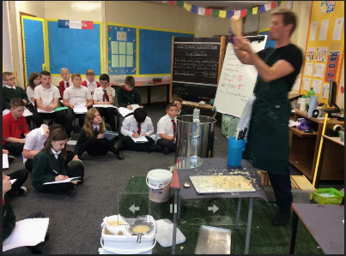

**Key Message**

**Parents play a vital role in education. The biggest influence on a child’s life is their family therefore children learn best when their parents and carers are actively engaged and involved in their school life. When parents are involved in supporting their child’s learning they will achieve more.**