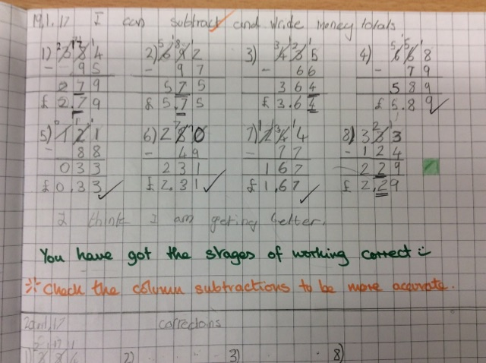



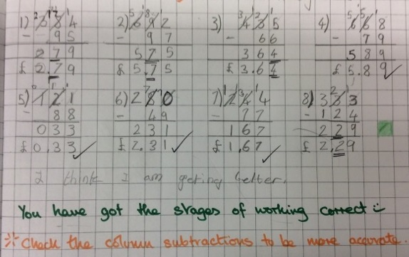

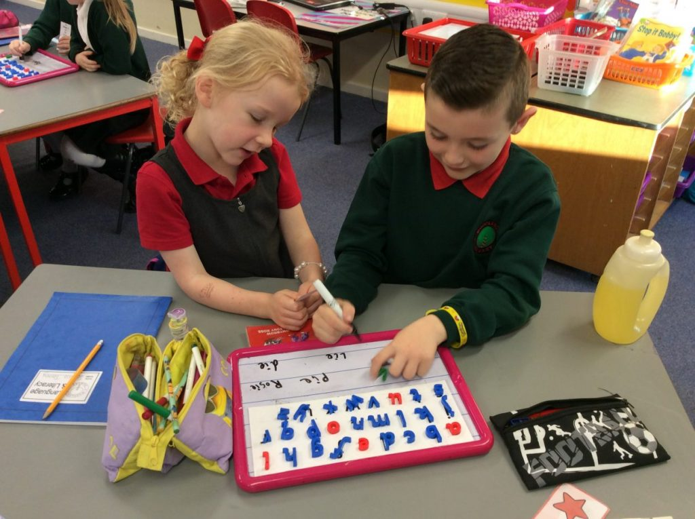

**Types of Feedback**

**Children will experience a wide range of approaches to feedback throughout the week including:**

**Written comments in their jotters, oral feedback from the teacher, stampers to show progress with core targets, stampers to offer praise, traffic lights (green – got it, amber – keep practising and red – I will help you with this), self-assessment using traffic lights and comments and peer assessment.**

**What does this mean for our children?**

**As the learner you are the most important person and are central to all discussion, you will receive feedback that is fair, clear and helps you to improve your work.**

**Key Message**

**As a Rights Respecting School we believe that all children have the right to have an opinion about their work and that this should be listened to and respected. The discussion that takes place between a child and their teacher about their learning is a key factor in a child’s progress. This discussion will focus on current progress, next steps for learning and most importantly how to improve their learning and meet their targets.**

**Effective Feedback**

**Approaches to feedback should be part of the planning process so that continuous assessment opportunities are part of daily teaching and learning. Feedback should be used to inform future lessons and lead to teaching that is responsive to individual pupil needs.**

**The most important aspect of feedback is what children do with it, feedback is only effective if it is used to move learning forward. Therefore effective feedback must ensure that next steps for learning provide challenge, build on the child’s existing skills and most importantly are achievable.**

**The key factor is achieving effective feedback is establishing strong and trusting relationships between pupils and their teacher.**

**Woodlands Primary School – Feedback Policy**



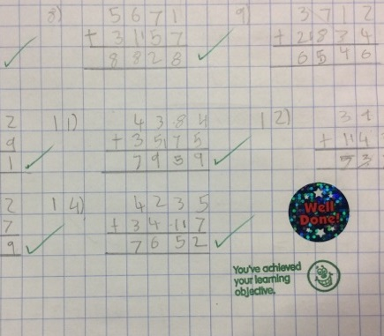

**What does this mean for our Parents?**

**You will be involved in discussion about your child’s progress and next steps for learning through parents meetings and at any point by making an appointment with the teacher. You will be given opportunities throughout the year to view your child’s learning log and offer your own feedback on their progress and next steps.**

**Approaches to Feedback**

**There are many approaches to feedback however some key elements are:**

* **Feedback will use a common language which encourages children to challenge themselves**
* **Feedback will involve dialogue between teacher, pupil and on occasions parents**
* **Feedback will be based on clear learning intentions and success criteria so that all children know how success will be measured**
* **Feedback will focus on small improvements in a child’s work as well as the end result to encourage children to believe that if they work hard then they can improve**