



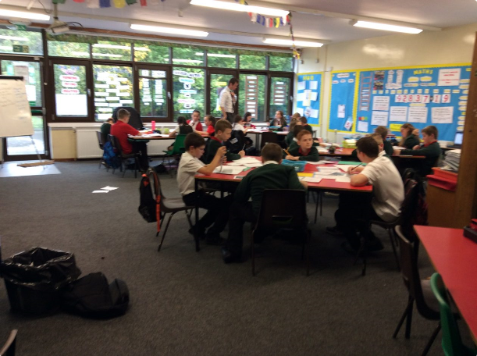

**What does this mean for our children?**

**Ensuring that all learners reach their potential and develop confidence in their own skills and abilities is our most important job. To do this all children must be given the same opportunities to succeed and steps taken to overcome challenges.**

**What does this means for our Parents?**

**As a parent you have the biggest impact on your child’s education and learning. By working closely with the school to support your child’s learning and development, their chances of reaching their potential is great.**

**Achievement**

**Supporting children to develop socially, emotionally and personally is a key aspect of our school. We have a responsibility to ensure that all of our children experience success, develop confidence and responsibility and contribute to wider school life by:**

* **Rights Respecting Schools Gold Status**
* **Celebrating their success out with school**
* **Wide range of clubs for all children**
* **Class assemblies to showcase learning**
* **Cool class cup and star pupils to celebrate success**
* **Pupil voice through ‘The Big Question’, camp fires and house assemblies**
* **Pupil Action Group**
* **Eco/Fairtrade Committee and JRSO**
* **Outdoor learning opportunities**
* **Involvement in local community**
* **School shows and events**
* **School and class blog to showcase learning**
* **Good work walls**
* **Learning stories**
* **Learning walks, learner conversations and focus groups**

**Attainment**

**Supporting all children to reach their academic potential requires us to ensure that all children are appropriately challenged and supported in their learning. To ensure that all children make good progress:**

* **We have high standards and expectations for all learners**
* **Build on prior learning to ensure continuous progress**
* **Make effective use of assessments**
* **Staff have a good understanding of standards allowing for sound professional judgements**
* **Pupil progress is regularly tracked and monitored by class teachers and SMT to ensure progress**
* **Interventions are in place to support children in their learning**
* **Transition information ensures that all children experience coherence in their learning**

**We use a range of specific approaches including:**

* **Core focus on raising standards in literacy and numeracy through targeted interventions to support learning**
* **Progress in reading, writing and numeracy is tracked over time by class teacher and HT**
* **Data used to ensure that all children are making progress and to inform interventions**
* **Tracking is used to identify areas for focussed intervention and support to ensure equity**
* **Targeted learning support to ensure impact**
* **Focus on language of learning to ensure children understand their own progress including learning ladders**
* **Effective use of resources to meet needs impact of which is reviewed regularly**
* **Assessment folders track progress of all children**
* **Moderation using agreed standards and criteria**
* **Stage planning for continuity/progression**

**Key Message**

**At Woodlands Primary School we strive to ensure that all children reach their full potential. We aim to support our learners to develop a wide range of skills and attributes that will equip them for life. In Woodlands all children will be challenged and supported in their learning and that their wider achievements will be shared and celebrated.**

**Woodlands Primary School – Achievement and Attainment**



