

**Active Approaches**

**All learning experiences encourage the learners to be fully engaged and motivated to learn.**

**Digital technologies are used effectively to enhance and support learning and teaching across all areas of the curriculum.**

**Staff ensure all explanations and instructions are clear.**

**Learning intentions and success criteria are on display for all learning experiences to ensure that children have a benchmark for success.**

**All learning activities are highly appropriate.**

**Questioning is used to encourage children to be curious, independent and confident and to develop higher order thinking skills.**

**Learners will be given opportunities for collaborative learning in a variety of settings.**

**Pupils will be encouraged to take responsibility for and lead their own learning.**



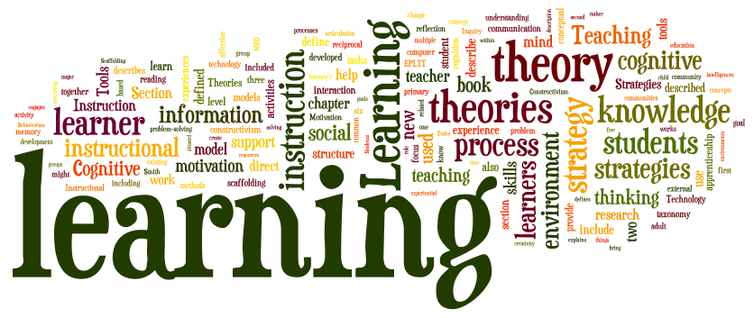

**Core Elements**

**All aspects of learning and teaching are built upon our shared vision and values, at the heart of which is RESPECT and is underpinned by children’s rights.**

**All children will experience learning and teaching based on nurturing and challenging relationships that leads to high quality learning outcomes.**

**Learners’ achievements both in and out of school help them develop their knowledge and skills for learning, life and work.**

**Learners are given opportunities to lead their own learning and are able to identify their own progress and ways in which they can improve.**

**All children will experience high quality learning experiences that meets their individual needs.**

**Planning for learning and teaching takes into account the individual needs of all learners, providing appropriate support and challenge.**

**All learners are included and their needs are met through interesting, challenging and motivating learning experiences.**

**Planning ensures that learning is coherent and progressive and builds on skills.**

**All learning is well planned but also responsive to the ongoing and changing needs and interests of the learner.**

**Assessment is integral to all aspects of learning and teaching from the planning stage onwards. Observations of learners inform appropriate, well timed interventions and next steps.**

**Learners are given opportunities to demonstrate and apply their knowledge and skills across the curriculum and in a variety of contexts.**

**What does this mean for our children?**

**Children and their development are at the heart of school life, staff will ensure that all children receive the support and challenge necessary to succeed in their learning. Our goal is that all learners understand the purpose of learning, are motivated to achieve success, have the necessary skills for life and are confident.**

**Woodlands Primary School –Learning & Teaching Policy**





**What does this means for our Parents?**

**As a parents you are key to your child’s progress and have an active role to play in your child’s education and development. Staff will strive to work in partnership with yourself to best support your child through homework activities, school blog and through opportunities for you to be involved in the life of the school.**

**Key Message**

**Our aim is that the learning and teaching taking place in our school encourages all learners to be eager and active participants and fully engaged in their learning. We want learners to be resilient, highly motivated and able to interact well with others in order that they reach their full potential.**