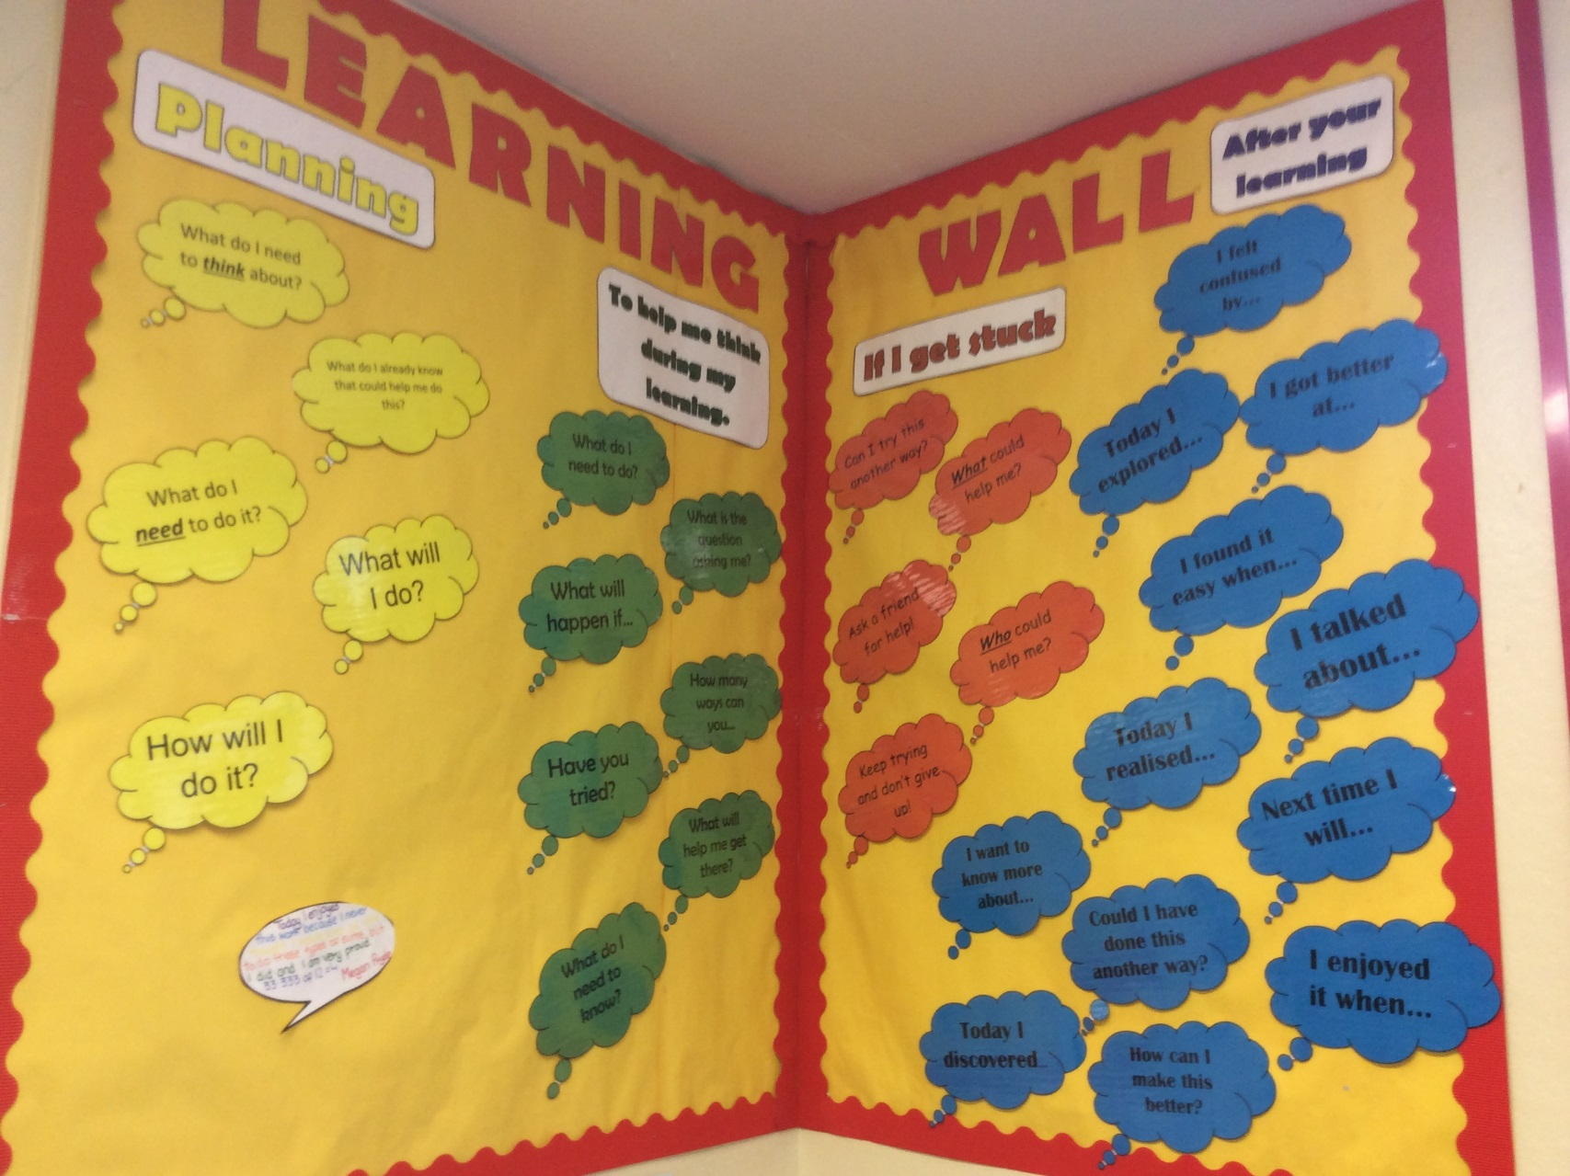



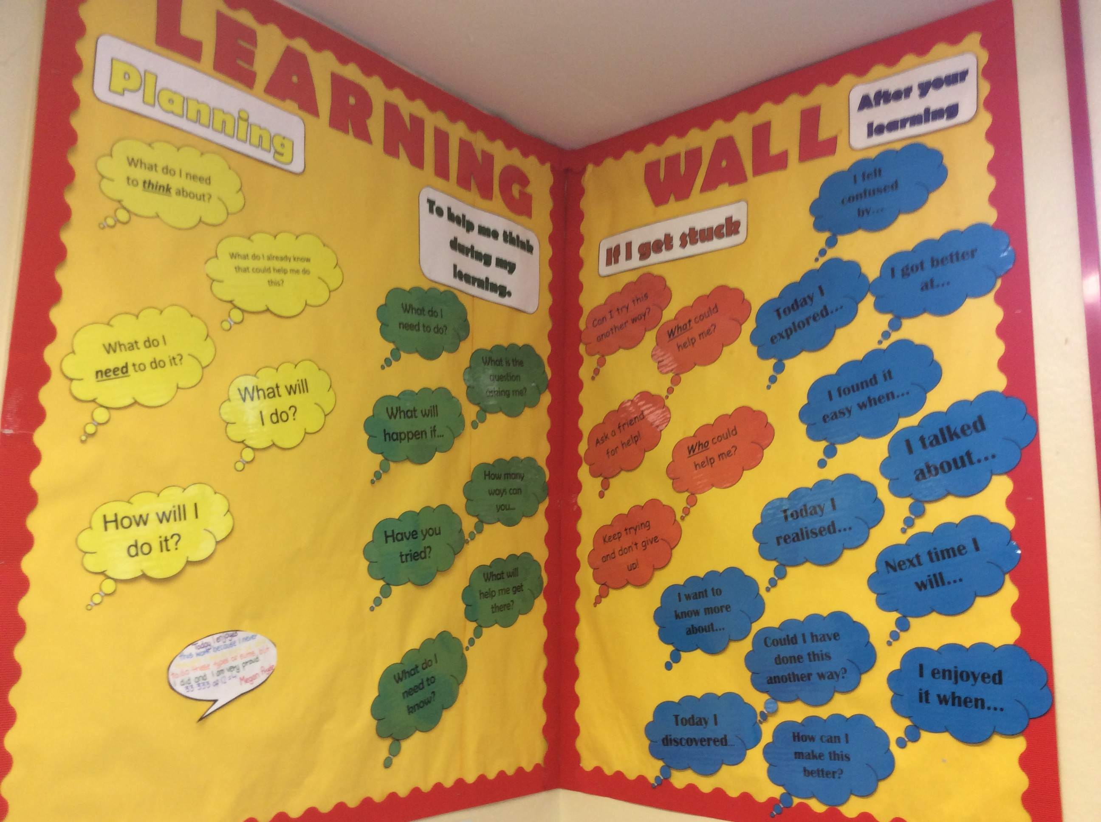

**What does this means for our Parents?**

**Parents will have access to extensions of the learning environment such as support videos for key concepts of literacy and numeracy, class blogs and twitter to encourage them to be an active participant in their child’s learning and to involve them in celebrating their success.**

**Learning Walls**

**Learning walls should:**

* **Promote the language of learning to support self and peer assessment.**
* **Be rich in language.**
* **Map learning experiences, achievements and success.**
* **Support learning and teaching.**
* **Set the tone for shared high expectations and provide high quality learning models to promote independence.**
* **Encourage independence through visual timetables and task boards.**
* **Model key vocabulary, sentence structures and presentation.**
* **Reflect learners thinking including what they already know and what they want to learn/find out.**
* **Act as a reference point by providing learning prompts and supports.**
* **Promote and celebrate Children’s Rights.**
* **Celebrate learner’s success.**

**What does this mean for our children?**

**Learning walls will show children what they need to do and how to go about it. It will provide them with clues and ideas that they can use in their learning. Everything in their environment should support them in their learning and demonstrate what good learning looks like. Most importantly it will celebrate their success and promote pride in their learning and achievements.**

**Key Elements**

**The learning environment should:**

* **Be well organised to allow children to access resources independently and safely.**
* **Be rich in language and promote and stimulate a child’s thinking.**
* **Use a range of approaches to present information both in text and visual formats to meet the needs of all stakeholders.**
* **Effectively use prompts, models and information to stimulate and support learning.**
* **Make effective use of platforms such as class blog and twitter to promote learning.**
* **Reflect learning across all areas of the curriculum.**
* **Serve as a point of reference for current and new learning.**
* **Provide staff, pupils, parents and visitors with insight into the learning that is taking place.**
* **Include opportunities and examples of feedback from pupils and parents.**
* **Promote wider achievements of learners.**

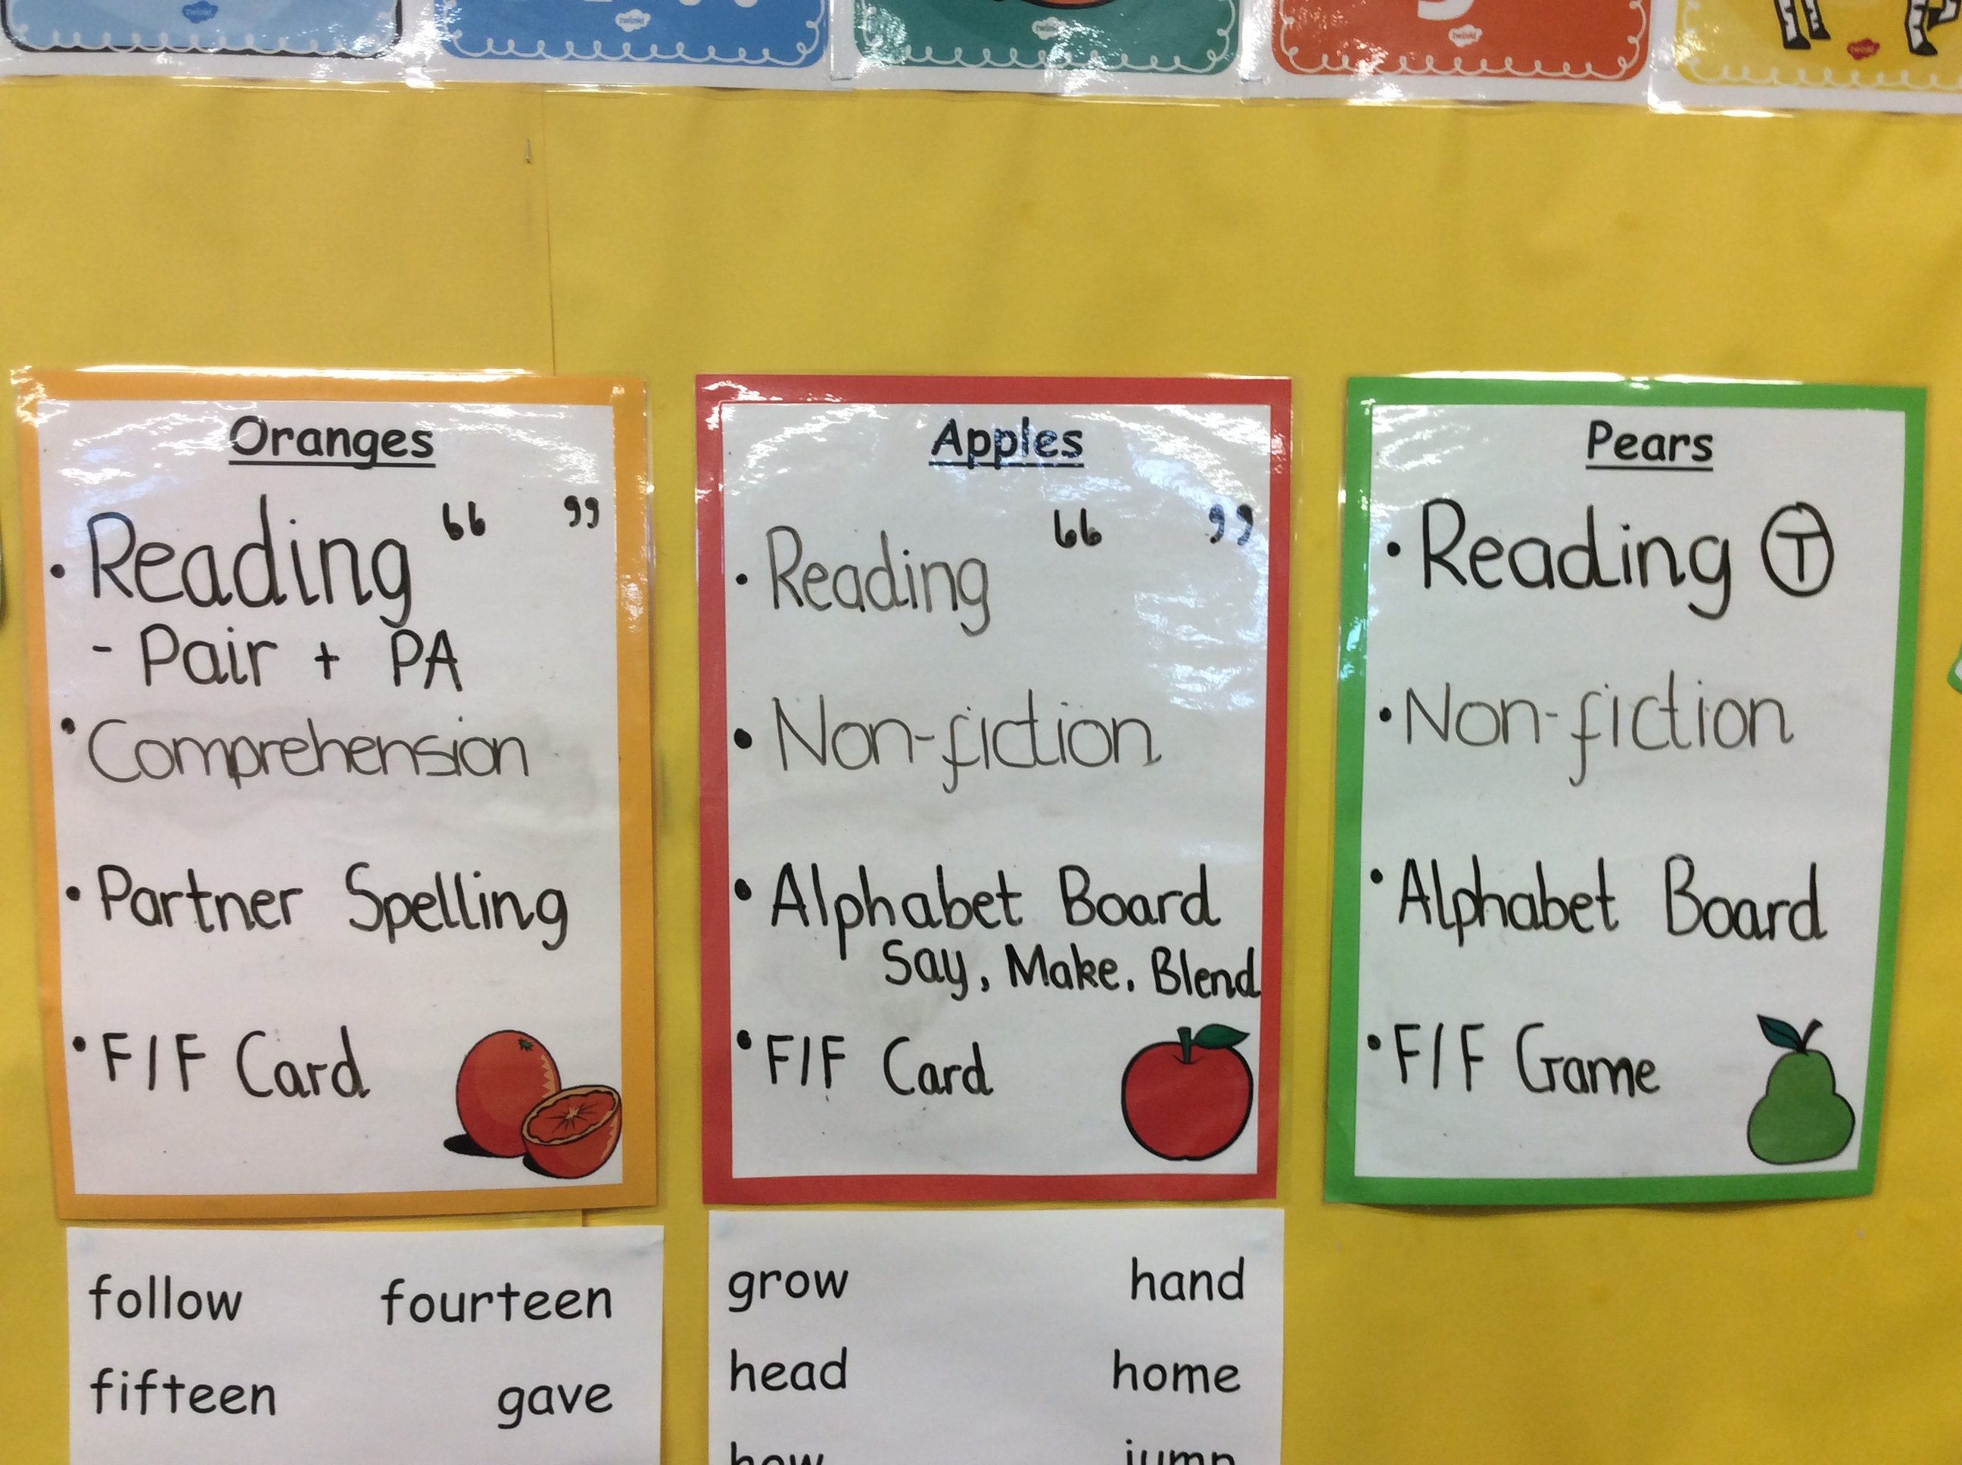

**Woodlands Primary School – Learning Environment Policy**



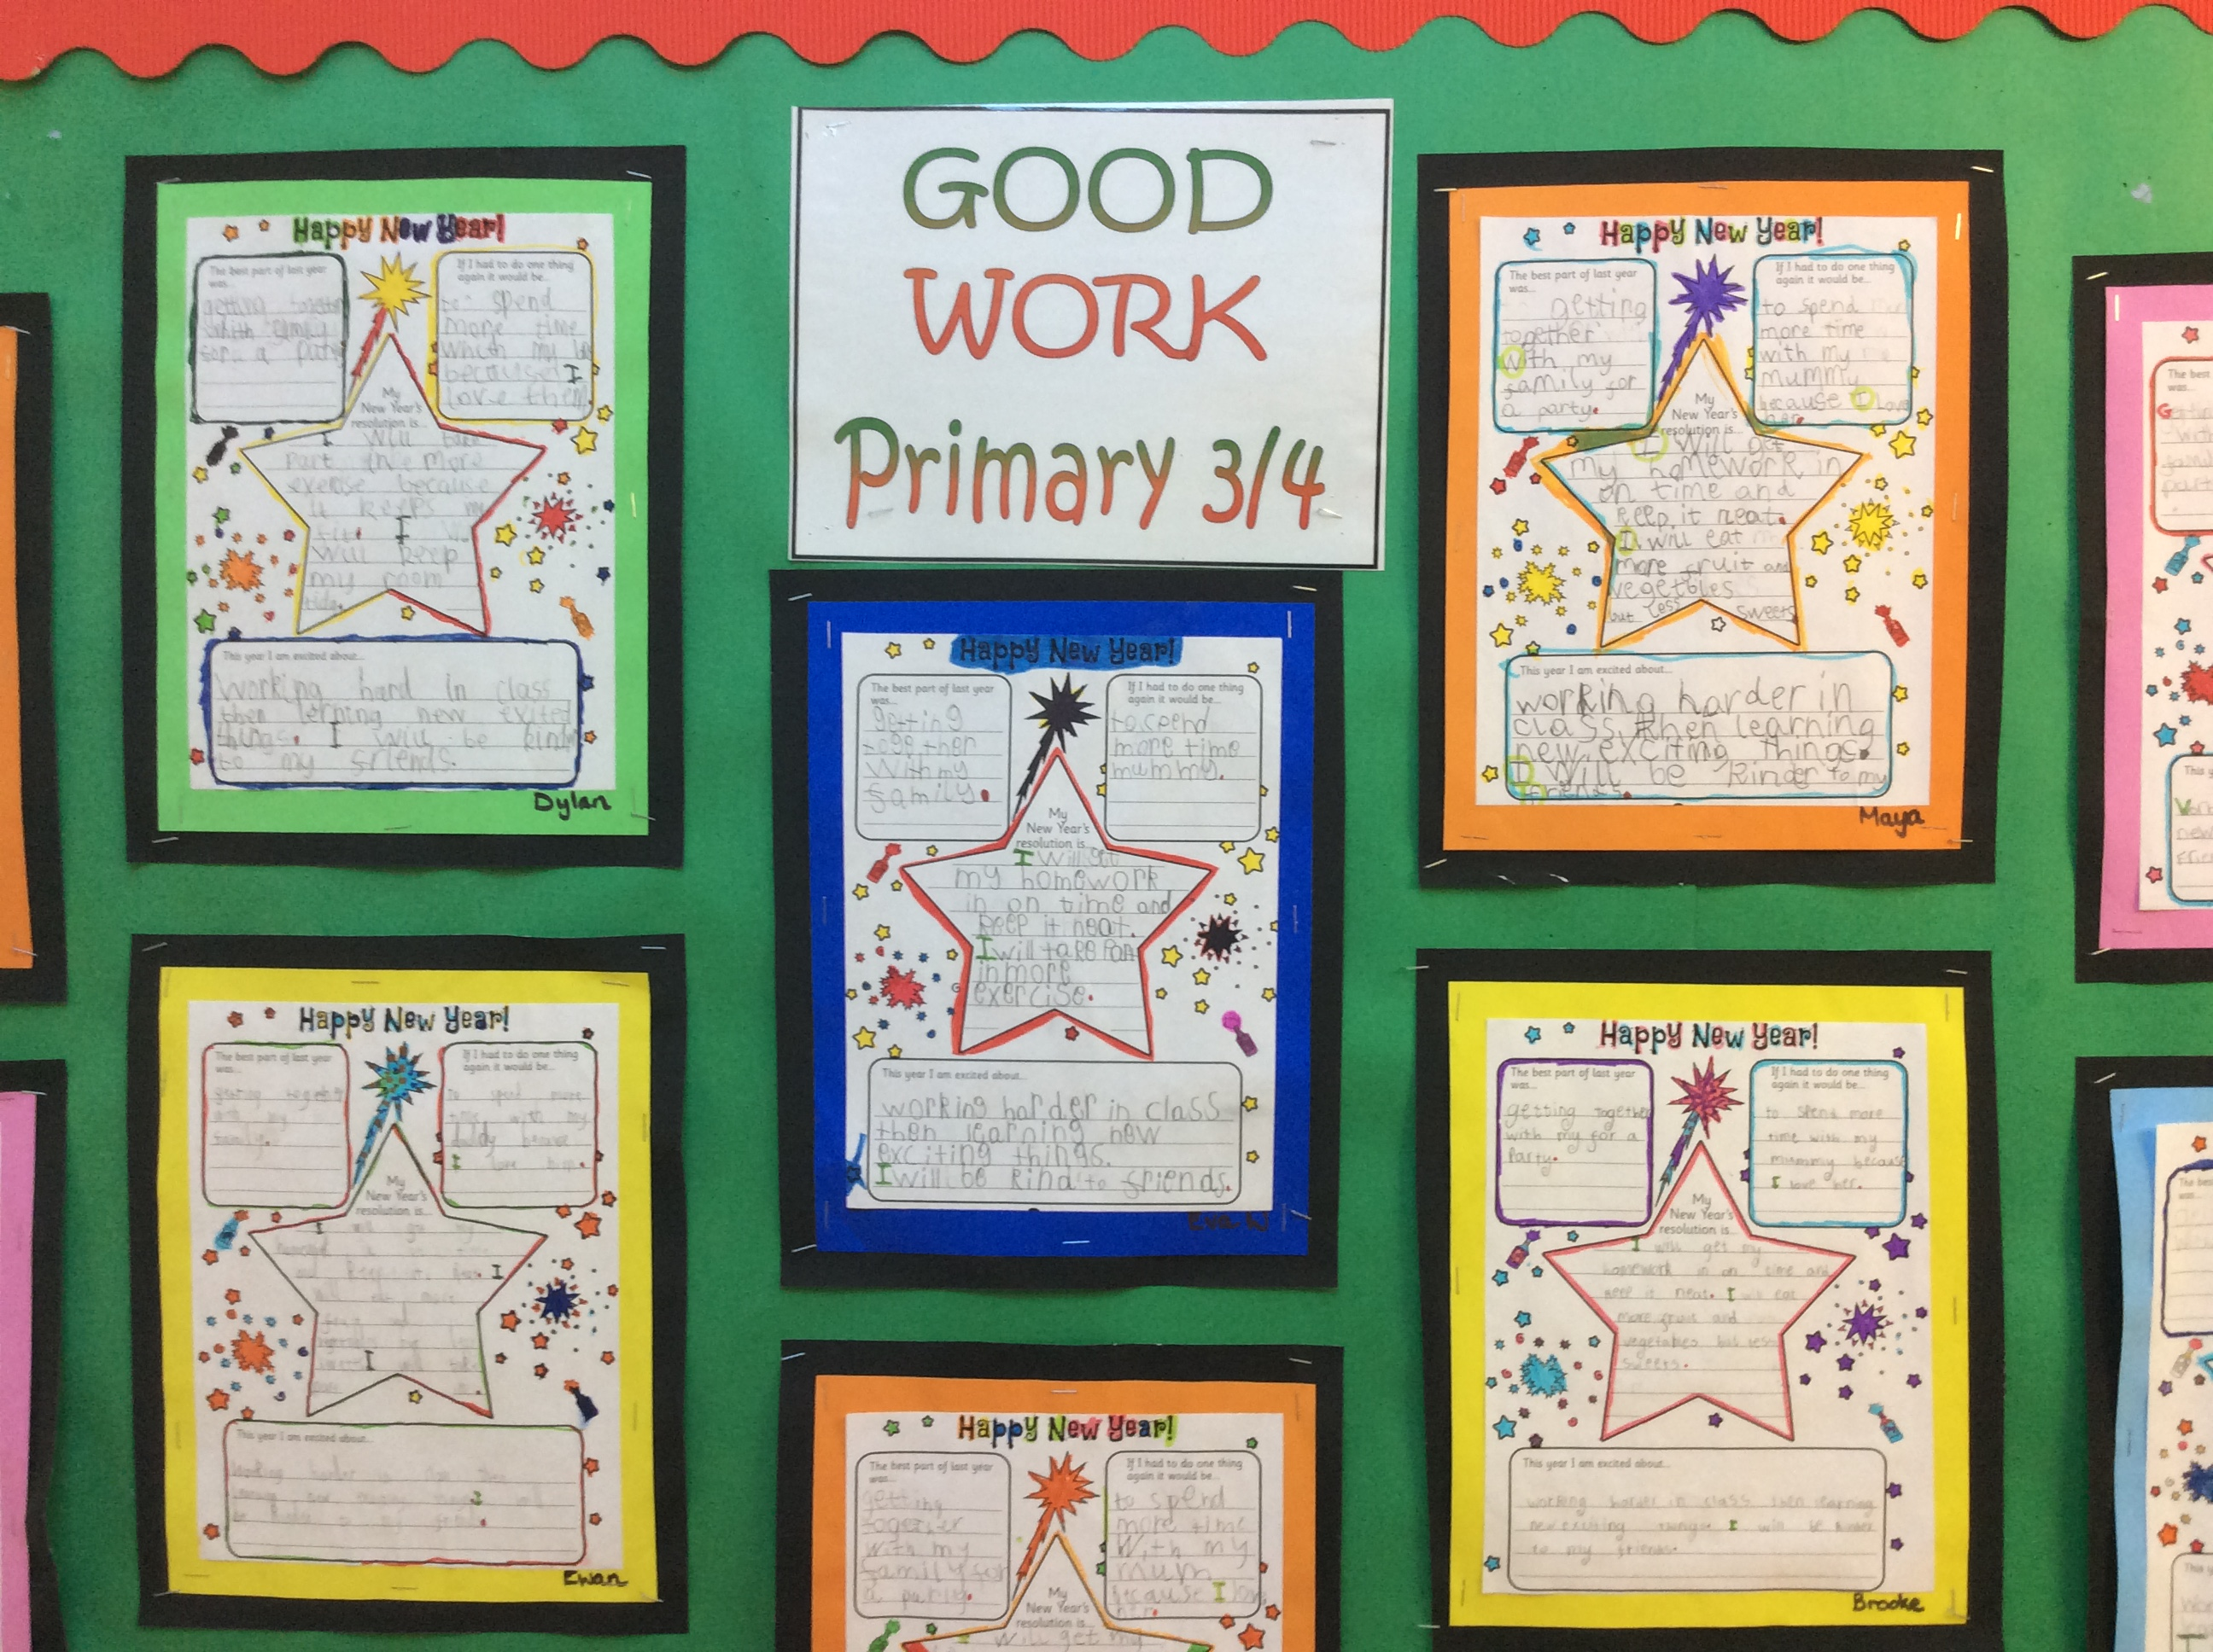

**Key Message**

**The learning environment is a visual representation of our core values and represents the standards we aspire to for all our learners. It is integral to all aspects of learning and teaching and should support children to become independent, successful learners with high expectations of their own and others achievements.**