What is Number Talks?

Number Talks is a resource designed to help and support Mental Agility.

Mental Agility is the ability to carry out multi-step mental questions accurately.

Number Talks outlines the range of mental strategies for solving number-based problems for all four number operations (addition, subtraction, multiplication and division). Throughout Number Talks sessions, the teacher will directly teach the range of strategies for their stage, engaging the children in a variety of active experiences that familiarise the children with the process of each mental strategies.

The resource specifically highlights the significance of purposeful conversation based around number problems that are to be solved mentally. The children are encouraged to select (from the variety of strategies taught by the teacher) the most effective strategy for mentally calculating the number problem posed and articulate clearly the process they went through to determine the answer.

The idea is, that regardless of the Maths lesson focus, the children begin every maths lesson with a number-based mental agility session. When Mental Agility using Number Talks is first implemented it may take up to 40 minutes, however as this becomes more embedded, a typical number talk can be conducted in fifteen minutes.

Key Features of Number Talks

- It is a conversation that takes place around a numeracy problem that the children should solve mentally
- The problems allow children to build on previous knowledge and use specific strategies
- Pupils are given a problem that they are expected to mentally solve, accurately and efficiently
- Pupils share how they have solved the problem, and what strategies they have used
- 15 minutes daily at the beginning of every Numeracy lesson

Benefits of Number Talks

Through participating in Number Talks, the pupils have the opportunity to:

- Explain their own thinking
- Consider other strategies suggested by their peers
- Learn about a range of efficient strategies
- Make decisions about choosing the best strategy for specific problems.

Grades and Stages
Number Talks | Scottish Education
Kindergarden | Nursery & Primary 1
Grade 1 | Primary 2 and 3
Grade 2 | Primary 4
Grade 3 | Primary 5
Grade 4 | Primary 6
Grade 5 | Primary 7

Strategies

Each stage is taught varying strategies. Below is a table that outlines which strategies should be taught at each stage. This information is also on pages xxix and xxx in the Number Talks book.

Category | Strategy/ Tool | K | 1 | 2 | 3 | 4 | 5 | Page Number
Addition | Counting All/ Counting On |  |  |  |  |  |  | 46, 50, 59, 60, 121
 | Doubles/ Near Doubles |  |  |  |  |  |  | 51, 60, 172, 341, 343
 | Making Tens |  |  |  |  |  |  | 51, 61, 172, 341, 343, 344
 | Making Friendly Numbers |  |  |  |  |  |  | 22, 46, 62, 171, 346
 | Breaking Each Number into Its Place Value |  |  |  |  |  |  | 23, 51, 63, 164, 171, 343, 344, 346
 | Compensation |  |  |  |  |  |  | 23, 62, 165, 173, 342
 | Adding Up in Chunks |  |  |  |  |  |  | 47, 64, 164, 173, 344, 345
Subtraction | Adding Up |  |  |  |  |  |  | 48, 54, 55, 65, 166, 167, 175, 349, 350, 367
 | Removal or Counting Back |  |  |  |  |  |  | 47, 55, 66, 176, 206, 349, 350, 367
 | Place Value & Negative Numbers |  |  |  |  |  |  | 177
 | Adjusting One Number to Create an Easier Problem |  |  |  |  |  |  | 167, 179, 349
 | Keeping a Constant Difference |  |  |  |  |  |  | 178, 348, 350
Multiplication | Repeated Addition or Skip Counting |  |  |  |  |  |  | 238, 239, 242, 245, 265, 351, 352, 353
 | Making Friendly Numbers |  |  |  |  |  |  | 242, 247, 360, 362
 | Partial Products |  |  |  |  |  |  | 242, 248, 352, 353, 354, 359, 361
 | Doubling & Halving |  |  |  |  |  |  | 250, 361, 362
 | Breaking Factors into Smaller Factors |  |  |  |  |  |  | 252, 362
Division | Repeated Subtraction |  |  |  |  |  |  | 254, 255, 256, 257, 287
 | Partial Quotients |  |  |  |  |  |  | 258
 | Multiplying Up |  |  |  |  |  |  | 258, 293
 | Proportional Reasoning |  |  |  |  |  |  | 259

Mental Agility Methodology

Mental Agility can take a variety of forms. As we know, children learn differently, some are visual learners etc. The aim of Number Talks is to provide children with an array of mental strategies that they can choose from. These strategies are further explained in the Number Talks book.

Hands On
Counters, cubes, coins, some practical experience to draw upon. This allows the child to see the problem.
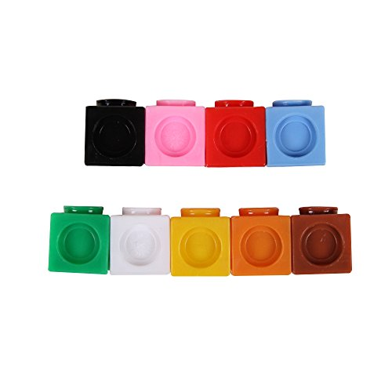

Visualisation
Dot images, ten frames etc.

Jottings
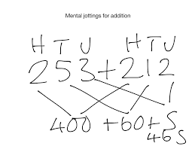
Informal notes, use of models and diagrams, white boards, jottings jotters.
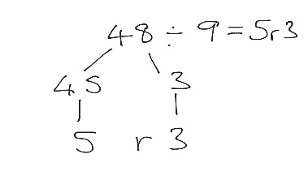

Empty Number Lines
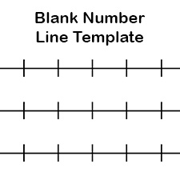
Modelling calculations, developing understanding, develop and image of a number in their head.

Mental Agility Methodology

Example of a Maths Lesson Structure

The following must be followed;

An example illustrates how Number Talks should be incorporated throughout every Maths lesson.

Approximate Time | Activity | Suggested Resources
15 minutes | Mental Maths  (Fun, active way to check recall of numeracy facts)
15 minutes | Number Talks  The children explore a range of strategies and talk about them – classroom conversations. The focus is then on a particular strategy – this should relate to the concept being taught. E.g. If you are teaching addition then the focus on addition strategies within Number Talks) | Number Talks book  Jottings Jotter  Ten Frames  Rekenreks  Dots  Empty Number Lines  100 Square  Whiteboards
5 minutes | Learning Intention and Success Criteria discussed and on display.  When pupils are ready they should be involved in creating the Success Criteria
30/ 40 minutes | Main Section of Lesson  Direct teaching of differentiated groupings. We advocate SEAL (P1-P4) and Developing Number Knowledge (P5-P7) methodology for this. Teaching is then further supported/ extended by an activity and a written task.  Group 1 Group 2 Group 3  DT (T) Activity/ Game/ ICT Written Task  Written Task DT (T) Activity/ Game/ ICT  Activity/ Game/ ICT Written Task DT (T) | SEAL and Developing Number Knowledge Planners &/ resources  Heinemann Active Maths  Teejay
10 minutes | Plenary  Teacher/ self/ peer assessment  Revisit of Learning Intention and Success Criteria | AiFL Strategies  Blooms questioning

Number Talks Planner

Stage/ Level | Experiences and Outcomes | Number Talks Strategy | Number Talks Book – page number
Nursery and Primary 1  Kindergarden  Early and First Level | MNU 0-02a  MNU 0-03a  MNU 0-07a  MNU 1-01a | Addition  Counting all/ counting on  Fluency with 3  Fluency with 4  Fluency with 5  Fluency with 6  Fluency with 7  Fluency with 8  Fluency with 9  Fluency with 10 | 46 & 50  71, 90 & 83  71, 90 & 83  73, 91 & 84  74, 92 & 84  76, 93 & 86  77, 94 & 86  78, 95 & 87  80, 96 & 88
Primary 2 and Primary 3  Grade 1  First Level | MNU 1-01a  MNU 1-02a  MNU 1-03a  MTH 1-15a | Addition  Counting all/ counting on  Doubles/ Near Doubles  Making Tens  Making Friendly Numbers  Breaking each Number into its Place Value  Compensation  Adding up in Chunks  Subtraction  Adding up  Removal or Counting back  Fluency with 6  Fluency with 7  Fluency with 8  Fluency with 9  Fluency with 10 | 98, 103, 101 & 106  109, 107 & 111  114, 112 & 117  118  133  23 & 62  47 & 64  48 & 54  47 & 55  74, 92 & 84  76, 93 & 86  77, 94 & 86  78, 95 & 87  80, 96 & 88
Primary 4  Grade 2  First Level | MNU 1-01a  MNU 1-02a  MNU 1-03a  MTH 1-15a | Addition  Counting all/ counting on  Doubles/ Near Doubles  Making Tens  Making Friendly Numbers  Breaking each Number into its Place Value  Compensation  Adding up in Chunks  Subtraction  Adding up  Removal or Counting back  Place Value and Negative Numbers  Fluency with 10 | 59, 60 & 121 122, 123 &124  125 – 128  129 – 128  133 – 136  137 – 140  141 – 144  147 – 149  152 – 154  177  80, 96 & 88
Primary 5 – Primary 7  Grade 3 – 5  Second Level | MNU 2-01a  MNU 2-02a  MNU 2-03a  MNU 2-03c  MNU 2-04a  MNU 2-07a  MNU 2-07b  MTH 2-07c  MTH 2-05a | Addition  Making Tens  Making Friendly Numbers  Doubles/ Near Doubles  Breaking each Number into its Place Value  Adding up in Chunks  Subtraction  Adding up  Removal or Counting back  Place Value and Negative Numbers  Adjusting One Number to Create an Easier Problem  Keeping a Constant Difference  Multiplication  Repeated Addition  Making Friendly Numbers  Partial Products  Doubling and Halving  Breaking Factors into Smaller Factors  Division  Repeated Subtraction  Partial Quotients  Multiplying up  Proportional Reasoning | 185- 188  189 – 192  193 – 196  197 – 200  201 – 204  209 – 211  212 – 216  217 – 220  221 – 225  227 – 229  265 – 266  267 – 271  272 – 275  276 – 281  282 – 285  287  288 – 292  293 – 297  299

Number Talks Planner

Stage/ Level | Experiences and Outcomes | Number Talks Strategy | Number Talks Book – page number
Primary 5 – Primary 7  Grade 3 – 5  Second Level | MNU 2-01a  MNU 2-02a  MNU 2-03a  MNU 2-03b  MTH 2-03c  MNU 2-07a  MNU 2-07b  MTH 2-07c | Fractional Reasoning  Equal Parts of a Fraction  Equivalent Fractions  Fractional Reasoning Using Set Models  Ordering Fractions  Integers as Benchmarks  Integers and Fractions as Benchmarks  Closer to 0, 1/2 ,1  Closer to 1, 1 ½ , 2  Distance from the Whole & Proximity to ½  Common Numerators  Multiplication with Whole Numbers and Fractions  Multiplying Whole Numbers by Fractions  Doubling and Halving  Decomposing  Division with Whole Numbers and Fractions  Whole Number Divisors  Using Unit Fractions as Divisors  Multiplying Up  Linking Fractions and Percentages  Use Benchmark Percentages as Fractions  Find Percentages of Whole Numbers  Compare Decimals to Decimals  Addition with Decimals  Place Value  Adding Up in Chunks  Benchmark Numbers  Subtraction with Decimals  Adding Up  Adjusting One Number  Keeping a Constant Difference  Place Value  Multiplication with Decimals  Ten Times Larger/Smaller  Partial Products | 77  86, 90  89  95  97  97  101  103  106, 108  109  237, 240  267  260  292, 294  296  313  121  123  129  338  342  347, 348  352  356, 357  360, 361  365  370, 372  376

