Digital Learning For Me!
Digital Learning GLOW
You know how important it is to learn so that you can be the very best that you can, and sometimes just now that means learning without your teacher in the same room!
If you’re not in school, remember you still need to plan time to learn and to complete the tasks set by your school.
You should know your GLOW username
and password and how to get onto your
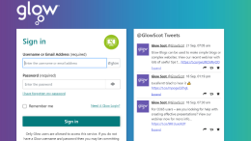
class team. There might be other logins
you need to know for other learning apps.
Your class team is where you can learn
with your friends and where you will be in
touch with your teacher.
If you don’t know how to do this you can
ask your teacher, even if you’re not in
school. Your school will be able to give
you any login details you don’t have or
have forgotten.
Remember do not share usernames or
passwords with anyone else. Keep
yourself safe online!
If you have to self-isolate or you cannot attend
school then you can continue your learning online.
Your teacher/school staff will set work for you. You
will be able to communicate with them online and
get feedback on your learning.
North Lanarkshire has a Digital School to help
teachers give you interesting and useful learning
experiences.
Not all your learning will need you to be online, your
school will give you tasks which do not involve
Glow.

