Meet the Teacher

*Mrs Collins*
Class information:
Your new class will be Bay 2.

In Primary 1 you will learn lots of new and interesting things such as your letter sounds, common words and numbers.

A little bit about me:
My name is Mrs Lorraine Collins and I have been a teacher at Wishaw Academy Primary School for 21 years.
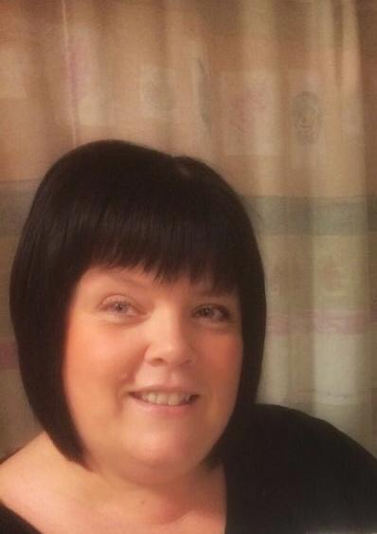
I love being a teacher because…
it is an amazing job! I get to work with lots of wonderful children and their families. I enjoy helping young people to blossom and grow.

Ways to contact me:
Phone the school office number:-
01698 522734

My favourite things:
I love spending time with my family, I have two big boys who keep me very busy. I really enjoy going to my caravan at the weekends where I can go for lovely long walks along the nature trails and the beach.





