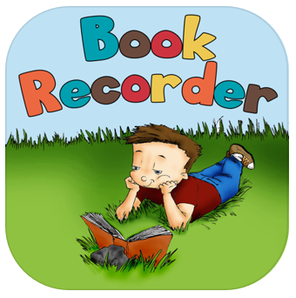
Book Recorder

Apple

Free

Use as an alternative to the Voice Memo app (Android device can use any Voice Recorder) to record children reading or telling their own stories – listen back to improve reading.
- Tap on mic to begin

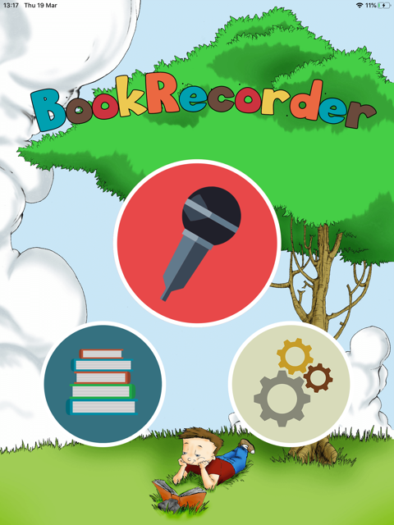

- Choose an icon, create a title and choose a cover image. Tap Next.

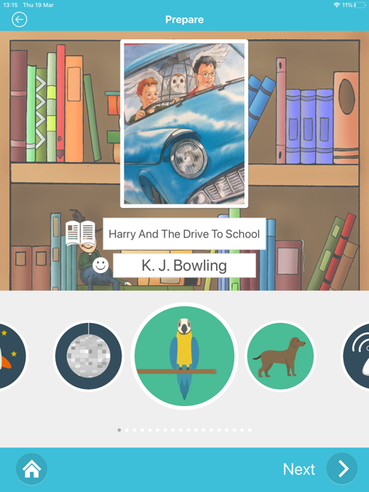

- When ready tap the red button and read aloud from your book or story. To re-record, tap the green circle with the arrow. Tap ‘Done’ when you are finished.

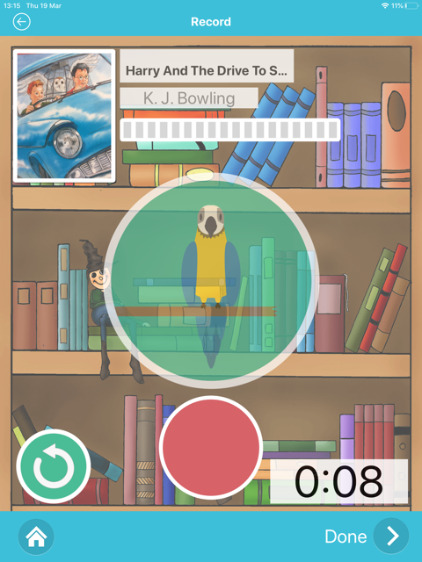

- You will be taken to the Library – tap on your story to listen to it.

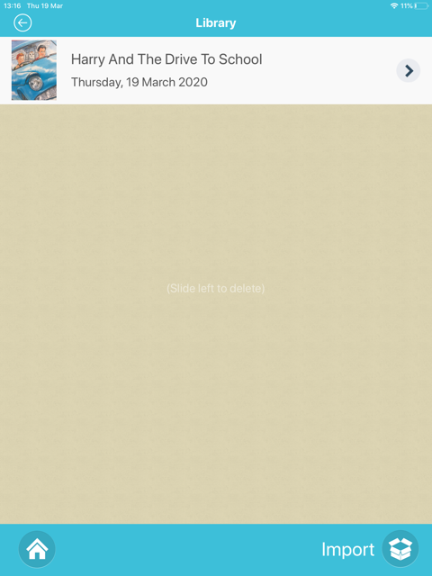

- If you want to delete a picture from the storyboard then simply drag it off the storyboard.

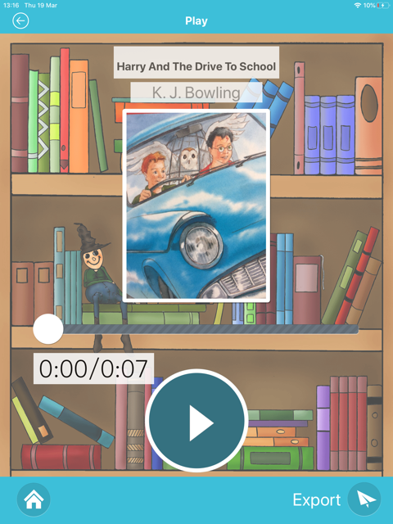

- To share your story tap Export.

