Tannochside Primary School
Participatory Budget



2024-25

Review June 2026

Background and Rationale
Participatory budgeting (PB) is a way for people to directly vote on how money should be spent. It is a powerful way for children and young people to have their say in the decisions that affect them.
Our Participatory Budget is directly funded from our allocated Pupil Equity Fund (PEF). This is money that is downloaded to Scottish Councils to help schools to support children and families who are living in poverty.

Participatory Budgeting supports Article 12 of the UNCRC ‘children and young people have the human right to have opinions and for these opinions to matter’.

“Participatory budgeting (PB) could be an innovative and effective mechanism to engage with parents and pupils, particularly those who face barriers to participation. PB directly involves people in participating in budgeting decisions that will have a direct impact on improving their lives and it can engage people who would not normally participate with traditional forms of communication.”
Paul Johnston, Director General Education, Communities and Justice, Scottish Government

Within the Bellshill Cluster in North Lanarkshire Council, schools are using the Pupil Equity Fund as a vehicle to provide children and young people with the opportunity to be involved and help decide where best to spend some of the budget allocated to schools by the council.
In Tannochside Primary School, we have allocated 5% (£5250) of our Pupil Equity Fund to our Participatory Budget.

In Tannochside Primary we aim to create an inclusive, nurturing and rights respecting community. We aim to have a nurturing and happy environment where our children can achieve to the best of their abilities.

How does it work?

A pupil focus group of Primary 6 & 7 pupils was createed to discuss issues/challenges our families may face with regards to money and finances.
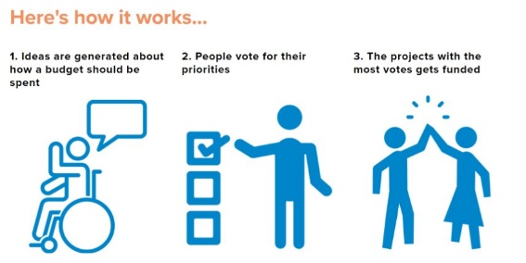
Parents/Carers will be asked for their opinions about everyday costs and how they impact their families.

Pupil Focus Group Responses
Costs
- Heating, electricity and gas
- Food
- Clothes
- Entertainment – books / toys
- Technology
- School supplies
- Transport
- Keeping children healthy
- Clubs
- Décor for home
- Toiletries

What can the school do to help with family costs?
- Food bank
- Computer after school club
- After school clubs
- Fundraise
- Clothing bank – clothing / costume / jackets swap shop
- Charge less for school trips

Parent/Carer Responses
Costs that families find most difficult to afford
- Food
- Swimming, clubs, days out
- Rent / mortgage
- Utility bills
- Clothes, shoes
- Clubs
- Lunches
- Childcare

What can the school do to help with family costs?
- Clothing bank – uniforms, costumes for themed events, casual clothing
- Keep offering activities in school
- Keep offering a wide range of after school clubs
- Provide more ICT opportunities
- Provide information on local activities/groups etc.
- Food bank

From our pupil focus group and parent/carer responses, Tannochside Primary is funding several projects:

- ‘No snack, we’ve got your back’
- Douglas’ Lending Library
- Uniform swap / clothing bank
- Food bank
- Stationery supplies
- Toiletries
- Continuing with after school club activities
- Inviting external providers into school during the day to provide different activities
- We will also signpost parents/carers to local events / community events that can help with cooking budgets, support for families, local clubs etc.
- Promote our school breakfast club and school lunches (free for P1-5 and for those in receipt of a free school meals)
- Continue with our Nurture ‘Rise and Shine’ breakfast club 9.00-9.30

‘No snack, we’ve got your back’
In Tannochside Primary, we encourage pupils to bring a small snack for playtime. This snack can be brought from home, or pupils can visit our tuck shop run by our catering staff.

For pupils who don’t have any snack we have a
‘No snack, we’ve got your back’ approach’

Our ‘No snack, we’ve got your back’ name was created by one of our P7 pupil focus group members.

A snack box/area will be available every playtime for pupils who do not have a snack, free of charge. Bottles of water will be available, as these can be reused throughout the day. Snack options will include fruit, crisps and toast from our catering staff.

Douglas’ Lending Library

Between our doors at the main entrance, we have created ‘Douglas’ Lending Library’. Douglas is our school bear who supports the implementation of our Promoting Positive Behaviour Policy. Douglas’ Lending Library is open from 8.45-3.15 every day. Pupils/parent can take books, swap books or donate books.
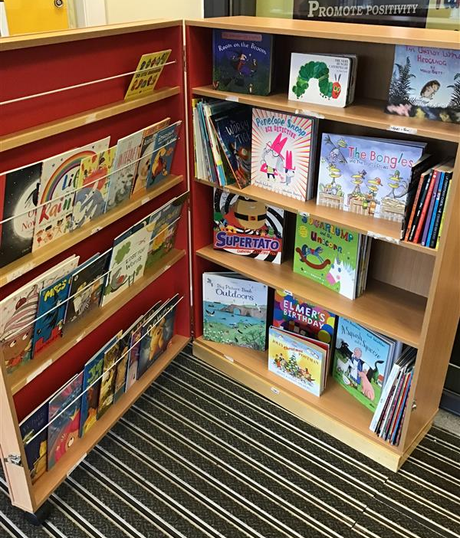
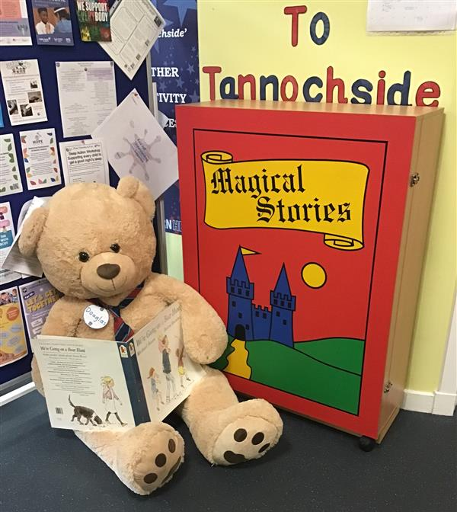

Uniform swap / clothing bank
Our responses showed that the cost of clothes, school uniform, costumes for events etc was a challenge for lots of our parents and pupils. At Tannochside Primary, we have taken a conscious decision to limit the number of dress down days and offer costume events free of charge. Whilst we encourage pupils to wear school uniform, we know that this is not always possible for some of our families.

We have lots of donations of preloved clothing in our school and with our Participatory Budget, we have purchased a washing machine and tumble dryer to wash and dry all these clothes. Money has also been spent on a large clothes railing to display all clothes, washing pods, clothes hangers and a clothes horse. Our clothing bank will be situated outside our main entrance under the shelter. Parents/carers can access this at any time of the day without having to ask / see staff. We are aware that many parents/carers may not feel able to ask for help in person.
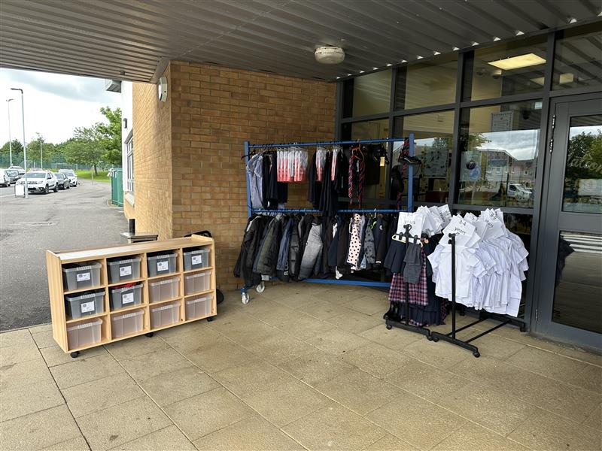
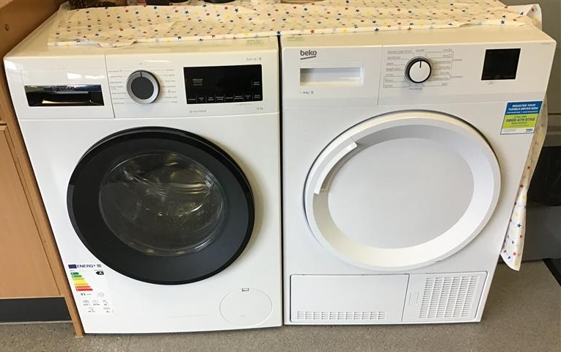
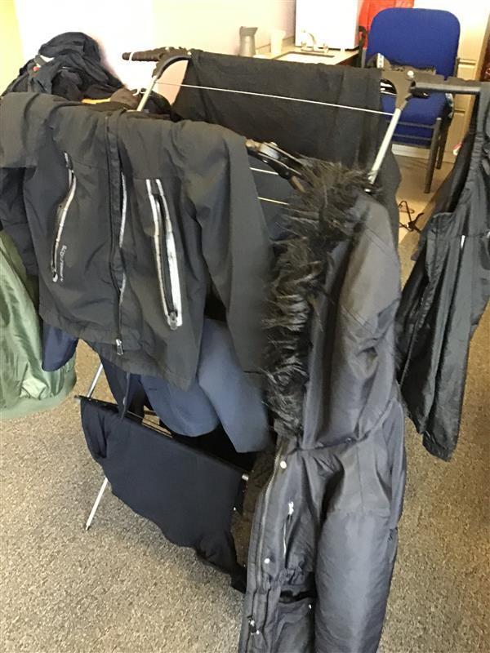
OPAL
In Tannochside, we promote Outdoor Play and Learning (OPAL) with our playground filled with exciting toys and games. During colder, wetter months, our playground can become muddy, and we are mindful of costs to parents to provide spare clothes in case their child is muddy/wet and the cost of washing/drying their child’s clothes. With our washing machine and tumble dryer, we can help our parents with this.

Food bank / toiletries
Many parents/carers/pupils said that they worried about the cost of food. Alongside our ‘No snack, we’ve got your back’ approach, we will be linking with Viewpark Church’s to signpost families to their food bank. We will also provide our own ‘Tannochside Pantry’ at targeted times across the year e.g. Christmas, holidays. Money has been spent on storage units to store non-perishable foods. This storage unit will also be placed outside our main entrance, under the shelter for parents/carers to access throughout the day at these targeted times.

After School Clubs
We have a variety of after school and lunch clubs running this year including:
- Basketball
- Multisport
- Dance
- STEM
- Tag Rugby

External Visitor – opportunities
At Tannochside Primary School, we are always looking for ways to involve our community in our daily school life. We have had several projects running:
- Credit Union
- Scripture Union
- Samba band
- Young Leaders
- City of Glasgow College students – PE
- Gardening Club

Costings

Item | Cost | Project | Projected / Purchased | One time purchase/regular purchase
Washing Machine | £549 | Clothing Bank | Purchased | One time purchase
Tumble Dryer | £344 | Clothing Bank | Purchased | One time purchase
Laundry Baskets | £15.10 | Clothing Bank | Purchased | One time purchase
Heated Clothes Rail | £204.98 | Clothing Bank |  | One time purchase
Laundry Pods | £11.10 | Clothing Bank | Purchased | Regular purchases
Coat Hangers | Donated | Clothing Bank | Donated | One time purchase
Large Clothes Rail | £131.00 | Clothing Bank | Purchased | One time purchase
Storage Units | £1499.96 | Food Bank | Purchased | One time purchase
Laminating Pouches | £23.34 | Food Bank / Clothing Bank | Purchased | Possible further purchases
Snacks |  | ‘No snack, we’ve got your back’ |  | Regular purchases
Bottles of Water |  | ‘No snack, we’ve got your back’ |  | Regular purchases
Fruit |  | ‘No snack, we’ve got your back’ |  | Regular purchases
Toiletries |  | Toiletries |  | Regular purchases
Bookcase | Free – donated by Parent Council | Douglas’ Lending Library | Donated | Donated
Books | Free  Donations from parents/  school | Douglas’ Lending Library | Donated | Donations ongoing
Clothing | Free donations from parents/carers | Clothing Bank | Donated | Donations ongoing

