Tannochside Primary School



Promoting Good Attendance
2025

Rationale
At Tannochside Primary School, we believe that regular attendance and punctuality are essential for children to achieve their full potential and to develop positive relationships, confidence, and learning habits.
This policy outlines the school’s commitment to promoting high attendance and sets out the responsibilities of pupils, parents/carers, and staff in supporting regular school attendance. We recognise that some absences are unavoidable and are committed to working in partnership with families to support pupils where attendance concerns arise.
As a nurturing school, we are committed to creating a safe, supportive, and inclusive environment where children feel valued, respected, and ready to learn. We recognise that wellbeing and attendance are closely linked, and we work with families to identify and support any barriers that may affect a child’s attendance at school.
We follow North Lanarkshire Council Attendance Policy. All information from this policy is attached.
In line with guidance from North Lanarkshire Council and the Scottish Government, we aim to create a positive and supportive environment where every child is encouraged to attend school regularly and succeed.

Aims
- To provide all pupils with the opportunity to achieve their full potential through maximising attendance
- To ensure attendance is the collective responsibility of every member of staff.
- To work in partnership with pupils, parents/carers, staff and external agencies.

Roles
Parents/carers Role in promoting good attendance -
Have a legal responsibility to ensure their child attends school until he or she reaches school leaving age (section 30, Education (Scotland) Act 1980). However, there is no clear evidence that legal sanctions improve school attendance. Working in partnership with schools and partner agencies is vital to ensure positive relationships are in place, promoting the benefits of regular attendance and reduce any barriers.
It is important that parents/carers liaise and communicate with the school when there is an indication that attendance at school is becoming an issue. This will allow any issues to be dealt with promptly and to allow the right support at the right time and to remove barriers to non- attendance as quickly as possible. Parents/carers should provide guidance and motivation to assist a child or young person to attend school and should encourage wider participation in whole school life and the wider community.
School/Establishment Role in promoting good attendance -
- We will provide a welcoming school ethos and a culture of support and encouragement and promote positive attitudes to attendance in children and young people and their families.
- We will work in close partnership with parents/carers and other professionals.
- We will work with partners to ensure that any barriers for families are supported and overcome when possible.
- We will aim to recognise early signs of potential non engagement and consider a flexible and creative approach to enthuse and engage learners.
- We will involve children and young people in areas of development around attendance.
- We will take appropriate preventative measures to identify early signs of concern which may lead to absence.
- We will track the attendance of all children in the establishment to identify patterns of absence and supports which may be required.
At the start of each school session, parents will be asked to update contact details including at least one emergency contact number via Parents Portal.
Parents/carers should inform the school of absences on the first day and indicate when their child or young person is likely to return to school.
Absences will remain ‘unauthorised’ until contact has been made and a reason for absence have been provided.
If the child is not returning to school in the afternoon we ask that parents inform the school by telephone. Failure to inform the school will result in absence being marked in the register as ‘unauthorised’.
A request for permission to leave school during the day for dental or doctor's appointment must also be accompanied by a note/ appointment card and the child must be collected by an adult who will be asked to sign out the child.
We cannot let any child leave school on his/her own during the school day. (Exception to this would be if a child was a home lunch, collected by an adult.)
Please note that children who take school meals or have packed lunches are required after eating these to stay within the confines of the school playground.
Every effort should be made to avoid family holidays during term time as this both disrupts the child’s education and reduces learning time. Parents/guardians should inform the Head Teacher by letter/ email, before going on holiday.
Absences due to ‘holiday’ will be classified as authorised only in exceptional circumstances. Comparative cost is not accepted as a reason for these absences to be authorised. Family holidays during term time will be recorded as unauthorised, other than in exceptional circumstances which may include where a parent/carer’s employment is of a nature where school holiday leave cannot be accommodated. Such employment may include the armed services,
emergency services or professions where parent/carers are required to work away from home for prolonged periods.
Good attendance and punctuality are very important and help to ensure that every child is receiving the maximum benefits from attendance at school.

Exceptional Domestic Circumstances
Parents may request permission for such leave in writing and the Head Teacher may authorise such requests under the following circumstances:
- The period immediately after an accident or illness
- A period of serious or critical illness of a close relative
- A domestic crisis which caused serious disruption to the family home, causing temporary relocation.

Our Approaches and strategies to promote good attendance -
- Ensure that the school attendance policy is clear and accessible to all
- Ensure parent/carer understanding of attendance processes using a range of media including visuals, posters, leaflets
- Encourage development of key relationships between staff and parent/carer
- Use multi-agency partnership approaches, where appropriate
- Regularly review and analyse attendance data
- Implement, regularly monitor, and evaluate targeted interventions for children/young people at the appropriate level of staged intervention
- Ensure timely communication with parent/carers and young people where appropriate
- Use a range of approaches including home visits to build relationships between home and school (where possible)
- Maintain regular, informal contact and encourage parent/carers to view the school as a source of support and help
- Many issues relating to absence in school can be dealt with quickly and promptly by using ‘within’ school supports and by ensuring that there are positive relationships in place to support children/young people and their families.

Daily Procedures
- Class Teachers complete paper register morning and after lunch, this is sent along to main office by 9.15am and 1.30pm respectively.
- Children attending school after the school bell, sign in at school office.
- Office staff update Seemis system using appropriate attendance codes.
- Text message is sent to all unauthorised absences by 9.45am.
- Focus Children – Focus children will be identified to office staff by SLT. If focus children have an unauthorised absence, office staff must follow the Focus Children flow chat as detailed below.
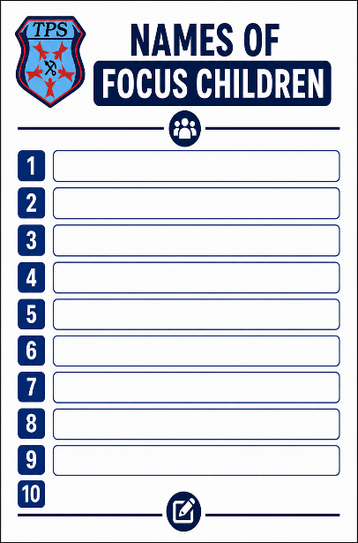
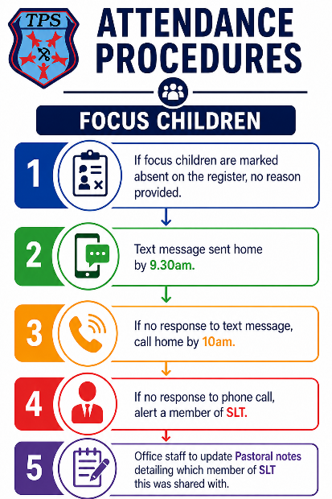

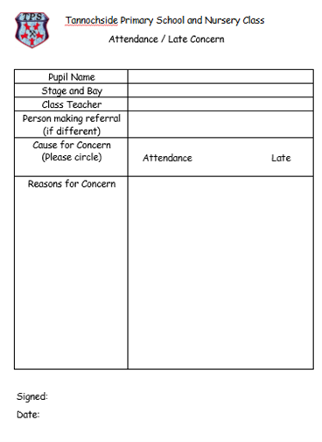

Monitoring
Attendance is tracked and monitored monthly by SLT.
Class teachers are advised if they have any attendance or late coming concerns to complete ‘Attendance Concern Form’ and email it to SLT. (Image above)
North Lanarkshire Attendance Policy is followed.
Partnership working with other agencies if required.

North Lanarkshire Attendance Policy
Introduction
In line with the Children and Young People (Scotland) Act 2014, North Lanarkshire Education and Families recognises that children and young people do best within a context that is underpinned by shared values of respect, inclusion, fairness, community engagement and partnership, supported by their parents and carers, families, and communities.

This relies on staff at all levels developing high quality relationship-based practice, linked closely to Getting it Right for Every Child - the national approach to improve outcomes and support the wellbeing of children and young people.

Promoting positive social and emotional development alongside working in partnership with families and communities is important in ensuring children and young people are positively engaged with their learning.
Adopting a whole school nurturing approach provides a context for children and young people to form positive relationships and helps them settle to learn.
Along with this, promoting resilience is important in supporting all children and young people as they make their way through early years and school, including those who may have experienced adverse childhood events in their life. Establishing a safe nurturing environment is the foundation for building resilient children and young people.
These approaches are particularly important when promoting good attendance. Absence, for whatever reason, leads to disrupted learning for children and young people and can result in poorer outcomes. Ensuring schools and establishments provide a rich and supportive context for learning for all children and young people, including those who are looked after / care experienced or have additional support needs, is crucial in promoting good attendance.
This Operating Policy should be used by schools and establishments to ensure that they are doing all they can to promote good attendance and to support schools in accurately classifying and recording attendance and absence for all children and young people on the school roll. Promoting good attendance extends to encouraging children and young people to arrive at school and at class on time and proactively addressing concerns over habitual lateness.

Legal Framework and Compliance

This policy takes account of legislative requirements and relevant Scottish Government guidance A full programme of support will be in place to ensure effective implementation of the policy.

The National Child Protection Guidance 2014 indicates that all agencies that work with children and their families have a shared responsibility for protecting children and young people and promoting, supporting, and safeguarding their wellbeing. The importance of promoting good attendance at school is highlighted by concerns about the safety and wellbeing of children who are not at school. Child protection is of paramount importance and non-attendance can indicate a child or young person is at risk.

Equality or Fairer Scotland Duty

Since young people in areas of socio-economic disadvantage often experience multiple barriers to learning, this policy should be understood to be coherent with the Council’s approach to ensuring fairness and diversity.

The Fairer Scotland Duty is intended to reduce the inequalities of outcomes caused by socioeconomic disadvantage. Inequalities of outcome mean any measurable differences between those who have experienced social – economic disadvantage and the rest of the population.

Roles and Responsibilities

Parents/carers - have a legal responsibility to ensure their child attends school until he or she reaches school leaving age (section 30, Education (Scotland) Act 1980). However, there is no clear evidence that legal sanctions improve school attendance. Working in partnership with schools and partner agencies is vital to ensure positive relationships are in place, promoting the benefits of regular attendance and reduce any barriers.
It is important that parents/carers liaise and communicate with the school when there is an indication that attendance at school is becoming an issue. This will allow any issues to be dealt with promptly and to allow the right support at the right time and to remove barriers to non- attendance as quickly as possible. Parents/carers should provide guidance and motivation to assist a child or young person to attend school and should encourage wider participation in whole school life and the wider community. Parents/carers should inform the school of absences on the first day and indicate when their child or young person is likely to return to school.
School/Establishment
- To provide a welcoming school ethos and a culture of support and encouragement and promote positive attitudes to attendance in children and young people and their families.
- To work in close partnership with parents/carers and other professionals. In discussing attendance with parents/carers and the child or young person it is important to maintain a practical focus that recognises the range of challenges. Schools should work with partners to ensure that any barriers for families are supported and overcome when possible.
- To recognise early signs of potential non engagement and steps are taken to consider a flexible and creative approach to enthuse and engage learners, by developing effective responses to support the needs and reintegration of children and young people into learning following absence from school.
- To involve children and young people in any areas of development around attendance and encourage children and young people to engage in wider school life. Families are also likely to encourage full attendance where they feel part of the school community, where schools work alongside them as equal partners
- To take appropriate preventative measures to identify early signs of concern which may lead to being absent from school and respond quickly to absence to ensure that children and young people are safe and well. Staff should ensure they implement robust assessment and planning as outlined in NLC Staged Intervention Framework.
- Providing additional support may help children and young people to engage more fully with school and promote good attendance. Schools should recognise that poor attendance can often be related to, or be an indication of, an additional support need and they should use their staged intervention processes to ensure that any barriers to learning are identified and appropriate support is provided.
- Track the attendance of all children in the establishment to identify patterns of absence and supports which may be required.

For ease of reference a checklist and sample letters have been drawn up which will support schools in ensuring that consideration has been given to actions to promoting good
attendance and contacting parents/carers.

Empowering cluster – Where a child or young person’s attendance is causing a concern or there is prolonged nonattendance, the Cluster Improvement, and Integration Lead, plays a vital role in liaising between the home and school in offering support, providing support strategies through groups or personalised support to encourage good attendance. They are also the link between the school and integrative practice with partner agencies.

Planning at this level can offer a range of support, which help address the barriers being faced.

- Discussion at Cluster Planning for Children’s Wellbeing
- Links with the Digital School to plan for online contact with children and families.
- Online learning offer and planning to track and record engagement with this.
- Use of the wellbeing base to support a return to in establishment learning.
- Broader pathway planning to increase curricular engagement and learning opportunities.
- Assessment of the barriers to attendance.

Importance of Good Attendance

Attendance is defined as participation in a programme of educational activities arranged and agreed by the school, including:

- Attendance at school
- Learning out-with the school provided by an alternative learning provider while still on
- The roll of the school
- Interviews, visits, and experiences (day and residential) relating to all aspects of the
- Curriculum and taking place in a location out-with the school.
- Study leaves for pupils participating in national exams, if arranged by the school during
- The period of the national examination timetable
- Tuition via hospital or outreach teaching services
- Work experience which can be considered in a variety of formats and activities, for
- Example: volunteering within the school community, participation in events that
- Develop skills for life, learning and work.

Non-attendance at nursery level can be one of the earliest indicators that a family is experiencing challenges. Staff in early learning and childcare (ELC) settings may also find this guidance useful as an indicator of good practice in the promotion of attendance and the prevention and reduction of absence. They should use staged intervention to support children and families at this stage.

The causes and resultant impact of poor attendance are complex and far reaching. Poor attendance has been linked to lower levels of attainment, difficulties with peer relationships, emotional and behaviour needs and poorer post school outcomes including employment opportunities.

Every School Day Counts
Children and young people are more likely to be motivated to attend school when they feel fully included, engaged, and involved in the wider life of the school. Promoting good attendance is a multi-faceted activity and requires schools to promote positive relationships within an inclusive ethos and culture.
The cumulative impact of missed days at school can have detrimental and long-lasting consequences and can significantly impact on positive destinations and outcomes for children and young people. Table 1 illustrates the cumulative effect of random days missed from school, in any single academic year, and the potential impact on participation and learning.
Attendance percentage needs to be considered along with other information. Clear communication with parents/carers is essential. It is important to recognise and celebrate improvements in attendance where there have been issues. The chart below can be used to highlight the impact of non-attendance with regards to days missed as opposed to communication through the use of excellent, good, satisfactory, and not satisfactory.

100 % Attendance | 0 Days missed | Gives your child the best chance of success and ensuring their full potential is achieved
95% Attendance | 9 Days of Absence  1 week and 4 days learning missed | Makes it harder to achieve full potential and secure the best possible outcomes
90% Attendance | 19 days of Absence
 | 3 weeks and 4 days of learning missed
85% Attendance | 27 Days of Absence  5 weeks and 3 days of Learning  Missed  Almost half a term missed | Impacts significantly on learning and progress which can lead to poorer outcomes in achievement, wellbeing, and social and emotional development
80% Attendance | 36 days of Absence  7 weeks and 3 days of learning missed.  Half of a term missed
75% Attendance | 45 Days of Absence  9 weeks and 1 day of learning missed.  Almost 1 whole term missed
If a child has 90% attendance, they will have the equivalent of
- ½ a day off per week
- 18 days off per year
- 247 days off over their school career of 12 academic years, equivalent to over 1 year of lost education.

Staged Intervention

Early and effective intervention is crucial in supporting attendance at school. Interventions
require to be implemented before situations reach crisis point and the potential for reengagement with school becomes more challenging.

When considering approaches and strategies to promote good attendance, schools will:
(1) Ensure that the school attendance policy is clear and accessible to all
(2) Ensure parent/carer understanding of attendance processes using a range of media
including visuals, posters, leaflets
(3) Encourage development of key relationships between staff and parent/carer
(4) Use multi-agency partnership approaches, where appropriate
(5) Regularly review and analyse attendance data
(6) Implement, regularly monitor, and evaluate targeted interventions for children/young
people at the appropriate level of staged intervention August 2020
(7) Ensure timely communication with parent/carers and young people where appropriate
(8) Use a range of approaches including home visits to build relationships between home
and school (where possible)
(9) Maintain regular, informal contact and encourage parent/carers to view the school as a
source of support and help

Many issues relating to absence in school can be dealt with quickly and promptly by using.
‘within’ school supports and by ensuring that there are positive relationships in place to support.
children/young people and their families.

Absence Matters -A positive Approach, Quick Guide for Schools. Has been created to support all establishments. This is available in Appendix 1. As part of this there are 3 letters which should be used at different stages of the staged intervention model. This are included at Appendix 3. The letters are also uploaded to Seemis.

Application- Reports-Standard Letters- Letter template editor

They are saved as : ATT L1 new 2024 , ATT L2 new 2024 and ATT L3 new 2024. All local information such as school name and average attendance for the school should be added prior to sending.

To support schools to identify planning and approached for children and young people, when attendance becomes and issue a planning checklist is included in Appendix 2

In addition, a Parent’s Guide (Attendance Matters- A Parent’s Guide) has been produced and is included in within Glow. Establishments should make this available to all parents and highlight through their normal channels such as the school website. A copy should be sent home annually.

Tracking and Planning

All establishments should have a system in place to regularly track attendance, this will enable robust communications with families and young people. It will also identify individuals, cohorts and specific groups who may be at greater risk of non-attendance due to other factors (poverty barriers, ASN, social groupings)

Getting it Right for Me Plan (Part I) (education)

If enhanced planning is needed to support the wellbeing and learning within the class, then a GIRFME plan is required. This should outline personalised strategies to support teaching and learning, adaptations to the classroom environment to ensure children and young people are able to achieve and be fully included, engaged, and involved in their learning.

Getting it Right for Me Plan (Part II) (education)
This outlines targeted literacy, numeracy and health and wellbeing outcomes in line with the curricular benchmarks and Experiences and Outcomes.

Intensive Learning Pathways

After a period of significant absence, a coherent, flexible, inclusive, and enriched curriculum may be required to be more flexible for children and young people to benefit from their educational experiences. Partner agencies can provide alternatives and contribute to a child or young person’s differentiated educational experiences.

For any child and young person returning for a period of significant absence, establishments, through the empowering cluster operating model should plan with the CIIL and individualised timetable which supports return to establishment-based learning. This must have review dates built in and be tracked for impact on the child/young person.

Specific Circumstances

Providing education for children and young people during long term illness:

Education authorities are required to make arrangements to support the learning of children or young people with prolonged ill-health (section 14 of the Education (Scotland) Act 1980 (“the 1980 Act”)) through outreach teaching or other special provision such as hospital education services. Where appropriate provision is in place, schools may record this as attendance. Where it is not in place, this is still categorised as authorised absence. However, the school in which the child or young person is enrolled must actively make alternative arrangements to ensure that the child/young person can access their entitlement to education.

Establishments should discuss with the CIIL any requirement for periods of home tuition. The CIIL will link with Inclusion to discuss needs and requirements. It is the responsibility of the Head Teacher to identify/ask a member of teaching staff to volunteer. Payment will be made for tuition done out of hours; in most cases this is from the school budget.

Young Carers
Understanding children, young people’s and their family’s circumstances is fundamental in schools. In situations where there is an unwell family member there can be challenges when it comes to attending school. It is important for a school to respond with care and sensitivity as school can provide consistent and long-term support, positive adult and peer relationship, and a place where they feel safe and supported.
Recognising Diversity
Schools respond to cultural differences with sensitivity. Children and young people of all faiths may be granted authorised absence to enable them to participate in religious observance. In some cultures, family weddings or funerals are major events which may require children and young people to travel or participate in extended celebrations. If a related absence lasts for more than four weeks, in these circumstances, children and young people should be recorded on Seemis as ‘‘extended leave with parent/carer consent’’. This allows them to remain on the school register with an expectation of their return which has been confirmed by parents.

Children from the Travelling Community
Children from the travelling community have some of the poorest educational outcomes of any group in Scotland. (Scottish Government 2018). As a group the gypsy/travellers still experience widespread prejudice and discrimination.
To improve these outcomes, partnership working is key and likely to involve health, social work, housing and community learning and development. Building positive relationships with families is vital to this and this should include taking cognisance of some family’s previous negative experiences of school. Some parents/carers may lack confidence in their own literacy skills.
Many traveller families wish to withdraw their children or young person from education at the end of primary school. In this case Inclusion and Interventions section should be contacted for advice and support.
https://www.gov.scot/policies/gypsy-travellers/educational-outcomes-for-gypsytravellerhttps://www.gov.scot/policies/gypsy-travellers/educational-outcomes-for-gypsytraveller-children/children/
Children or young people missing from education for extended periods.
There may be occasions where a child or young person goes missing from education for an extended period and the education authority has made extensive unsuccessful attempts to contact a family. In these circumstances, the education authority should liaise with their local social work team.
There are many complex reasons why a family might move unannounced. Often, staff in schools are aware of individual circumstances and family connections which will enable them to find children or young people quickly. Children or young people may simply have moved schools or have moved homes, and when the new school is contacted, information can be transferred to help the child or young person settle quickly.
Attendance beyond school leaving age.
Young people who choose to stay on at school beyond statutory school leaving age, usually 16 years of age, should be asked to consider their continued commitment to full attendance. Some schools develop a learning agreement outlining these expectations. Attendance must also be monitored to ensure proper entitlement to the Education Maintenance Allowance (EMA). The EMA is a weekly payment, paid directly to young people who stay on at school and is designed to help overcome financial barriers which otherwise may prevent them from staying on.
Recording Attendance through SEEMIS
In the event of children or young people’s absences, the school should endeavour to establish a reason for the absence through a phone call or letter from the parent/carer. The use of Group Call is an effective way of trying to establish the reason for an absence quickly. There should be a member(s) of staff with responsibility for the use of Group Call ensuring that a notification is sent to parents/carers informing them of an absence and seeking clarification. Schools should endeavour to send a text notification to the key contact within one hour of the beginning of the morning and/or afternoon sessions There may be occasions when the attendance issue may require to be escalated to the appropriate member of the senior management team, the Depute Head Teacher, or Head Teacher.
Recording of attendance should take place at least twice a day to enable the school to note attendance and absence for each morning and afternoon session. Attendance can be recorded more frequently on a period-by-period basis in secondary schools.
Where no notification of absence has been received and the contact (e.g. text) has not been responded to, this should be followed up as soon as is reasonably practicable. Schools may consider prioritising contact with parent/carers of children and young people where those children/young people are in an ASN base, or are care experienced, given the higher level of vulnerability of these children and young people.
If contact has not been possible and the school has cause for concern, then the school may consider contacting the child or young person’s emergency contacts or contact other agencies involved with the child or young person and/or family.
If absences cause a concern, then there are several ways that this can be approached. Schools should be pro-active and engage in dialogue as early as possible in a supportive manner with parents/carers to build communication and trust. Schools should not wait until absences have fallen below a percentage to trigger communication with parents/carers establish reasons for absences in the form of a phone call or a letter to parents/carers. There should be an element of discretion here as there may be occasions when the school is aware of the absences and a letter or call may not be appropriate.
In the case of care experienced or vulnerable children, when the child or young person does not attend school, this should always be followed up immediately. To enable swift action to be taken it is vitally important that the school has an up to date and accurate record of the key contact information for the parent/carer. In the case of children or young people who are care experienced, looked after at home, away from home, kinship care or foster care, the social worker should also be contacted.
A list of SEEMiS codes for accurate recording can be found at Appendix 5. To support establishment use of the codes, posters have been issued to all establishments which should be displayed in the office area. A PDF of these is included in Appendix 6, to enable further copies to be printed and displayed.
Schools should be pro-active and engage in dialogue as early as possible in a supportive manner with parent/carers to build communication and trust. Schools should not wait until absence has reached a trigger which would prompt communication in the form of a letter or phone call with parent/carers to establish the reason/cause of the absence. Schools can exercise an element of discretion as there may be occasions when the school is aware of the reason for the absence and a letter or call may not be appropriate.
Managing Authorised Absence
School staff are best placed to decide the most appropriate response to requests for absence to be authorised. Schools may authorise absence when they are satisfied with the reason provided, usually by the parent/carer (a note, email, phone call), self-certified or sometimes the reason may be provided by another service which is actively engaged with the child or young person or their family.
Reasons for authorised absence may include (full details are within the Seemis Absence Codes):
- illness where no learning provision is made (including mental health and wellbeing concerns)
- Medical and dental appointments (parent/carers and children and young people should be encouraged to arrange appointments outside school hours)
- Meetings prior to and during court appearances and other legal processes
- Attendance at, or in connection with a Children’s Hearing or Care Review, or appointment with another service working with the child or young person /family.
- Religious observance
- Bereavement
- Weddings or funerals of close friends and family
- Arranged absence in relation to child or young person in Gypsy/Traveller families.
- Participation in non-school based debates, sports, musical or drama activities agreed by the school.
- Lack of transport (including due to bad weather).
- Family recovery from exceptional domestic circumstances or trauma
- Authorised parental holiday.
- Extended leave with parent/carer consent including some young carer activities.

Managing Unauthorised Absence
Schools should record absence as unauthorised when they perceive that there is no valid reason for the absence provided. Such absence may be:
(1) Family holidays during term time
(2) Occasional absence without parent/carer awareness
(3) Longer term absence (home, community, and school related issues)
(4) Absence relating to substance and alcohol misuse
Family holidays are one of the most common reasons why children and young people are absent from school during term time. Comparative cost is not accepted as a reason for these absences to be authorised. Family holidays during term time should be recorded as unauthorised, other than in exceptional circumstances which may include where a parent/carer’s employment is of a nature where school holiday leave cannot be accommodated. Such employment may include the armed services, emergency services or professions where parent/carers are required to work away from home for prolonged periods.
Longer term absence – home, community, and school related issues
For some children and young people reluctance to attend school can be related to a range of social and emotional issues such as:
(1) Challenging family circumstances
(2) Coping with adversity or trauma
(3) Care Experience
(4) Anxiety or mental health difficulties
(5) Bullying
(6) Issues relating to social media
It is essential to identify any underlying causes (home, school, or community related) and for schools to take corrective action to address these barriers. Empowering Cluster and CIIL have a key role to play and should forge strong links with partner agencies to strengthen support for children and young people and their families. Assessment of wellbeing and associated multi agency planning will help to ensure that the right support is offered at the right time.

Appendices

Appendix 1 [Attendance Matters- A positive Approach, a Quick Guide for Schools]
Appendix 2 [Planning Checklist and Wellbeing Risks and Interventions]
Appendix 3 [ Parental Letters]
Appendix 4 [New Attendance in Seemis - Mapping Secondary Establishments only]
Appendix 5 [Seemis Codes]
Appendix 6 [Seemis Codes - posters]

Appendix 1


Attendance Matters – A Relationships Based Approach
At a Glance Guide

Schools work in partnership with families to ensure that effective communication and supports are in place to remove the barriers that impact on attendance. These barriers may be different for every child and family, though some similarities will exist. Effective systems to track and monitor attendance to ensure early intervention is triggered and children and young people should be supported within the GIRFEC framework of staged intervention.

Through all planning it is important all establishments

- Following Seemis codes for attendance and absence
- Record attendance/absence daily.
- Track attendance.

Establishment Planning - Universal
Research has shown that early help/support is needed for a child or young person, in collaboration with the child, young person, parent/carer. Longer term absences, become more challenging to manage and the barriers to attendance can increase. In line with the national practice model of GIRFEC, the questions below should be asked by an appropriate link adult in school to help inform why attendance is challenging and we can in partnership support a child or young person. The Head Teacher has overall responsibility to track and monitor attendance. Whilst key link staff will plan interventions and supports with the families.

GIRFEC 5 key questions:

- What’s getting in the way of this child or young person’s wellbeing?
- Do I have all the information I need to help this child or young person?
- What can I do now to help this child or young person?
- What can my agency do to help this child or young person?
- What additional help, if any, may be needed from others?

Assessment and Planning tools to help practitioners answer the key questions:

- The wellbeing assessment/GIRFME plans
- The My World Assessment Triangle
- The Resilience Matrix
- Outcome Star to track impact of health and wellbeing interventions.
- Wellbeing App
The universal support for all children and families is their school and the known/identified link staff within the establishment. Should staff answer be ‘no’ to the GIRFEC questions above, the process planning on the next page will support with the next steps. The above planning and assessment tools must be used by establishments to plan, record and track attendance and appropriate interventions.

Cluster – Additional Planning

When attendance and wellbeing concerns cannot be met within universal level alone, consideration needs to be given to what additional support is required. This first place to discuss an integrated approach is through the Empowering Cluster.

The link adult in school, which can be a PT pupil Support, PT/DHT or Head Teacher in some cases must have a discussion with the Cluster Integration and Improvement Lead. The CIIL is the link to partner agencies, providers, and integrated approaches to supporting children/young people and their families.

Planning at this level can offer a range of support, which help address the barriers being faced.

- Discussion at Cluster Planning for Childrens wellbeing
- Links with the Digital School to plan for online contact with children and families.
- Online learning offer and planning to track and record engagement with this.
- Use of the wellbeing base to support a return to in establishment learning.
- Broader pathway planning to increase curricular engagement and learning opportunities.
- Assessment of the barriers to attendance.

Multi Agency - Intensive Planning

This meeting can facilitate further assessment and interventions from additional staff from other agencies for intensive supports.
Named Person or Lead Professional is responsible for the assess, plan, review cycle.
This planning may also include referral to the Children’s reporter.

NLC Education and Families to Promoting Positive Attendance
At every stage involve children and young people in discussions.
Below 95%
Child/young person’s attendance drops below this figure.

Stage 1 intervention
School calls home, talking to parents about attendance and identify supports in school. Identify barriers to attendance and systems in place to support child and family.
Continual monitoring and tracking are in place, with pupil support staff in regular contact with the pupil.

Attendance continues to decrease.

Attendance Improves. Celebrate with children and families.

Below 90%
School remains in contact with parents/carers, to develop planning and discuss barriers to attendance and support. Can use letter 1 at this stage.
Continue to monitor through regular tracking.

Stage 2 Intervention -
Establishment wellbeing planning meeting: Prior to and during the meeting, barriers to attendance are identified. These may be multiple and complex, e.g. health, learning, peer relationships related, transport, family challenges etc. Attendance support offered, plan created and tracking periods built in. Planning recorder through GIRFme and Wellbeing application.

Attendance Improves. Celebrate with children and families.

Attendance continues to decrease. Parents/carers and young person find engagement challenging.

Below 85%
Contact from school management to parent/carer this can be to arrange a meeting. Use letter 2 at this stage.
Stage 3 Intervention - Seek advice and support from Cluster Integration and Improvement Lead to explore additional cluster resources.
- GIRFEC processes are underway. Assess, Plan Review
- Family support offered.
- Ensure learning provision is available.
- Consider involvement of other appropriate services e.g. cluster, School Counselling Service; School Nurse; CAMHS; Social Work; SDS, VS, Pathways, 3rd sector etc.

Continue assess, plan review cycle as appropriate.

Attendance Improves. Celebrate with children and families.
Continue assess, plan, review as appropriate.
Attendance continues to decrease. Parents/carers and young person find engagement challenging.

Below 80%
Continuing engagement with the parents/carers. Send letter 3.
Cluster Wellbeing Planning Meeting – Chaired by CIIL with key partner agencies to plan and explore further offers of support. This may where appropriately include support for around the family.

Attendance continues to decrease. Parents/carers and young person find engagement challenging.

Attendance Improves. Celebrate with children and families.
Monitor plans and amend as necessary. Assess, Plan review cycle.
Continue monitoring for a further 6 weeks. - and discuss at next meeting

Assess. Plan, Review

Below 70%
Request Support from other agencies Agree and Amend Child’s Plan
Have discussion with child protection coordinator re risks and assessment.
If other concerns exist, referral to Children Reporter

Establishment/Cluster Checklist Guide to Support Positive Attendance

Key consideration questions | ✔ ✖ or comment if necessary
UNIVERSAL OFFER
All support is underpinned by a Trauma informed approach, nurturing principes and strong positive relationships with children, young people, and families.

Are there robust procedures for identifying and preventing potential non-attendance? Refer to education and Families Flowchart

Curriculum accessibility and adaptations are in place.

GIRFEC assessment and planning is in place, Barriers to non-attendance identified.

- The wellbeing assessment/GIRFME plans
- The My World Assessment Triangle
- The Resilience Matrix
- Outcome Star to track impact of health and wellbeing interventions.
- Wellbeing App

Has the child or young person been identified as vulnerable, ASN, experiencing poverty or care experienced. If so what actions/protocols have been put in place?

Has there been early intervention and prevention?
- Early identification
- face to face engagement with parents/carers and gathered their views?
- Letters

Have the views of the child or young person been gathered?

School based supports utilised and exhausted.
- Examples
- home school partnership officer
- nurture groups.
- CLD
- Alternative curriculum - Have alternative arrangements been made e.g. curriculum alternatives,
- School counselling
- Play Base Therapy
- On-line learning platform
- GIRFEC planning assess, plan review cycle.
- RFA to Partner Agencies
- Access cluster resources through dialogue with CIIL
- Family Engagement Support

Additional Resources – Toolkit

- https://education.gov.scot/improvement/self-evaluation/promoting-attendance-self-reflection-questions-for-schools/

- https://www.gov.scot/publications/included-engaged-involved-part-1-positive-approach-promotion-management-attendance-scottish-schools/

- ThingLink

- National Improvement Hub – Education Scotland, The Circle Framework

- National Improvement Hub – Education Scotland, The Wellbeing Cycle

- North Lanarkshire Educational Psychology Service GLOW Sharepoint site at the link below:

- https://glowscotland.sharepoint.com/sites/nlcpsychservice

- https://blogs.glowscotland.org.uk/re/renfrewshireedpsych/emotionally-based-school-avoidance-ebsa/

- The Attendance Symposium Brochure and Presentations – Forth Valley & West Lothian Regional Improvement Collaborative (glowscotland.org.uk)

Our Ref:  Your Ref:  Contact:  Tel:  E-mail:  Date: |  | <<Name>>  <<Telephone Number>>  <<email address>>
 |  |  |  | Education and Families

Appendix 3 - Letter 1

JointName» <<Head Teachers Name>>
«TenancyCorrAddress1» <<School>>
«TenancyCorrAddress2» <<Address 1>>
«TenancyCorrAddress3» <<Address 2>>
«TenancyCorrAddress4» <<Town Postcode>>
«TenancyCorrAddress5» www.northlanarkshire.gov.uk
«TenancyCorrAddress6»

Dear
ATTENDANCE AT SCHOOL - (NAME OF PUPIL) (CLASS OF PUPIL) (DATE OF BIRTH):

(NAME OF SCHOOL) is committed to working in partnership with you, your child/young people, and our partner agencies to ensure that all our children/young people benefit from an education that maximises their attainment, achievements, and attendance.

School staff have a responsibility to track and monitor attendance. We can support you to remove barriers which may prevent your child from attending school.

As part of our regular attendance monitoring, we have noticed that INSERT NAME attendance is below 90% and is currently sitting at INSERT ATTENDANCE %

We appreciate that there can be many reasons for non-attendance and are committed to working in partnership with you and your child to improve their attendance at school.

Please let us know if there is any way in which we can support you.

We have attached a printout of current attendance and would ask you to check this and contact me in school to acknowledge and discuss.

Kind regards,

Name
Job Title

Letter 2
Our Ref:
Your Ref:
Contact: <<Name>>
Tel: <<Telephone Number>>
E-mail: <<email address>> Date:

Education and Families
<<Head Teachers Name>>
«JointName» <<School>>
«TenancyCorrAddress1» <<Address 1>>
«TenancyCorrAddress2» <<Address 2>>
«TenancyCorrAddress3» <<Town Postcode>>
«TenancyCorrAddress4» www.northlanarkshire.gov.uk
«TenancyCorrAddress5»
«TenancyCorrAddress6»
Dear
ATTENDANCE AT SCHOOL - (NAME OF PUPIL) (CLASS OF PUPIL) (DATE OF BIRTH):

Further to my previous letter/discussion regarding INSET NAME attendance (delete as appropriate)

We continue to be concerned about INSERT NAME attendance and the impact that this will be having on their attainment and wellbeing. At INSERT SCHOOL NAME are committed to ensuring that all children and young people receive an education that maximises their full potential. We are committed to working in partnership with you, supporting INSERT NAME to achieve new skills for life, work, and learning.

We recognise that non-attendance at schools is an early indication that a child/young person may require support through planning and interventions to enable attendance, curricular attainment, wider achievement and positive health and wellbeing.

I would therefore invite you into school to discuss 's absence and to plan agreed strategies to help support an improved level of attendance.

Please contact me at the school to arrange a suitable time to meet.

Kind regards

Name
Job Title

Letter 3
Our Ref:
Your Ref:
Contact: <<Name>>
Tel: <<Telephone Number>>
E-mail: <<email address>> Date:

Education and Families
<<Head Teachers Name>>
«JointName» <<School>>
«TenancyCorrAddress1» <<Address 1>>
«TenancyCorrAddress2» <<Address 2>>
«TenancyCorrAddress3» <<Town Postcode>>
«TenancyCorrAddress4» www.northlanarkshire.gov.uk
«TenancyCorrAddress5»
«TenancyCorrAddress6»
Dear
ATTENDANCE AT SCHOOL - (NAME OF PUPIL) (CLASS OF PUPIL) (DATE OF BIRTH):

I refer to our previous letters and have to advise to you that INSERT NAME attendance has not improved and is still well below our school average of INSERT PERCENTAGE %. I am very concerned about the impact this will be having upon their progress, attainment, and well-being.

At INSERT SCHOOL NAME we are committed to ensuring that all children and young people receive an education that maximises their full potential. We are committed to working in partnership with you, supporting INSERT NAME to achieve new skills for life, work, and learning.

I would ask that you arrange an appointment with me as soon as you can. It is important that we are able to put a plan in place to improve INSERT NAME attendance.

If we are not able to do this, we may require to request assistance from our partner agencies to support you and INSERT NAME. We would urge you to work in partnership with us.

Please contact me at the school as soon as you can to arrange a suitable time to meet.

Kind regards

Name
Job Title

Appendix 4

Absence Code Mapping Guidance – For new codes in Secondary establishments only

For schools using New Attendance, in North Lanarkshire this is only secondary establishments the new codes must be mapped, in the school, to ensure that they appear on the legend and on the Guidance attendance report within Records/Pupil Profile. Head Teachers, should ensure that the senior clerical has completed this mapping prior to use of the new codes.
Process to complete
Application | New Attendance | Absence Code Mapping - Use the ‘+’ button at the top left of the screen, create the New Single Letter Code ‘>’, enter the Description then click OK. (An alternative short code can be selected is required)
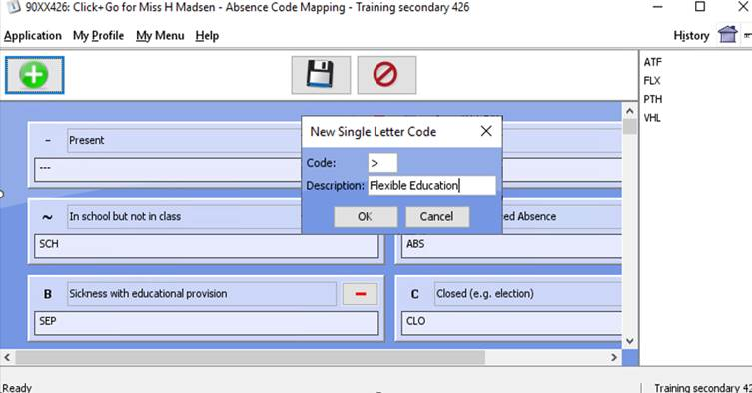
Drag the codes to the newly created short code ‘>’ area and click the Save icon.

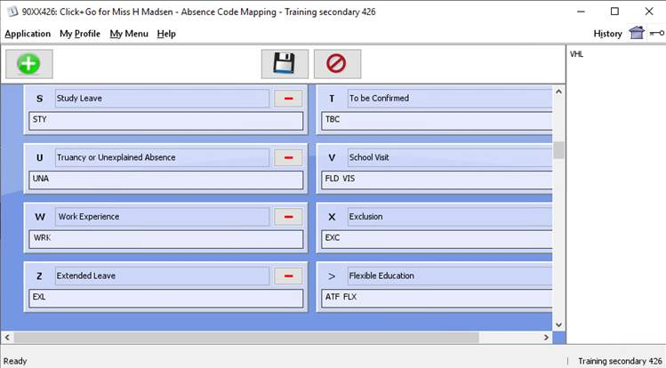
Appendix 5
Guide to Classifying and Recording Pupil Attendance and Absence Codes North Lanarkshire Council Education & Families

In August 2024, Seemis added 3 new attendance codes, following approval from Scottish Government. These short codes will show on the Individual Pupil Attendance Summary as symbol ‘ >’ These codes are listed below and detailed in the full attendance code table.
Code | Description | Short Code | ScotXed Attendance Code
ATF | Adapted Timetable (flexible Education) | > | 10 (Attendance Code)
VHL | Virtual Home Learning | > | 10 (Attendance Code)
FLX | Flexible Learning | > | 10 (Attendance Code)

Attendance Codes
Category | Definition and IEI number | When marking attendance, choose | SEEMiS Code displayed | Included, Engaged & Involved Part 1, App. 2
Present | Attendance at school. | Button: Present | - | 10
Field Trip | Pupil on Field Trip. | Other > selected from list | FLD | 10
School Visit | Educational Visits organised by the school, including:  - Education visits, day, and residential visits to outdoor centres.  - Interviews and visits relating to further or higher education or careers events.  - Debates, sports, musical or drama activities in conjunction with the school.  - Activities connected to Psychological Services | Other > selected from list | VIS | 10
Study Leave | Study leave for young people participating in national exams, if arranged by the school during the period of the national examination timetable. | Other > selected from list | STY | 10
Late  (arrives before mid-point of opening) | Where a child or young person has arrived late but during the first half of the opening, this will be marked as late (lat). This is regardless of whether the lateness is for a valid reason. | Button: Late | LAT | 11
Work Experience | - Work experience arranged or agreed by the school.  - Volunteering, arranged or agreed by the school | Other > selected from list | WRK | 12
Sickness with educational provision | This may include time spent on sick leave or maternity leave, with parental confirmation or medical certificate, and where adequate education provision has been made. Where a child or young person's illness is known, or reasonably thought, to be likely to extend to or beyond 5 days, then education should proceed immediately, if medical assessment permits. Where there is less certainty over the possible length of any absence, education out with school should commence at the earliest opportunity and certainly no more than 15 working days of continuous or 20 working days of intermittent absence. Illness related outreach teaching or other education provision such as hospital education services. | Other > selected from list | SEP | 13
In school but not in class | Child or Young Person in attendance at school, supervised out with classroom e.g. Groupwork, 1-1 Sessions. (no number) | Other > selected from list | SCH | 10
Other Attendance Out of School | It is the responsibility of both the school and learning provider to communicate attendance and absences to ensure SEEMIS records are up to date.  - Learning out with the school provided by a college or other learning provider while still on the roll of the school.  - Undertaking alternative and off-site education as a part measure to address non engagement in school (except if pupil is excluded from school)  - Off-site provision for children of travelling families on roll of school.  - Any other undefined activity out of school, authorised or sanctioned by the school such as a special interest activity. | Other > selected from list | OAT | 10
Medical or Dental Appointment | This code should only be used where a pupil is absent from school due to a Medical or Dental appointment for part of an opening (AM or PM). This code counts as attendance.  Where a pupil is absent for an appointment for an entire opening (ie morning / afternoon), the code D (SEL) – Self Certified Medical or F (MED) – Medically Certified should be used. (See below) Both of these codes count as authorised absence. | Button: Med/Dent | PER | 10
Missing | 'Missing' (having previously been marked present) - if there is any period marked as 'absent' after there has been a 'present' in an opening, then the resultant mark is 'Missing'. 'Missing' is counted as attendance. This code is generated by SEEMiS Period by Period Attendance Calculation. This code does not relate to Children Missing from Education (CME). | Other > selected from list | MIS | 10
Adapted Timetable  (flexible education) | Adapted Timetable (flexible education) where the student is engaging with school led learning.  Planned and arranged in collaboration with the school and the family based on the needs of the child with a view to returning to fulltime education in a supportive, phased way. It is the responsibility of the school to provide a relevant timetable for the student.  Some of the reasons schools may offer an adapted timetable include:-  - poor school attendance, related to anxiety and/or emotional issues;  - a staged return to school after extended absence;  - where the pupil has experienced ongoing difficulties with accessing the mainstream school curriculum despite appropriate supports being put in place to meet their learning, social and emotional needs;  - where there is a likelihood of interrupted attendance, examples include military families, gypsy/traveller families, family separation  - where school attendance has proved difficult despite robust assessment of need and staged interventions  Note: If a student is not engaging in the agreed adapted timetable, then their absence should be recorded using the appropriate absence code. | Other > selected from list | ATF | 10
Virtual Home Learning | To be used for unplanned home learning that is not health or wellbeing related. This would be for situations when schools are open but some individual students or small groups cannot physically attend due to external factors, but school led learning is being carried out remotely and the student is engaging. Examples include localised weather conditions, transport failure, power failure, police incident, emergency placement, hazardous conditions in the school building or in part of the school building (e.g. problem with water distribution, the heating or the ventilation system).  This code would not apply to individual short term, unplanned home learning due to a health or wellbeing issue as these instances could be recorded under the existing “Sickness with Education Provision” (SEP) code.  Note: If a student is not engaging in the virtual learning provided then their absence should be recorded using the appropriate absence code. | Other > selected from list | VHL | 10
Flexible Learning | The parent wishes to nurture a particular talent, skill or interest of their child through a regular private arrangement (e.g. private tuition for the young person to represent in music or sporting events etc, at national level). This is at the discretion of the school/authority. It is the responsibility of the parent to provide meaningful activity at home/outwith school, monitored regularly by the school.  Note: use Other Authorised Absence (ABS) for occasional sporting & cultural events not arranged but approved by the school  The parent wishes to provide their child with a particular experience or set of experiences which cannot be accessed through the local authority school (e.g. an engineering project; intensive outdoor learning opportunities). This is at the discretion of the school/authority. It is the responsibility of the parent to provide meaningful activity at home, monitored regularly by the school. | Other > selected from list | FLX | 10

Authorised Absence Codes
Category | Definition | When marking attendance, choose | Code displayed | Included, Engaged & Involved Part 1, App. 2
Sickness - Self Certified –short term code  (no educational provision) | Pupil is off sick with parental communication as proof of illness. Where a child or young person's illness is known, or reasonably thought, to be likely to extend to or beyond 5 days, then education should proceed immediately, if medical assessment permits. Where there is less certainty over the possible length of any absence, education out with school should commence at the earliest opportunity and certainly no more than 15 working days of continuous or 20 working days of intermittent absence. | Button: Self Cert | SEL | 20
Sickness - Medically Certified  (no educational provision) | Pupil is off sick with Medical Certificate as proof of illness.  Where a child or young person's illness is known, or reasonably thought, to be likely to extend to or beyond 5 days, then education should proceed immediately, if medical assessment permits. Where there is less certainty over the possible length of any absence, education out with school should commence at the earliest opportunity and certainly no more than 15 working days of continuous or 20 working days of intermittent absence. | Other > selected from list.  (shown as ‘Medically Certified) | MED | 20
Notifiable illness (self-certified) | To be used to record the self-certified absence (absence verified by note from parent or guardian) of a pupil due to the identified notifiable illness during a period when the authority has requested establishments to register a notifiable illness. | Other > selected from list | NIS | 20
Notifiable illness (medically certified) | To be used to record the medically certified absence of a pupil due to the identified notifiable illness during a period when the authority has requested establishments to register a notifiable illness. | Other > selected from list | NIM | 20
Late (arrives after mid-point of opening) | Where a child or young person has arrived late but during the second half of the opening, then this will be marked as Late (lt2). This recording is regardless of whether the lateness is for a valid reason.  For schools using period-by-period registration, any registration in periods beginning in the second half of the opening, without any registration in periods beginning in the first half of the opening, will be converted to an overall ‘lt2’ code for the opening (even if a later period is subsequently missed). | Button: LT2 | LT2 | 21
Authorised Parental Holiday  (Family holidays authorised by school) | Under exceptional circumstances schools can authorise a family holiday during term time. Such circumstances may include exceptional domestic circumstances, where a parent’s employment is of a nature where school holiday leave cannot be accommodated (e.g. armed services, emergency services, professions where parents are required to work away from the family for prolonged periods of time).  A family holiday classified under the “authorised absence” category should not include reasons such as:  • the availability of cheap holidays  • the availability of desired accommodation  • poor weather experienced during school holidays  • holidays which overlap the beginning or end of term  • parental difficulty in obtaining leave | Other > selected from list | PHL | 22
Exceptional domestic circumstances (authorised) | This relates to short-term exceptional domestic circumstances absence related to:  - the period immediately after an accident or illness  - a period of serious or critical illness of a close relative including short-term caring responsibilities  - a domestic crisis which causes serious disruption to the family home, causing temporary relocation | Other > selected from list | DCA | 23
Other Authorised Absence | Absent with notification given to the school and permission given, including:  - Bereavement  - Religious observances  - Attendance at court  - Attendance at or in connection with a Children’s Hearing or Care Review  - Weddings of immediate family  - Lack of transport – including due to bad weather  - Sporting & cultural events not arranged by but approved by the school | Other > selected from list | ABS | 24

*Please note: Whilst this is an Authorised Absence, all Part-time Timetables must be discussed and sanctioned by the Inclusion Team.

Category | Definition | When marking attendance, choose | Code displayed
Part-time timetable (exclusion related) | Exceptional circumstances when implementing a package of support that could be achieved in a reduced timetable, with an agreed flexible time limited timescale as to when it will end. Arrangements should be short, agreed with and authorised by your Head of Service. | Other > selected from list | PTX
Part-time timetable (health related) | This code should be used in exceptional circumstances when implementing a package of support that could be achieved in a reduced timetable, with an agreed flexible time limited timescale as to when it will end. Arrangements should be short, agreed with and authorised by the Inclusion Team. This may also be used where part time attendance is required due to a Health condition | Other > selected from list | PTH

Unauthorised Absence Codes

Category | Definition | When marking attendance, choose | Code displayed | Included, Engaged & Involved Part 1, App. 2
Unauthorised Parental Holiday  (Family holidays not authorised by school) | Family holidays with the following, or similar, characteristics are unauthorised:  - The availability of cheap holidays  - The availability of desired accommodation  - Poor weather experienced during school holidays.  - Holidays which overlap the beginning or end of term  - Parental difficulty in obtaining leave (local judgement may be applied, see ‘Authorised Parental Holiday’ category)  - Any family holiday during term-time where the school’s prior agreement has not been sought 30 | Other > selected from list | UPH | 30
Truancy or Unexplained Absence  (Occasional absence without parental awareness) | All absences for which no adequate explanation has been provided. | Other > selected from list | UNA | 31
Exceptional domestic circumstances (unauthorised) | Long-term care responsibilities where additional services have not been accessed.  Under section 14 of the 1980 Act, education authorities must make special arrangements to ensure young people with care responsibilities do not miss out on their entitlement to an education. If a pupil is unable to attend school due to care responsibilities, there is an expectation that additional support services will be assessed to support the pupil, and their absence from education will not be long-term and therefore categorised as authorised absence. However, where additional services have not been accessed by the pupil and care responsibilities become long term, the absence should be categorised as unauthorised absence. | Other > selected from list | DCU | 32
Other unauthorised absence | Any other undefined unauthorised absence (e.g. where a parent is refusing to send their child to school following a dispute with the school | Other > selected from list | OUA | 33
To be Confirmed ~ (Short term code) | Unable to assign an appropriate code without further information. School staff using tbc should seek to confirm the nature of the absence and convert to the appropriate code within 1 week and in difficult circumstances within 4 week maximum. | Other > selected from list | TBC | 31

~ - When an appropriate code has been determined all TBC codes should be changed- within 1-4 weeks. Any ‘To Be Confirmed’ codes remaining on the system at the end of session will be converted automatically to unexplained absence (unauthorised Absence).
Codes included separately in summary statistics.

Category | Definition | When marking attendance, choose | Code displayed | Included, Engaged & Involved Part 1, App. 2
Exclusion | Pupil excluded from school | Exclusions are recorded separately in Click & Go at:  Application > Attendance > Exclusions | EXC | 40

**Codes out with attendance and absence
All of the ‘out with attendance and absence’ codes can be used but will be excluded from the Scottish Government’s calculation of attendance and absence statistics.
Exclusions are analysed separately by the Scottish Government.

Category | Definition | When marking attendance, choose | Code displayed
Should not attend (notifiable illness) | Registration mark to be used when a pupil has been advised by the school, under specific instruction from the authority, not to attend during a period of notifiable illness. https://www.nhs.uk/live-well/healthy-body/is-my-child-too-ill-for-school/ | Other > selected from list | NIX
Extended leave with parental consent | Extended leave with parental consent is not to be considered the same as a family holiday.  Extended leave with parental consent will be recorded separately outside the figures for attendance and absence, and includes circumstances such as:  - extended overseas educational trips not organised by the school.  - short-term parental placement abroad  - family returning to its country of origin (to care for relative, or for cultural reasons)  - supporting inclusive educational approaches for pupils from travelling cultures when travelling | Other > selected from list | EXL
Religious Holiday |  | Other > selected from list | REL
Holiday | School Holiday. | These codes are applied in Click & Go in the school calendar at:  Application > Management > Calendar | HOL
Closed | School Closed (e.g. election) or for adverse weather school closures. |  | CLO
In-Service | School In-service. |  | INS
Should Not Attend | Pupils should not attend.  For example, pupils in Primary 1 who initially do not attend in the afternoons or sanctioned extended absence in relation to children of travelling families at Secondary School level. |  | SNA

*All Part-time Timetables must be discussed and sanctioned by the Inclusion Team.

** All of the ‘out with attendance and absence’ codes above will be excluded from the Scottish Government’s calculation of attendance and absence statistics.
Exclusions are analysed separately by the Scottish Government.

If you wish to clarify the use of any code, please contact your Cluster Improvement and Integration Lead

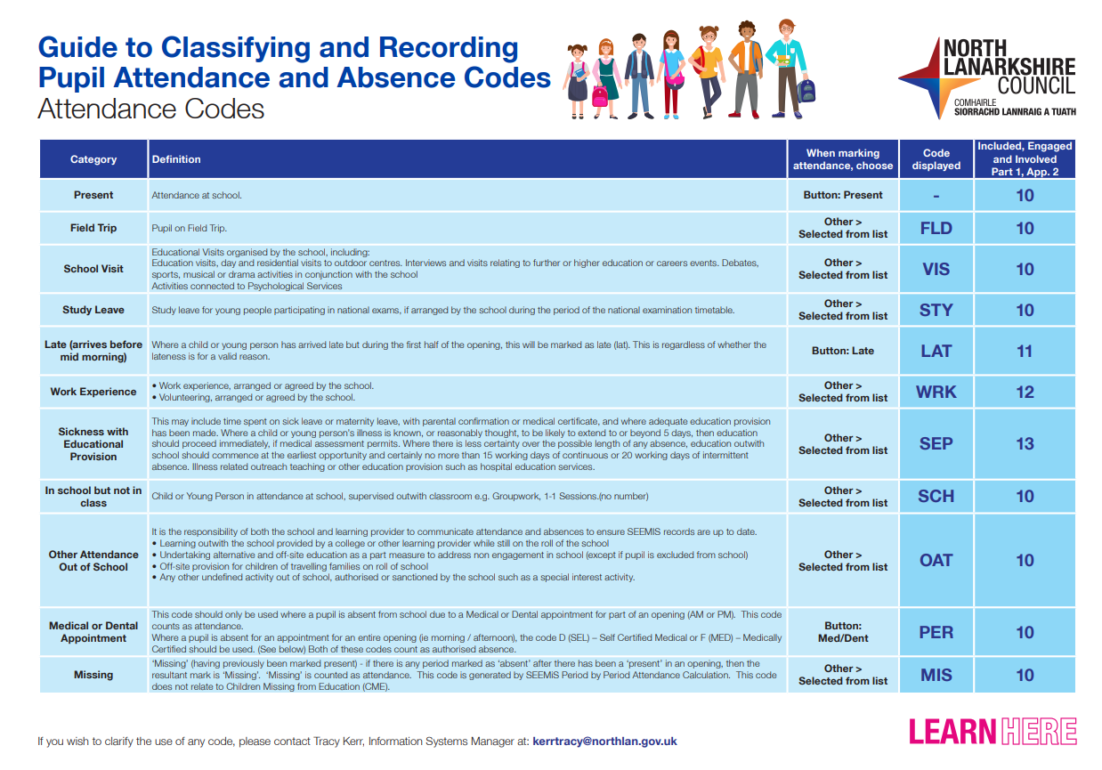
Appendix 6
