Tannochside
Primary School


Anti-Bullying Policy
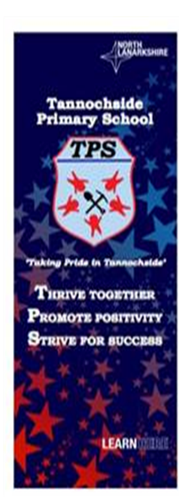
24-25

Introduction
The Scottish Government and North Lanarkshire Council have policies to help prevent and tackle Bullying in Schools, which state that all schools must have an Anti-Bullying Policy.

At Tannochside Primary School we want to make sure that all our pupils feel safe, respected, valued, and included, which is very important for their health and well-being. As a Rights-Respecting School, we aim for all our pupils to understand that under the UNCRC, all children have the right to be safe from harm. Bullying is not tolerated, and we work together to make sure that Tannochside Primary is a happy, safe place for everyone to learn and grow.
Our Promoting Positive Relationships and Behaviour Policy, details all the ways in which Tannochside Primary School promotes positive behaviour.
This policy is designed to make sure that all pupils, staff, parents, and carers know what bullying is, how we can prevent it, and what to do if it happens.

What is Bullying?
Bullying is when someone is hurtful or unkind to another person on purpose, over and over again. It can happen in different ways:
- Physical Bullying: Hitting, pushing, or hurting someone.
- Verbal Bullying: Calling someone names, making fun of them, or saying hurtful things.
- Social Bullying: Leaving someone out, spreading lies, or gossiping.
- Cyberbullying: Being mean or hurtful online or on social media.
Bullying is when a person (or a group of people) behaves in a way that is unkind or abusive towards another or excludes them. It can be direct, or in-direct. Bullying can be physical, verbal, or emotional. It is sometimes a result of prejudices about people’s differences. Bullying can be persistent, but even one incident can have an impact. It is still bullying even if it is not intentional, because it still has an impact.

When is it not bullying?
Children will fall out and disagree as they learn how to make and keep friends. It is important that children learn how to manage disagreements as positively as possible, to learn about cooperation and develop their resilience (the ability to bounce back).
Falling out is not necessarily Bullying, and the school can help you to talk about what has gone wrong, and how to fix it. If disagreements are not solved, they can sometimes become more serious and lead to Bullying. It can become Bullying if the balance of power in a disagreement is unequal, for example an older child to a much younger child, or a group of children falling out with or excluding one child.
Bullying is not the same as a one-off disagreement or when someone accidentally hurts someone else.
The Equality Act 2010 makes it illegal to treat somebody badly, or differently, because of characteristics such as:
- Age
- Disability
- Gender
- Race
- Religion

At Tannochside Primary School we celebrate diversity, and any behaviour demonstrating discrimination based on any of the above characteristics is unacceptable.
At Tannochside Primary School:
- We will respect each other
- We will speak out
- We will listen and help
- Embody our Vision, Values and Aims

Reporting Bullying Behaviour
Bullying behaviour should be reported straight away. One incident is enough to merit reporting.
Pupils can report bullying to any member of school staff, or trusted adult outside of school.

How will the school investigate Bullying Behaviour?
When dealing with bullying, the head teacher, depute head teacher or the principal teachers will investigate by interviewing all the children who were involved. If it is bullying, then we will then decide what actions need to be taken. These might include consequences for wrong behaviour, and support to make sure that relationships are restored and that the bullying does not happen again.
The school’s actions might include:
- Talking to everyone involved to understand what happened
- A mediation (problem solving) meeting with the pupils involved
- Behaviour charts
- Meeting with parents
- Help from other people, e.g. Community Police
The school must record all bullying investigations. If an incident is bullying, it is recorded on a North Lanarkshire computer system.

How will we prevent bullying?
- Teach pupils about kindness, respect, and how to resolve conflicts.
- Celebrate diversity and encourage everyone to appreciate differences.
- Have regular activities that promote friendship and teamwork.
- Make sure that everyone knows who they can talk to if they feel unsafe

Role of Parents/Carers
We ask parents and carers to:
- Encourage your child to treat others with respect and kindness.
- Listen to your child if they are upset and encourage them to talk to someone at school if they are being bullied.
- Contact the school if you believe your child is being bullied, or if your child is worried about someone else being bullied.
Conclusion
At Tannochside Primary School we are committed to making our school a happy, safe place for everyone. By working together, we can stop bullying and make sure that all children feel respected, included, and valued.
This policy will be reviewed annually, or sooner if necessary to ensure its effectiveness.
This policy should be used in conjunction with the following school policies:
- Promoting Positive Behaviour and Relationships Policy
- De-escalation Policy
- Child Protection. Safeguarding Policy

