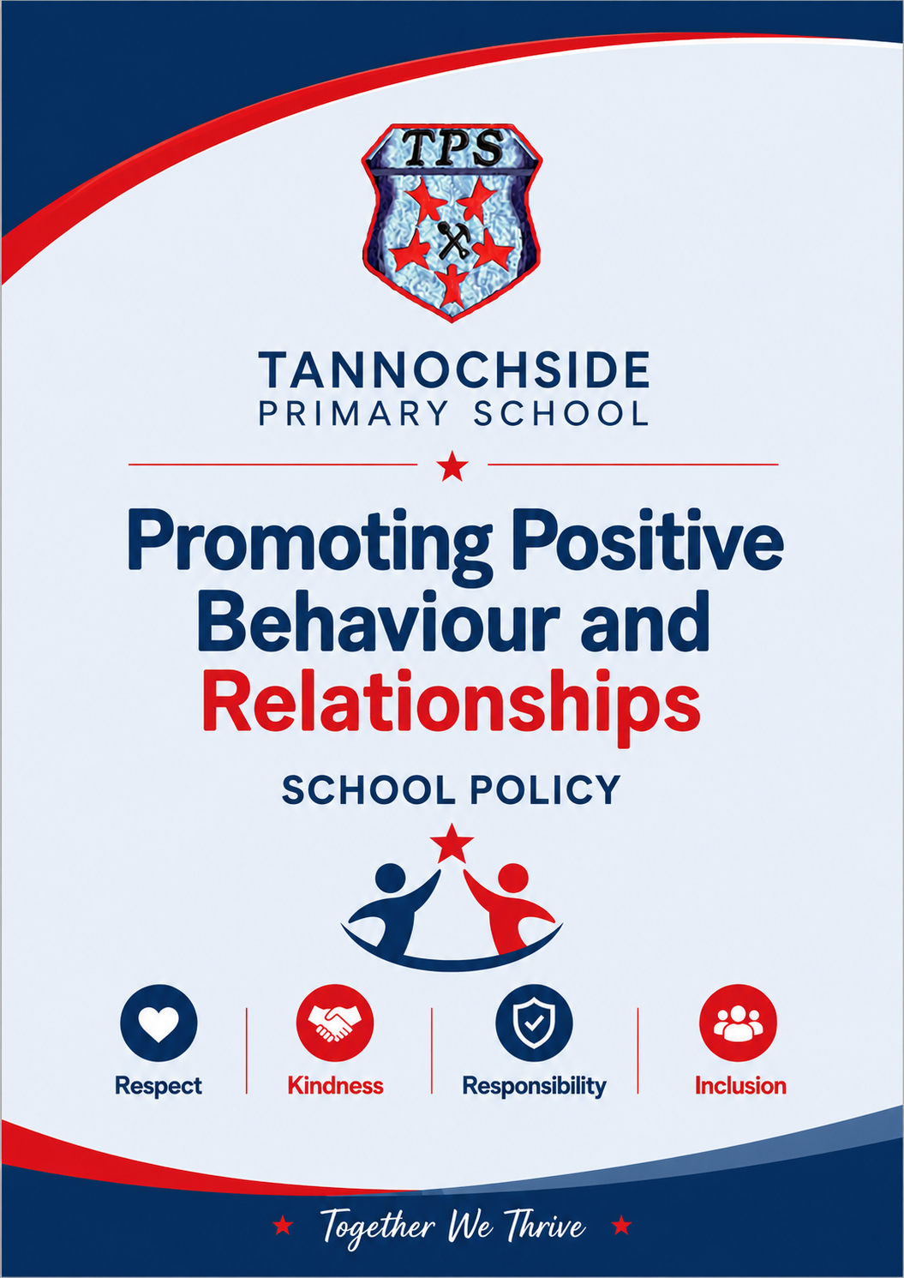

Tannochside Primary School 
Promoting Positive Behaviour and Relationship Policy
Aim
To foster a supportive and inclusive environment in Tannochside Primary School that encourages positive behaviour and nurtures respectful, compassionate relationships amongst pupils, staff, and the wider school community, thereby promoting the emotional and social development of each child. All members of the school community have the right to work and learn in a safe and secure environment without disruption from others.
Rationale
Within Tannochisde Primary School we Thrive Together, Promote Positivity and Strive for success, our vision along with nurture and UNCRC underpins all that we do.
Promoting positive behaviour and relationships in primary school is essential for creating a safe, nurturing environment where all pupils can thrive academically, socially, and emotionally. By encouraging positive behaviour, we help pupils to learn the importance of respect, empathy, and cooperation, which are foundational to their long-term well-being and success.
A focus on positive behaviour not only reduces disruptions and conflicts within the classroom but also enhances pupils’ ability to concentrate and engage with their learning. Additionally fostering positive relationships among pupils, teachers, and the wider community builds a strong sense of belonging and security, which is crucial for children’s confidence and self-esteem.
Ultimately, promoting positive behaviour and relationships in primary school contributes to the development of responsible, effective, successful, and confident individuals who are prepared to contribute positively to society.
Nurture
The Nurturing Approach in Scotland is guided by six principles.
- Children’s learning is understood developmentally.
- The learning environment offers a safe base.
- The importance of nurture for the development of wellbeing.
- Language is a vital means of communication.
- All behaviour is communication.
UNCRC
The United Nations Convention on the Rights of the Child (UNCRC) is the base standard for children’s rights and sets out the fundamental rights of all children. There are 54 articles and apply to those 18 years and under.
We want to recognise, respect and promote children’s rights. These include rights to be treated fairly, to be heard and to be as healthy as possible.
We already use the UNCRC as a framework to ensure that we consider children's rights whenever we take decisions, and to help provide every child with a good start in life and a safe, healthy, and happy childhood. It forms the basis of our national approach for supporting children, called Getting it right for every child (GIRFEC). Fulfilling children’s rights is also critical to our commitment to #KeepThePromise.
Articles specifically linked to this policy -
Article 12 says that every child has the right to express their views, feelings and wishes in all matters affecting them, and to have their views considered and taken seriously. This principle recognises children and young people as actors in their own lives and applies at all times throughout a child's life.
Article 28: every child has the right to an education. Primary education must be free and different forms of secondary education must be available to every child. Discipline in schools must respect children's dignity and their rights. Richer countries must help poorer countries achieve this.
Article 29 of the UNCRC says that a child or young person's education should help their mind, body and talents be the best they can. It should also build their respect for other people and the world around them. In particular, they should learn to respect: their rights and the rights of others.
Article 31 of the UNCRC says that children and young people have the right to have fun in the way they want to, whether by playing sports, watching films, or doing something else entirely. They have the right to rest, too.
Within Tannochside Primary School we promote positive behaviour and relationships in a variety of ways.
Class System
Each class teacher will have their class charter on display which is referred to often with the class. They will have their own class system to promote positive behaviour and relationships that is specific to the age and stage of children they are working with. This may include Dojo points, star of the week, pebbles, Happy Mail, class economy/ shop.
House System
Our Houses are Loch Leven, Loch Lomond, Loch Fyne and Loch Ness, each child, class teacher and support staff member is allocated a house, siblings are in the same house.
Each class will have 4 jars for counters to be kept in – each colour coded for each house.
House and Vice Captains count points in classes each week.
House reward: Winners receive end of year extra play and treat.
Our sports day will be linked to our houses.
One counter can be given by any member of staff to children they see following our vision, values and aims. In addition to this there will be a monthly focus on kindness, being a good friend etc.

Douglas the School Bear
Douglas Post – teachers will post their weekly teacher certificates and Douglas will bring them to assembly.
Douglas post can be used to post any type of certificate/award/ Happy Mail/ Praise notes to pupils.

Weekly teacher certificates
Teacher certificates will continue to be awarded weekly at assembly for embedding our vision, values and aims. The certificates will be delivered by Douglas Post.
Winners of the weekly teacher certificates will receive a ‘Golden Lanyard’ to wear for the week.

Weekly Assembly
Weekly focus on an aspect of our promoting positive behaviour and relationships policy and what this looks like in Tannochside.

WOW Wall
Pupils are sent to SLT with pieces of WOW work that they are proud of. Children are given a certificate and sticker from a member of the SLT, and their work is put on display in our main school corridor.

SWAY
As a school we share positive news and celebrate achievements and successes through this platform. Each class teacher has their own SWAY account as well as the school having an account.
Wider Achievements
Once a term we will host a red-carpet assembly to celebrate wider achievements out with school. This will be shared on our Achievement Tree.
Golden Gab
Once a fortnight, a pupil from each class will have the opportunity to have a ‘Golden Gab’ with SLT. There will be a specific focus for each fortnight for the children to aim for.

Fun 31 (Linked to UNCRC Article 31)
This will take place on a Friday for 40mins. Pupils will sign up to an activity offered by staff. This will run in 4-week blocks.

Pupil Leadership
We have several opportunities for children across the school to take on additional leadership roles within the school, these include ECO, Rights, House and Vice Captains, Playground Leaders, Friendship Buddies, P7 – P1 buddies. Pupils who are part of these committees will wear a lanyard so that they can be identified within the school.
From each of these groups children will form a pupil focus group to discuss matters relating to our school with members of the SLT.
Unexpected Behaviour
When a child is displaying challenging behaviour or not demonstrating our school values all staff should respond using their knowledge and understanding of the 6 principles of nurture.
All staff should use restorative conversations/reflections with pupils to discuss what happened and discuss how relationships can be repaired.

Repeated behaviour that causes concern should be communicated to parents by the class teacher in the first instance and the principal teacher for their stage should be informed of this.

If behaviour continues to cause concern the class teacher should complete a behaviour support form and give this to the principal teacher for their stage who will decide whether a further appointment with the parent/ carer is needed and help support the class teacher with further strategies.

Following on from this procedure there would be involvement from the Depute Head teacher and then the Head Teacher if there are still concerns.

Behaviour and relationships that cause concern at break and lunch time should be communicated to the principal teacher for the child’s stage. The principal teacher would deal with this in the first instance and should communicate the information back to the class teacher.

There will be no blanket repercussions for pupils – e.g., if they do X, then Y is the outcome. It will be on an individual basis.

To be reviewed May 2027

