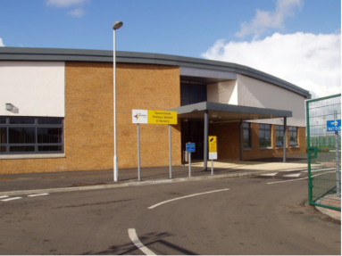

To our new Tannochside Primary 1 pupils

You will soon be starting Tannochside Primary School and we are all very excited to meet you and your parents and getting to know more about you.

We are going to have so much fun together and have lots of exciting things to learn and new things to do.

We would love for you to come and visit our school, meet our staff and see our Primary 1 classrooms.

When you come to visit us, you will be taking part in exciting activities while your parents learn about our school. Our transition dates are:

1. Wednesday 8th May 3.15pm – 4.15pm – meet your teacher / tour of school
2. Wednesday 15th May 9.30am – 10.30am – in class & PE
3. Wednesday 22nd May 11.am-12.15pm - lunch

Tips / things to practise ready for Primary 1:

* Taking shoes off and on
* Putting on and zipping up jumpers, hoodies, jackets etc
* Recognising your name

We will post video clips and information on our Primary 1 Twitter Transition page @TPSP1Transition

We can’t wait to meet you.

Team Tannochside Primary

**Tannochside Primary School**

**Primary 1 Transition**