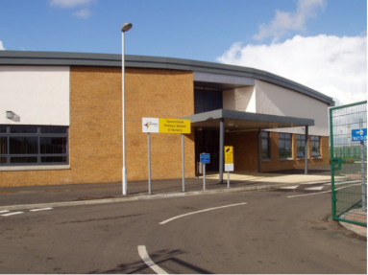

Dear

You will soon be starting Tannochside Primary School and we are all very excited to meet you and your parents and getting to know more about you.

We are going to have so much fun together and have lots of exciting things to learn and new things to do.

We would love for you to come and visit our school, meet our staff and see our Primary 1 classrooms.

When you come to visit us, you will be taking part in exciting activities while your parents learn about our school. Our transition dates are:

1. Wednesday 31st May 3.15pm – 4.15pm - Literacy
2. Wednesday 7th June 3.15pm – 4.15pm - Numeracy
3. Wednesday 14th June 11.00 – 12.15 Mock school day & lunch

Tips / things to practise ready for Primary 1:

* Taking shoes off and on
* Putting on and zipping up jumpers, hoodies, jackets etc
* Recognising your name

We will post video clips and information on our Primary 1 Twitter Transition page @TPSP1Transition

We can’t wait to meet you.

Team Tannochide Primary

**Tannochside Primary School**

**Primary 1 Transition**

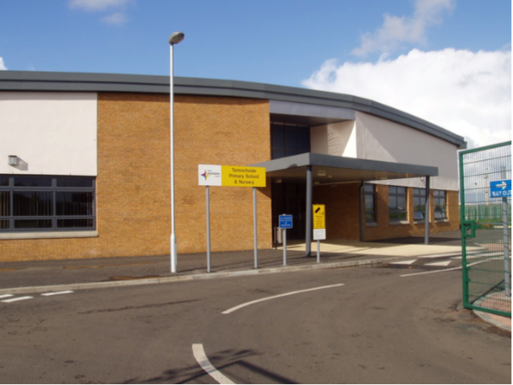

**Tannochside Primary School**

**Primary 1 Transition**

Dear Parent / Carer

We can’t wait to welcome you and your child to Tannochside Primary School.

We have several transition dates for you and your child to attend.

During these transition times, your child will take part in fun activities in our Primary 1 classes, while our Senior Management Team meet with you and discuss all things Tannochside. The transition dates are:

1. Literacy
2. Numeracy
3. Mock school day & lunch

We have our very own Primary 1 transition Twitter page where we post information, updates and video clips ready for your child starting school.

Please follow us on Twitter: @TPSP1Transition