Welcome to Tannochside Primary School

Starting School
Welcome to
Tannochside Primary School

Your child is approaching the next exciting stage of
his or her life….starting school! We are delighted to welcome your child to Tannochside Primary School.

Starting school involves change for you and your child. Often the children come into school bright and excited and it’s the parents who are outside in tears!
We want you and your child to feel happy, relaxed and confident about starting school. By working together with you, we are confident your child will settle into school life and have a fabulous first year at Tannochside as well as many more to come.

We recognise that you are your child’s first teacher! The early years at home are when your child learns most, and more quickly than at any other time in his or her life! We hope that the handy hints in this booklet will help you prepare your child for school and make you feel part of our school community.
The First Day
On the first day Wednesday 17th August 2022 Primary One children start school at 10am and finish at 2.30pm.

The children will enter via the main school gate with their parent/carer and the class teacher will direct them to their class. There will be an opportunity for parent/carers to take photographs of their child in class, however we ask that this is limited to 2 adults per child. The children will sit at their table with their name label and the class teacher will process the lunch order: school dinner or packed lunch. The lunch menu for the week is shared on the school Twitter page weekly.

Each child has a peg with their name for their coat and outdoor shoes.

Children should bring indoor shoes to change into and keep in school.

At 2.30pm, children will exit the school via the the creche garden gate.

The Second Day

On the second day Thursday 18th August Primary One children start school at 8.55am and come in through the school gate. They finish at 2.50pm and can be collected from the creche garden gate- this will give them a chance to go out the school gate before the other children. Under normal circumstances if you could discuss with your child and choose a position where you will stand, it will make it easier for your child to locate you.

It’s a very exciting day for pupils, parents, grandparents, friends, family and teachers!

We look forward to welcoming you and your child to Tannochside. For some this may be your last child starting school, for others it may be your first or one in between but for everyone it’s an emotional and special day.
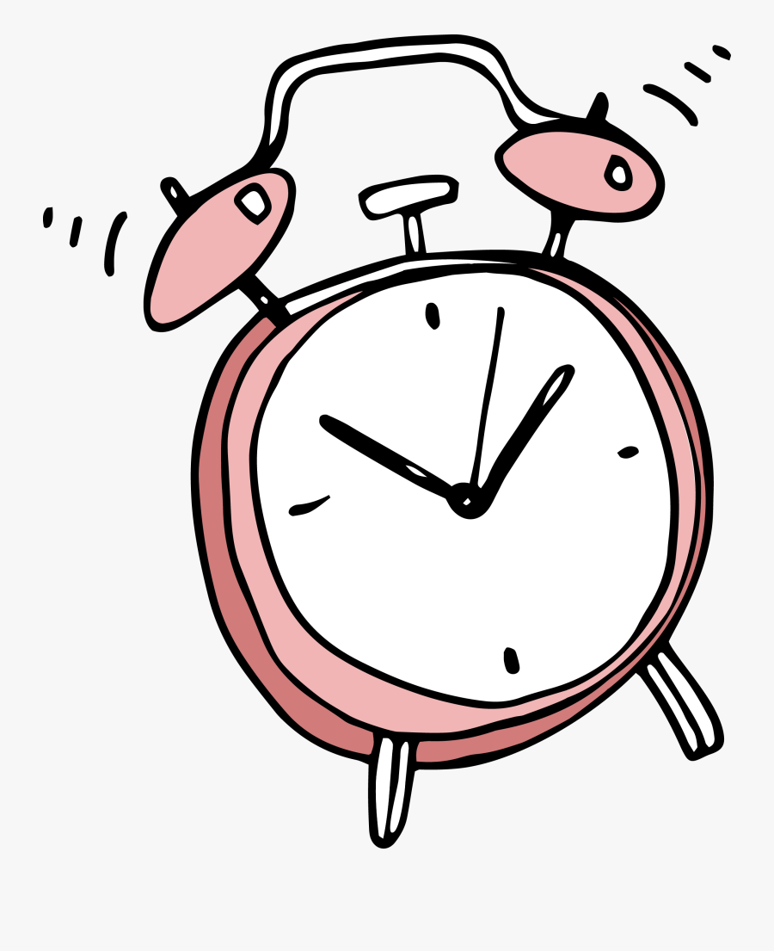
The School Day
When your child starts school in August he or she will come from 8.55am to 3pm every day. We try to release our P1 children from 2:55pm from the creche garden.

DATES AND TIMES

School starts 8.55am
Interval 10.40am – 10.55am
Lunch 12.30pm – 1.20pm
School finishes 3.00pm

Breakfast Service
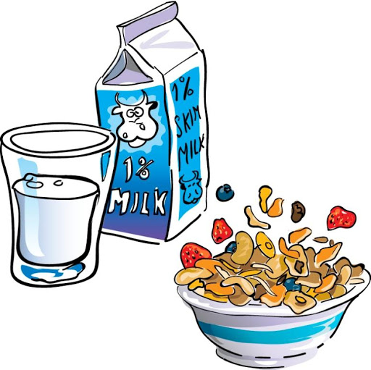
The catering staff offer a Breakfast Service from 8.15am, Monday to Friday in the school hall. The children pay £1 for a breakfast tray which has fruit juice, choice of cereal and a slice of toast.

The morning
The school day starts at 8.55am. It is important that your child comes to school every day and on time. This helps them settle into daily routines and arrive in class with their friends. Please ensure your child is not in the playground too early as there is no supervision available before 8.40am. A bell will sound at 8.53 to allow children to make their way down to the their line ready for the 8.55am bell.

When the children come into school, they hang their coat on their peg and change their shoes into soft indoor shoes. Each peg has the child’s name and a picture on it. Each class also has a trolley in the wing to store packed lunch boxes.
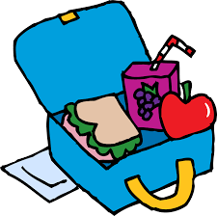
Ready for School

Being able to cope with a few everyday activities that are expected at school will help your child settle more easily and feel confident and independent. Lots of these little tasks develop from experience. Children love to learn to do things by themselves, especially now they feel grown up and are starting schol. Here are a few practical skills which will help your child as they start school. Some of these tasks they can probably do already proving they are ready to go!

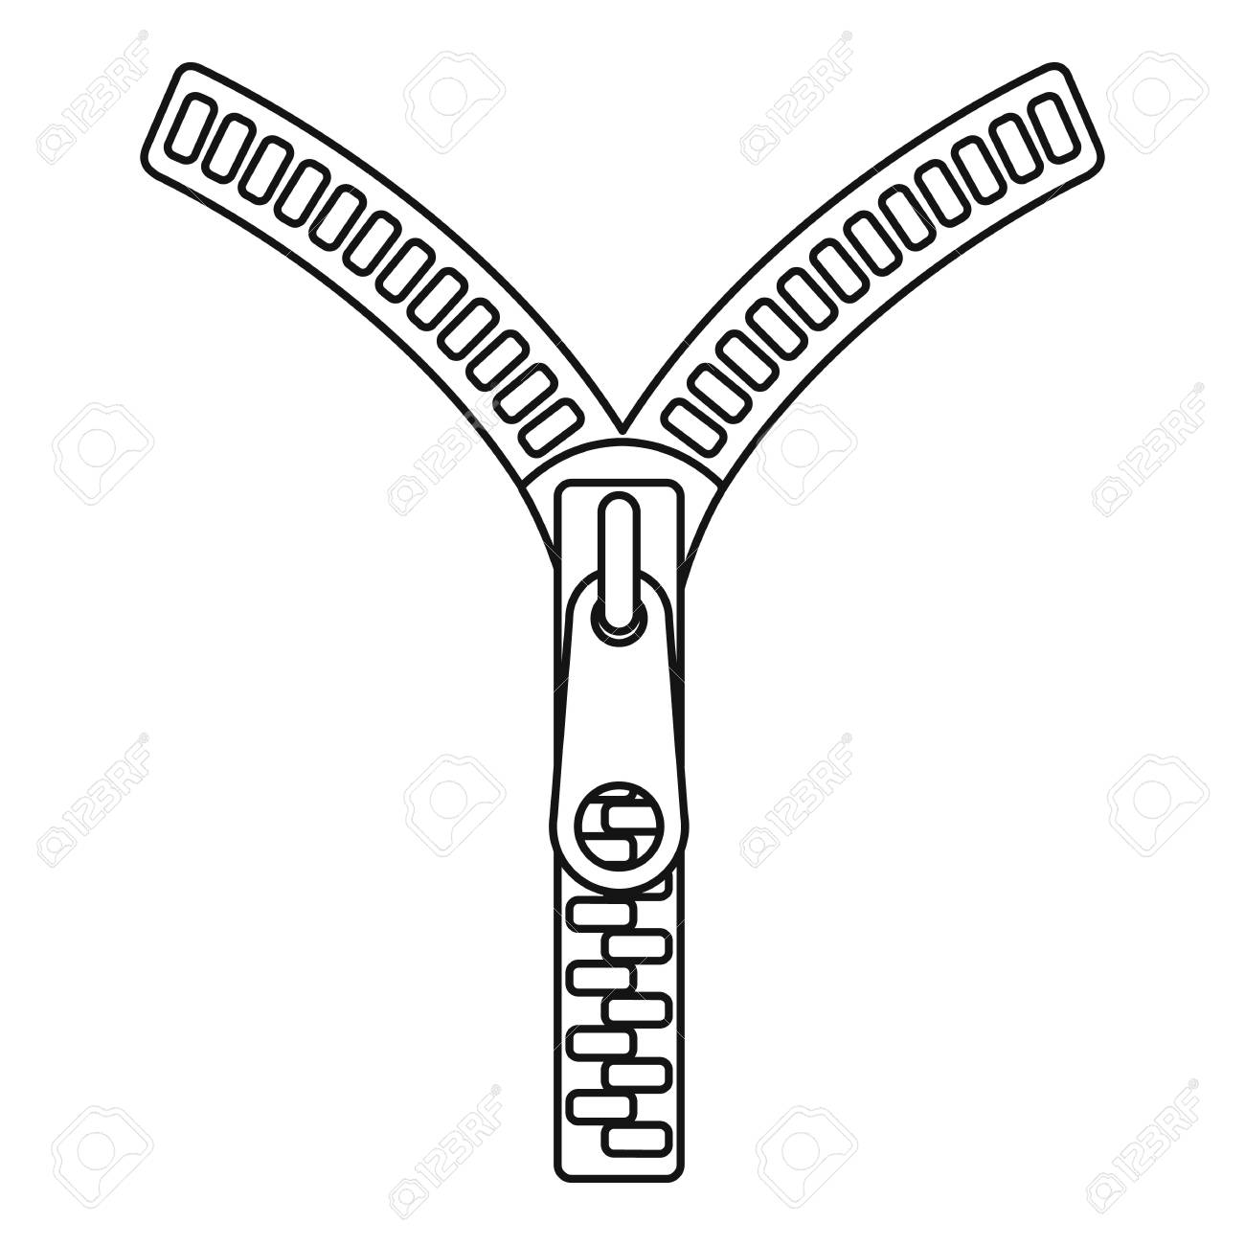
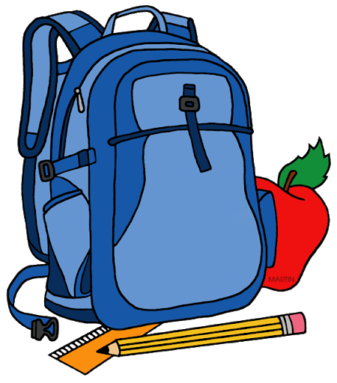
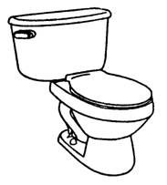
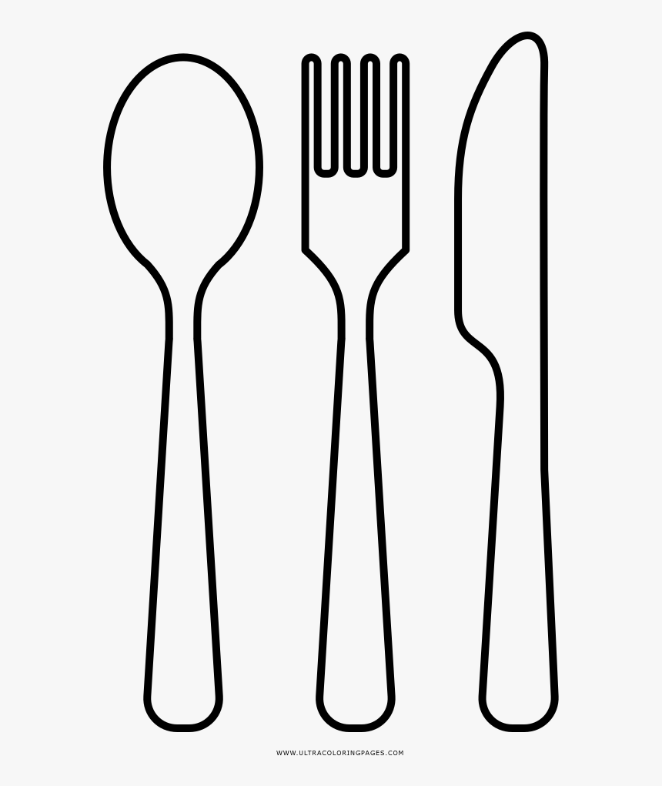

Put on and take off their coat

Do and undo zips and buttons

Pack and unpack their school bag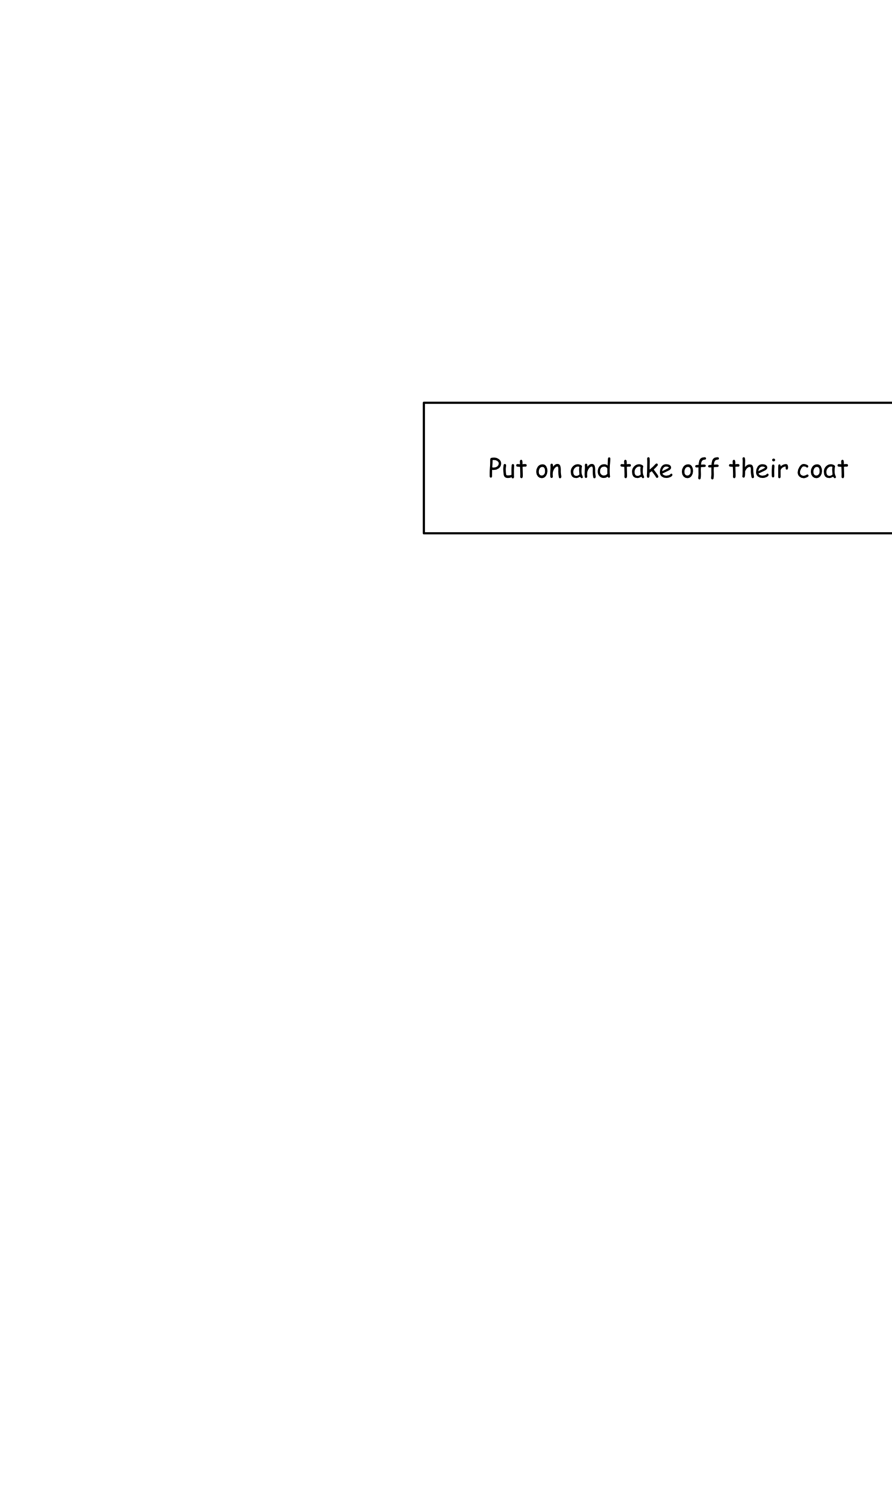

Use the toilet independently

Use a knife and fork correctly

Open a packet of crisps
Ready for School
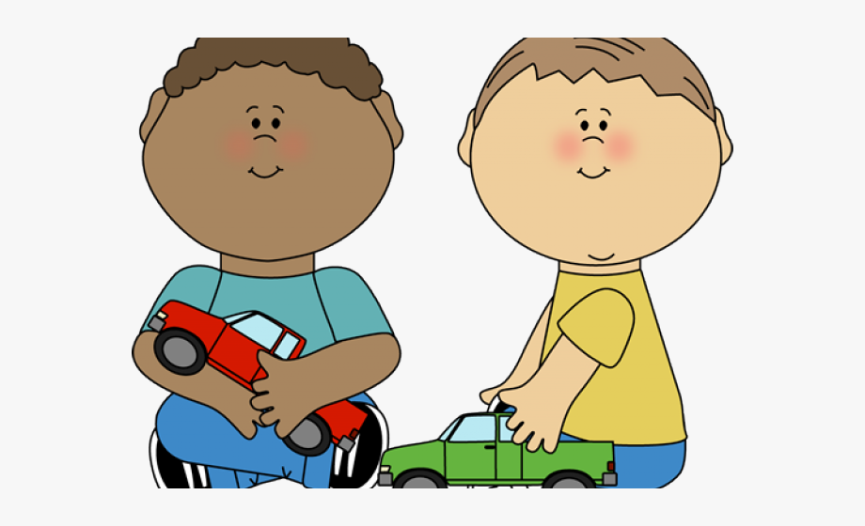
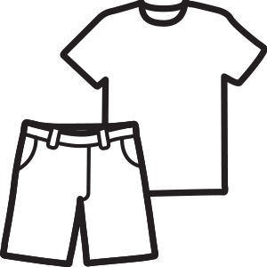
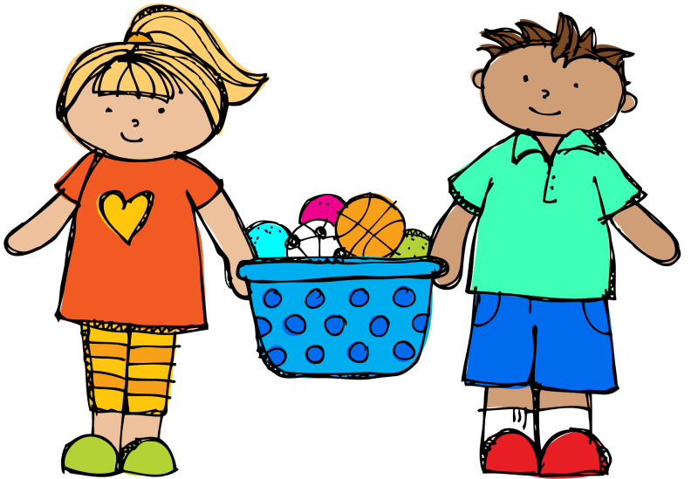
How Can I Help?

Tidy away their own toys

Recognise their own name

Share with other children

Change into their gym kit

Andrew

Follow simple instructions

Take turns when playing a game
To help prepare your child for school there are lots of activities you can do at home. These will introduce your child to some of the skills they will be learning at home.

Set aside time to read with your child every day. Make use of magazines, comics, books and story tapes. Make reading a relaxed time you can both enjoy. Talk about the pictures, point to the characters, use your finger to point to the words and show the way your finger moves from left to right along the line of print.

Look at signs and notices when you are out and about. Look at shop names and logos. Talk about menus, look at the packaging on food and snacks. Talk about the letters and the shape of words. Get your child excited about reading print!

Sing lots of songs and nursery rhymes. Teach your child some of the older rhymes you learned as a child. Make mistakes with rhyming words for your child to correct. Let your child fill in the missing rhyming word or have a go at making up a new rhyme!

More Ideas

Encourage your child to use play dough and plasticine. Make letters, shapes and words.

Let your child draw and scribble for lots of different purposes. Let them ‘write’ the shopping list, phone message, diaries or address book or birthday cards.
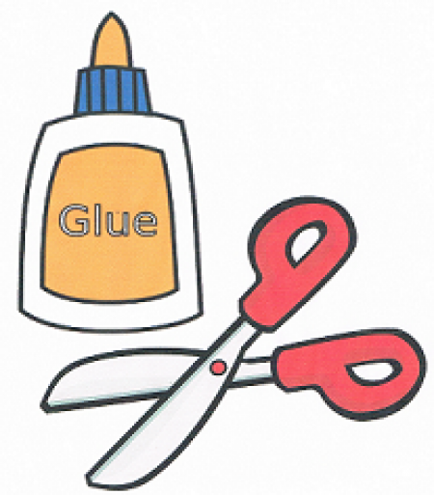
Encourage your child to use scissors to cut pictures out of magazines and use glue to make a picture or scrap book.

Having your child’s name on a wall or bedroom door helps them to recognise it. (Use a capital letter for the first letter and small letters for the rest). Let your child read his/her name, trace it with their finger or copy it onto paper or a chalk board.

Andrew

Count out sets of everyday objects. Count the stairs as you go up and down, count pegs, sweets, buttons on clothes or tins in the cupboard.

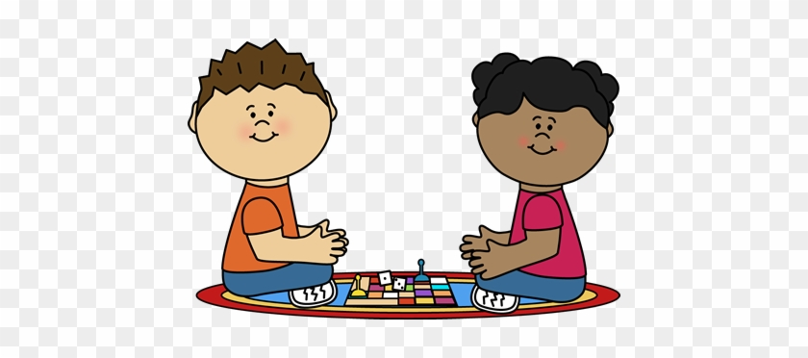
Play simple board games like snakes and ladders. They are great for learning to recognise numbers, count on and introduce children to addition and subtraction.

I hope some of these ideas are helpful! Teaching your child can be fun, watching your child learn is rewarding!
We can’t wait to meet you …

It’s a very exciting day for pupils, parents, grandparents, friends, family and teachers!

We look forward to welcoming you and your child to Tannochside. For some this may be your last child starting school, for others it may be your first or one in between but for everyone it’s an emotional and special day.

We understand that you may be feeling very anxious about your child starting school. We want to reassure you as much as we possibly can. The information we have provided may be subject to change due to current circumstances. We will keep you updated as best we can of any changes.

Have a lovely summer holiday and we look forward to seeing you in August!

People You Will Meet
Acting Head Teacher
Mrs Clare Ferrie

Acting Depute Head
Mrs Gallagher
Acting Depute Head
Mrs Calder

Primary One Teachers for session 2020-2021

Primary 1a
Mrs Martin
Primary 1b
Miss Ford

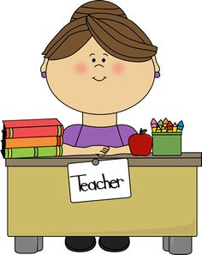

Contact Us

We hope this booklet helps you prepare your child for school and has answered some of your questions.

Please don’t hesitate to get in touch if there is anything else you wish to discuss.

Tannochside Primary School
111 Douglas Street
Tannochside
G71 5 RJ
Tel: 01698 522726

E-Mail

Mrs Ferrie: nlferriec@northlan.org.uk

Mrs Gallagher: nlgallagherl1@northlan.org.uk

Mrs Calder: nlcalderc@northlan.org.uk

Twitter

Primary 1 Transition: @TPSP1Transition
Tannochside Primary: @TannochsidePS

See you in August!

