Priority 2: To increase pupil and parent engagement in learning and participation in school life by:-

* Increasing the opportunities for parental engagement and participation, e.g. opening up learning opportunities, family learning events, improved communication.
* Supporting new members to establish their vision for the Parent Council and to fulfil their new roles.
* Developing additional parent/family support interventions available within school and the cluster.

Priority 1: To increase attainment in Numeracy for targeted groups of children in P4 and P7 by:-

* Targeting groups of children for additional support in Maths and Numeracy.
* Planning and implementing improvements to our universal provision across the school.
* Increasing maths and numeracy experiences within our outdoor learning and Discovery Zones.
* Planning additional family learning activities in maths and numeracy.

Tollbrae’s

Improvement Plan

2022 - 23

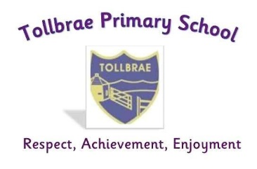

Tollbrae Nursery Class/Sgoil Àraich Tollbrae Priority: To evaluate and further develop our tracking and reporting of children’s learning and progressby:-

* Updating our planning and tracking procedures in line with the findings of our self-evaluation activities.
* Monitoring the effectiveness of the universal and additional support available to our children and families.

Airdrie Academy Cluster Priority: To embed the empowering cluster model to support children, young people and their families to realise their potential by:-

* Increasing attendance and decreasing the number of school exclusions across the cluster.
* Supporting children, young people and families’ health and wellbeing through the Airdrie Ambassadors initiative, targeted support and partnership working across the cluster.
* Increasing attainment in writing at P2, P5 and P7/S1 through targeting particular groups of children for additional support.

Priority 3: To evaluate and refresh our Curriculum Rationale and to further develop our curriculum offer in line with this by:-

* Using the NLC E&F Curriculum Rational Toolkit to evaluate and refresh our Curriculum Rationale.
* Re-introduce Clan Challenges.
* Continue to develop our STEM curriculum.
* Further develop our Active Schools and Outdoor Learning provision.