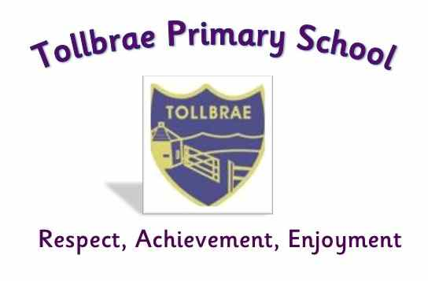

Child Protection Policy

The care, welfare and protection of children are of paramount importance. The rights and needs of children must be placed first. The protection of children is a shared responsibility and staff will work collectively to create a climate of mutual trust, respect and confidence.

Aims
- To ensure that children learn in a safe environment where they feel secure and respected
- To develop attitudes and beliefs which help children to understand and value themselves as individuals
- To ensure that children feel confident and able to approach adults about matters that concern them,
- To ensure that staff are fully aware of North Lanarkshire Council’s Child Protection Guidelines and Procedures
- To ensure that staff have access to appropriate training on Child Protection
- To ensure effective communication between staff when dealing with Child Protection issues

Roles and Responsibilities
Tollbrae Primary School’s designated Child Protection Coordinator is Mrs Clare Welsh, Head Teacher.
A full description of the role of CP Coordinator can be found in the NLC Guidelines (section 5).
All staff should be familiar with North Lanarkshire Councils’ Child Protection Guidelines and Procedures. A copy is available from the school office. A copy of the Child Protection Policy for staff is located on the staff notice board in the school and nursery staffrooms.
The Head Teacher must inform and update staff on the Child Protection Guidelines and Procedures on an annual basis. This will take place in the first Inset day of each new session.
The Child Protection Coordinator will encourage staff to take part in staff development.
The Head Teacher must ensure that parent helpers go through the PVG process if they to carry out activities which involve the supervision of children.
All staff are encouraged to record any minor concerns or incidents concerning child Health and Wellbeing. This may inform future actions or decisions.

Procedures
If a member of staff has feelings of unease about a child’s welfare as a result of a child’s actions and/or comments, then they must report these concerns to the Head Teacher/Depute Headteacher as soon as possible. The procedures in the Child Protection Guidelines will then be referred to and followed.
(Section 9/10/11 – Action in response to Grounds for Concern).

In the event of a Child Protection concern, the role of staff is to;
- Observe
- Listen Carefully
- Report accurately
- Record accurately
- Follow procedures

Any information regarding Child Protection issues is confidential. We only pass on information on a need to know basis to appropriate persons.
All information and records concerning Child Protection, both written and electronic, must be stored securely at all times.

Absence of Senior Management
In the absence of the Head Teacher/Child Protection Coordinator, staff who have concerns about a child’s welfare should contact the Depute Head or Principal Teacher.

For further advice or support, staff can contact Lindsey Mitchell (NLC Child Protection Development Officer) on 07939 284856

Policy reviewed : August 2022

Next review date : August 2023

