SQA Information evening

Taylor High School

Spanish



**Studying Spanish in the Senior Phase**

* At Taylor High School we offer Spanish in the Senior Phase from National 3 through to Higher level.
* All courses provide an in-depth study of Spanish, through class work, both individual and group work, enabling pupils to continue to develop the skills they learned in the BGE as they progress through the different levels.
* The four key skills developed when studying a language are Reading, Writing, Listening and Talking and it is in these four areas where learners will be assessed.
* The topic areas covered when learning a language in the Senior Phase aim to expand on what pupils have learned during the BGE. Pupils will develop their knowledge and understanding of detailed and complex language in the four broad contexts of Society, Learning, Employability and Culture.
* Pupils will learn how to structure Spanish present, past and future tenses as they advance through the courses.

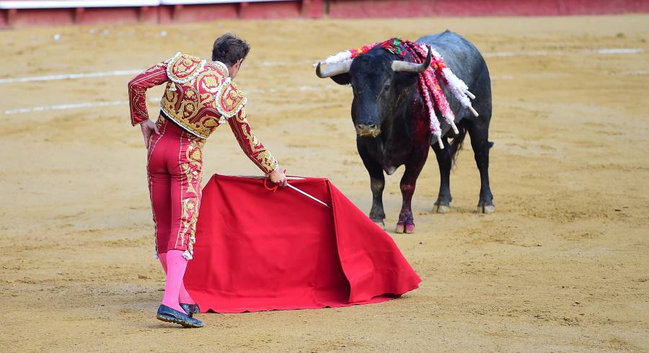

**National 3/ 4 Spanish**

Pupils sitting National 3 or National 4 Spanish will be internally assessed across the 4 key skill areas of Reading, Writing, Listening and Talking. There is no final exam at these levels. Instead, pupils will undertake coursework tasks in each of the four skill areas. For National 4, pupils are also required to do an AVU which involves reading and talking skills. Successful completion of these courses would allow pupils the opportunity to progress to National 5 level.

**National 5 Spanish**

National 5 Spanish continues to build on skills learned in the BGE and through National 3 and 4 courses. At National 5 level, pupils must complete coursework throughout the year as well as sit the final exam in May.

**Coursework**

**Writing Assignment:**

Pupils will prepare to write a short essay (120-200 words) on a topic area from within the contexts of Society, Learning and Culture, as the topic of Employability is covered in the exam day Writing. Pupils must address the given stimuli in their writing. Pupils will produce a first draft over a period of time which will be corrected using a correction code. Teachers will give support and feedback to pupils who will then work to improve their writing before completing a final draft which will be submitted to the SQA for marking. This component is worth 20 marks out of a total of 120.

**Performance Talking:**

Pupils will undertake a Talk in the modern language with their teacher at a determined point in the year, which will be agreed in advance. The talk comprises two separate parts; presentation and conversation. Pupils will prepare a presentation lasting 1-2 minutes on a topic covered in the course, to allow demonstration of language resource, accuracy, and pronunciation and intonation. During the presentation, pupils may refer to up to five headings of no more than eight words each as prompts, and/or use visual aids. Following the presentation, the teacher will then ask a series of questions which must also cover an additional context to that of the presentation. The conversation should last approximately 5–6 minutes to allow pupils to demonstrate their ability to take part in a conversation in the modern language, using detailed language. The information to be exchanged is mainly of a factual nature and includes some ideas and opinions.

The Talk will be audio/video recorded. It will be marked internally but could be requested for verification by SQA.

The Talk is worth 30 marks in total; 10 marks for the presentation, 15 marks for the conversation and an additional 5 marks for sustaining the conversation.

**Final Exam**

**Paper 1- Reading and Directed Writing:**

Pupils will have an hour and a half for Paper 1 which is split into two sections- Reading and Directed Writing. The Reading comprises three texts in Spanish with comprehension questions to be answered in English. Each text is worth ten marks, totalling thirty marks for this section.

The Directed Writing involves pupils writing a Job Application letter in Spanish. Pupils will be provided with a brief job description in Spanish and six bullet points as a guide. The first four bullet points will always remain the same, with the final two being unpredictable. This section is worth twenty marks overall.

Pupils will have access to a Spanish dictionary for this paper.

**Paper 2- Listening:**

Pupils will listen to both a monologue and a dialogue in Spanish and will answer comprehension questions on each in English. Each section will be played three times. The monologue is worth eight marks, the dialogue ten, totalling twenty marks for this section.

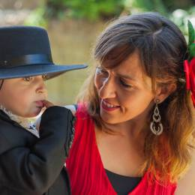

**Higher Spanish**

Higher Spanish allows pupils the opportunity to further develop the skills and knowledge the gained from studying National 5. As with National 5, Higher pupils must complete coursework throughout the year as well as sit the final exam in May.

**Coursework**

**Writing Assignment:**

Pupils will prepare to write a short essay (200-250 words) on a topic area from within the four contexts. The writing should be discursive in nature, providing different viewpoints and drawing a conclusion. Pupils must address the given stimuli in their writing. Pupils will produce a first draft over a period of time which will be corrected using a correction code. Teachers will give support and feedback to pupils who will then work to improve their writing before completing a final draft which will be submitted to the SQA for marking. This component is worth 20 marks out of a total of 120.

**Performance Talking:**

Pupils will undertake a Talk in the modern language with their teacher at a determined point in the year, which will be agreed in advance. The talk will take the format of a discussion. It should last around ten minutes to allow pupils to demonstrate language resource, accuracy, pronunciation and intonation and it should cover at least two of the four contexts studied at Higher. Pupils must identify the contexts for the discussion and communicate these to the teacher before taking part in the performance—talking. Pupils will be provided with a form on which they will note their chosen contexts. The information to be exchanged is mainly of a factual nature and includes some ideas and opinions. During the discussion pupils may refer to up to five headings of not more than eight words each, and/or use visual aids. These may be in the modern language or English. You must use these only as prompts and not read them out word for word. The Talk will be audio/video recorded. It will be marked internally but could be requested for verification by SQA. The Talk is worth 30 marks in total.

**Final Exam**

**Paper 1- Reading and Directed Writing:**

Pupils will have two hours for Paper 1 which is split into two sections- Reading and Directed Writing. The Reading comprises one text in Spanish with comprehension questions to be answered in English as well as a translation task. The questions are worth twenty marks and the translation ten, totalling thirty marks for this section.

The Directed Writing involves pupils writing about a past trip to Spain or a Spanish-speaking country. Pupils will be given two different scenarios to choose from; each linked to one of the four contexts. Pupils will be provided with a brief stimulus and six bullet points as a guide for each scenario and should choose which scenario they feel most confident to write about. In order to perform well in this section, candidates will be required to express themselves in the past tense as well as either future or conditional tenses. This section is worth twenty marks overall.

Pupils will have access to a Spanish dictionary for this paper.

**Paper 2- Listening:**

Pupils will listen to both a monologue and a dialogue in Spanish and will answer comprehension questions on each in English. Each section will be played twice. The monologue is worth eight marks, the dialogue ten, totalling twenty marks for this section.

**Support and Resources for Learners**

-Class Teams pages have been set up for all pupils and all teaching resources will be made available to pupils through these Teams.

-In addition, pupils will also have access to a wealth of study and revision resources

through:

*SCHOLAR [Scholar- HIGHER](https://scholar.hw.ac.uk/courses/browse/H-CSPA/-1/-1) [Scholar- National 5](https://scholar.hw.ac.uk/courses/browse/N5SPA/-1/-1)

*ACHIEVE [ACHIEVE - ACHIEVE more at National 5 and Higher](https://letsachieve.co.uk/)

*BBC BITESIZE. [National 5 Spanish - BBC Bitesize](https://www.bbc.co.uk/bitesize/subjects/zrtykqt) [Higher Spanish - BBC Bitesize](https://www.bbc.co.uk/bitesize/subjects/zchv87h)

*Quizlet and Duolingo are also fantastic study resources for language learners.

-The Modern Languages staff will be running supported study sessions for both National 5 and Higher pupils. Days and times will be agreed with the class teacher. Staff are also more than willing to provide additional support to groups or individual pupils on an ad-hoc basis, to be agreed between pupils and their teacher.

-The department will run targeted intervention sessions for the different skill areas as we progress towards Prelim and Final exam time, and pupils will also have the opportunity to receive additional support at Easter School by attending a morning/afternoon of study support.

-Pupils will be invited to attend a Spanish Immersion Day in the days prior to the final exam for any additional help or support.

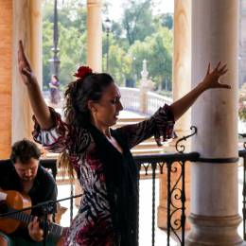

**What are the benefits of studying a modern language?**

* Better job opportunities
* Bilingualism benefits your brain & your employability!
* Help you build strong relationships
* Improved communication skills
* Travel opportunities
* Better understanding of other people and cultures
* Better understanding of how your own language/s work
* Helps build your vocabulary in your own language
* Develops your skills in working with your own language
* A competitive edge in the job market
* Improved listening skills and memory
* Increased confidence
* Impress people!
* It’s fun!

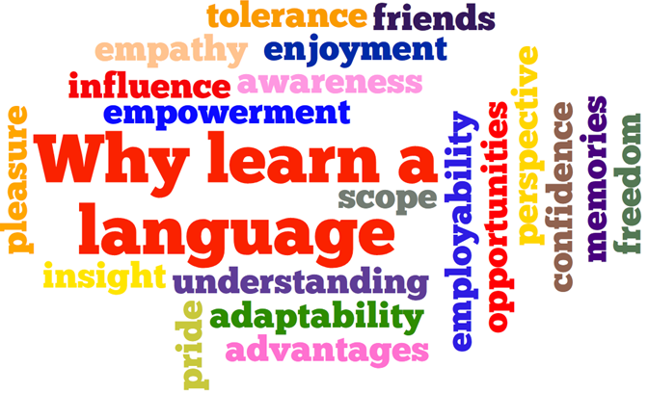

**Where could learning a language take you?**

-Teaching

-Interpreting

-Law

-Marketing

-Finance

-Media and Journalism

-Travel and Tourism

-Customer Service Sector

-Intelligence Agencies



**Course Documents**

National 5 Course Specification

<https://www.sqa.org.uk/sqa/files_ccc/n5-course-spec-modern-languages.pdf>

National 5 Writing Assignment <https://www.sqa.org.uk/files_ccc/ModernLanguagesN5CATAssignmentWriting.docx>

National 5 Performance Talking

<https://www.sqa.org.uk/files_ccc/ModernLanguagesN5CATPerformanceTalking.doc>

Higher Course Specification

<https://www.sqa.org.uk/sqa/files_ccc/h-course-spec-modern-languages.pdf>

Higher Writing Assignment

<https://www.sqa.org.uk/files_ccc/HigherCATModernLanguagesAssignmentWriting.docx>

Higher Performance Talking

<https://www.sqa.org.uk/files_ccc/HigherCATModernLanguagesPerformanceTalking.docx>