Taylor High School Languages Faculty

English

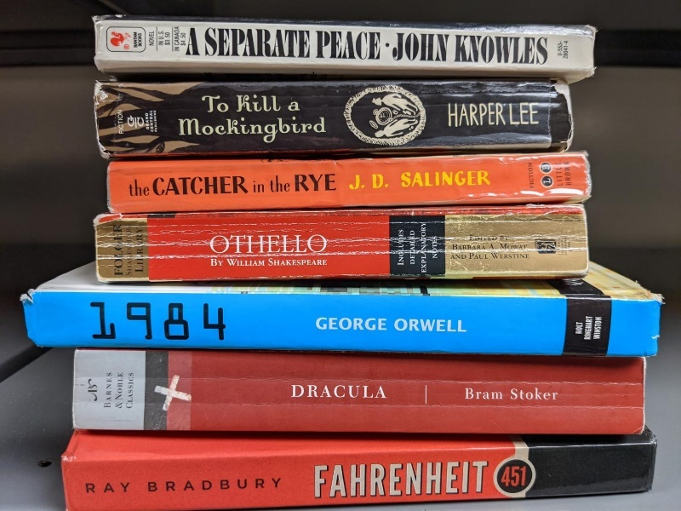

What you need to know about studying English in the Senior Phase

Why study English ?

Language is at the heart of life. If you consider that the average person encounters 105,000 words per day, then you get some measure of why language skills matter. The ability to understand and analyse language, combined with the ability to use spoken language to communicate your ideas and your learning, will largely determine how successfully you learn, and indeed how successful you are in life.

What can I expect ?

English is a compulsory subject until the end of S5. In S5-6 students are studying English at the next level from their achievement in S4, according to their progression pathway.

NPA in Journalism

N3 N4 N5 Higher

Young people will be in class for six periods per week. Assessments will take place throughout all of our courses to help young people to determine their own next steps in learning. In addition to this young people will set targets regularly and have a chance to discuss their targets and progression through regular learning conversations with their teacher.

At every stage our curriculum is designed to offer balance and breadth, with a mix of language and literary studies. Students will continue to develop the core skills of reading, writing, talking and listening.

**National 3 English:** National 3 consists of two units: producing language and using language. Both need to be successfully overtaken to achieve a full award. There is no formal exam at National 3 and the assessments are complete and assessed in class.

Producing Language: young people are required to prepare and deliver a short presentation to their class and answer questions from the audience. They also need to produce a piece of factual writing of at least 80 words in length.

Using Language: young people have to answer question on both written text and an oral text (video). They are required to show they understand the text and its content, analyse the language used and evaluate how good it is.

**National 4 English & Literacy:** National 4 consists of four units, two of which are core units: *Analysis & Evaluation* (reading and listening) and *Creation & Production* (talking and writing.) There is also a Literacy Unit & an Added Value Unit which combines the four essential skills. There is **no** external assessment (exam) at this level. Units are assessed on a pass/fail basis in school. The Literacy Unit is overtaken through Analysis and Evaluation and Creation and Production, as long as students have worked with, and produced, non-fiction texts.

Analysis and Evaluation: young people have to answer question on both written text and an oral text (video). They are required to show they understand the text and its content, analyse the language used and evaluate how good it is.

Creation and Production: young people are required to prepare and deliver a short presentation to their class and answer questions from the audience. They also need to produce a piece of factual writing of at least 300 words in length.

Added Value Unit: young people need to write an essay of at least 600 words on a text they have studied in class. As we as summarising the text they need to discuss the language and themes and also answer questions on the text they have written about.

**National 5 English**: continues to develop the core skills required for life and work. Namely: reading, writing, talking and listening. Students are required to study detailed texts and to produce texts which are detailed in content.

Spoken Presentation: The course consists of a Spoken Presentation which is internally assessed, candidates need to display a range of spoken skills in order to meet the standard. This has to be achieved to receive a full award at National 5. This is generally achieved by candidates researching and delivering a presentation either to a small group or the wider class. Young people are also required to ask and answer thoughtful questions.

Folio of Writing: Young people are also required to produce a folio of writing which is submitted to the SQA in March for external assessment. This folio consists of ONE piece of writing which should be no more than 1,000 words in length. Young people can choose between transactional (non-fiction) writing such as reports, persuasive essays etc and creative (short-stories, monologues, poetry, drama) or reflective where they consider their own experiences. **The folio of writing is worth 30% of the final award** and allows young people to showcase their writing skills. As such the use of AI is not permitted and young people are required to sign that the finished folio is their own work. To guarantee the authenticity of the folio young people will work on their folio for one period per week in class. During this time young people can discuss their folio with the class teacher and seek any support they may need. SQA require that all learners write their first draft under exam conditions, within class, (dates for folio will be on the assessment calendar which can be found in Teams.) Following the first draft young people will receive extensive written feedback from their teacher and will have an opportunity to discuss their folio during learner conversations held in class. Following this young people will have an opportunity to re-draft and produce the final version of their folio which is sent to the SQA.

Exam: The National 5 **exam** consists of two papers: Reading for Understanding, Analysis and Evaluation (RUAE) and Critical Reading.

The Reading for Understanding, Analysis and Evaluation (RUA**E)** paper is where students face questions on an unseen non-fiction text. This paper is one hour long and is worth 30% of the final award.

The Critical Reading paper has two components and lasts for 90 minutes. Firstly students will face a Scottish Text, which they have studied in class. They will be required to answer question on the extract in the paper and also the wider text they have studied. This component is worth 20% of the final mark and texts include the plays “Sailmaker,” “Tally’s Blood” and “Sequammer” or poetry from Jackie Kay, Norman MacCaig or Carol Anne Duffy.

The second part of the Critical Reading paper is Critical Essay where candidates are expected to answer a question on a text they have studied in class. The text has to be a different genre from the Scottish text and classes will study a wide range of texts including non-fiction writing, novels, poetry, media and drama.

If young people achieve a grade A-D in the final exam they are also credited with a level 5 Literacy qualification.

**Higher English**: National 5 English continues to develop the core skills required for life and work. Namely: reading, writing, talking and listening. Students are required to study detailed and complex texts and to produce texts which are both detailed and complex in content.

Spoken Presentation: The course consists of a Spoken Presentation which is internally assessed, candidates need to display a range of spoken skills in order to meet the standard. This has to be achieved to receive a full award at Higher. Candidates generally research and prepare a presentation which they deliver in class either to a small group or the wider class. Young people are also required to ask and answer thoughtful questions.

Folio of Writing: Young people are also required to produce a folio of writing which is submitted to the SQA in April for external assessment. This folio consists of ONE piece of writing which should be no more than 1,300 words in length. Young people can choose between transactional (non-fiction) writing such as reports, persuasive essays etc and creative (short-stories, monologues, poetry, drama) or reflective where they consider their own experiences. **The folio of writing is worth 30% of the final award** and allows young people to showcase their writing skills. As such the use of AI is not permitted and young people are required to sign that the finished folio is their own work. To guarantee the authenticity of the folio young people will work on their folio for one period per week in class. During this time young people can discuss their folio with the class teacher and seek any support they may need. The SQA require that all learners write their first draft under exam conditions within class (dates for folio will be on the assessment calendar which can be found in Teams.) Following the first draft young people will receive extensive written feedback from their teacher and will have an opportunity to discuss their folio during learner conversations held in class. Following this young people will have an opportunity to re-draft and produce the final version of their folio which is sent to the SQA.

Exam: The Higher exam consists of the same two papers as National 5: Reading for Understanding, Analysis and Evaluation (RUAE) and Critical Reading.

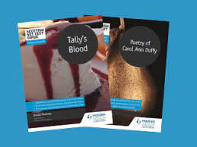The Reading for Understanding, Analysis and Evaluation (RUAE) paper is where students face questions on two unseen non-fiction texts, with the final question asking candidates to look for similarities or differences in the two passages. This paper is one and a half hours long and is worth 30% of the final award.

Critical Reading has two components and lasts for 90 minutes. Firstly students will face a Scottish Text which they have studied in class and which they will be required to answer question on the extract in the paper and also the wider text they have studied. This component is worth 20% of the final mark and texts include the play “Men Should Weep,” the novel: “Jekyll and Hyde” as well as poetry from Norman MacCaig or Carol Anne Duffy.

The second part of the Critical Reading paper is Critical Essay where candidates are expected to answer a question on a text they have studied in class. The text has to be a different genre from the Scottish texts and classes study a wide range of texts including non-fiction writing, novels, poetry, media and drama.

**NPA in Journalism:** As well as study of English we offer an NPA in Journalism in S5-6 which offers students a chance to develop knowledge of the world or journalism while also developing their skills in this area. This course also offers students an opportunity to continue to develop their skills and knowledge in reading, writing, talking and listening. This can be a good option for students wishing to undertake Higher in S6 as the skills and knowledge are a clear pathway for Higher English as well as offering young people the chance to gain a qualification in S5 before embarking on Higher. This course is assessed internally which means there is not the pressure of a high stakes exam.

Careers:

While English is essential for many occupations and also for a high number of Further and Higher Education courses for those who wish to continue their studies in English and Literacy there are a vast array of career options including: journalism, film, television and radio (presenting, production and support roles,) writing, Ecommerce, retail, teaching, law, marketing, librarian, research, politics, events management and public sector management.

Support Opportunities:

National 5: Supported study will be available for National 5 candidates on a weekly basis. This will run on a Tuesday from 3.45-4.45 within the English Department.

Higher: Supported study will be available for Higher candidates on a fortnightly basis. This will run on a Monday from 3.34-4.45 within the English Department.

In addition to Supported Study, we offer folio clinic for young people following the first draft. Folio clinic is operated on a sign-up basis and offers young people an opportunity to work on their folio in the department on a Friday afternoon. They can also discuss or their folio or seek further support from a teacher during this time.

Following assessments and prelims there will also be targeted interventions on offer on Friday afternoons. These are focused workshops on different aspects and are offered to young people whom the class teacher has invited for additional support.

**Learning/Study Aids:**

Digital Resources:

**MS Teams**: All of the resources used in class will be shared via MS Teams in files either on the general channel or on the teacher’s own channel. In addition to this there are a wide range of resources such as past papers, practice papers, texts books and copies of the texts studied. Teachers will also communicate homework and general messages via MS Teams. Copies of relevant SQA documentation and our assessment calendars can also be found on Teams.

**Scholar** – Scholar can be accessed by young people via their Glow launchpad. It contains a wide range of materials for young people on all aspects of their course as well as very helpful revision materials. Scholar is an invaluable resource for those working in the Senior Phase in English.

**Achieve–** all young people can access Achieve online to help with practice and revision materials. Again, this is helpful to consolidate skills and support revision.

**West OS** - for learners who like a video West OS contains a wide range of videos to support all aspects of the courses in English. These can be accessed via the West OS tile on Glow.

**BBC Bitesize:** Students can access this website for free. This includes revision materials for students to read and activities to support them with their studies. [Home - BBC Bitesize](https://www.bbc.co.uk/bitesize)

**Learning Cauldron:** Students can access this website for free. It includes interactive videos and activities about specific areas of the course. [The Learning Cauldron | Language and Exam Tuition](https://thelearningcauldron.co.uk/)

**Gizmo:** This is a free website/ app which allows students to create their own digital flashcards/ revision notes. [Gizmo | The easiest way to learn](https://gizmo.ai/?ref=futureen)

**SQA Documentation**

[**N3 Course Specification**](C://Users/15099BurtonMary/Downloads/CfE_CourseSpec_N3_Languages_English.pdf)

[**N4 Course Specification**](C://Users/15099BurtonMary/Downloads/n4-course-spec-english.pdf)

[**N5 English Course Specification**](C://Users/15099BurtonMary/Downloads/n5-course-spec-english%20(1).pdf)

[Higher English Course Specification](C://Users/15099BurtonMary/Downloads/h-course-spec-english%20(1).pdf)

[N5/H English Folio Template](https://view.officeapps.live.com/op/view.aspx?src=https%3A%2F%2Fwww.sqa.org.uk%2Ffiles_ccc%2FEnglishCourseworkTemplateMicrosoftWord.docx&wdOrigin=BROWSELINK)

[AH Course Specification](C://Users/15099BurtonMary/Downloads/ah-course-spec-english.pdf)

[NPA in Journalism (Level 6)](https://www.sqa.org.uk/sqa/38426.html)

**Homework:**

Class teachers will post regular homework on their channel on MS Teams.

Updates: Please access the faculty blog, via the school website for regular updates on courses and classes as well as faculty news.