The Tiger Who Came To Tea by Judith Kerr

Clink on the link below to listen to the story:  https://youtu.be/p1_lnmdyR1s | Who would you most like to visit you at teatime?  Have you ever wanted your favourite animal to ring the doorbell? Is there a person you’ve always wanted to meet, or would your favourite visitor just be your best friend?  Draw your favourite teatime guest. | Sing-along  The tiger likes Karaoke and having lots of fun. Let’s join in with the singing.  https://youtu.be/CgTHukOXhDw  Can you make a song that the tiger might sing to say 'Goodbye' and 'Thank you' to Sophie's family?
Let’s Talk  What colour is the tiger?  What did the tiger eat first?  What did the tiger drink that was Daddy’s?  Do you think the tiger was a nice guest?  The tiger wasn't very polite when he ate all of Sophie's food. Can you think of some manners that he should need to remember when he visits someone else's house | 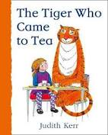 | Let’s Get Active!  Play ‘This little tiger’ game.  You can play this with your family by saying this little tiger likes to jump, run, leap, etc.  https://youtu.be/X2-7NftSJlA
Let’s Discover  What do tigers like to eat?  Where do they live?  How big do you think a tiger is?  Is there different types of tigers? | Let’s Pretend  Can you make your own tiger puppet and then re-tell the story to your family?  You can use anything you like.  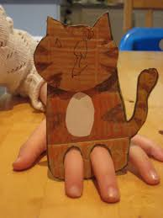 | Let’s Create  Can you create a tea party for a hungry tiger?  What will you have to eat? What will you wear?  Maybe you could make an invitation, tiger mask, or a shopping list of things to buy.

