We’re Going on a Bear Hunt by Michael Rosen

Clink on the link below to listen to the story:  https://youtu.be/0gyI6ykDwds | After listening to the story, can you make your own map to go on a bear hunt?  You can use whatever materials or resources you have at home to create the long grass, the river, the mud, the dark forest, snowstorm and the gloomy cave. | Now you have your map why don’t you go on a bear hunt adventure with your family?  You might find a bear!!!  You can make a list of all the things you might need to take on your bear hunt such as a torch, wellies, coat, binoculars and a net.
Let’s Talk  What was your favourite part of the story?  How did you feel when going on the Bear hunt?  Can you remember all the different places the family had to go through to find the bear? | 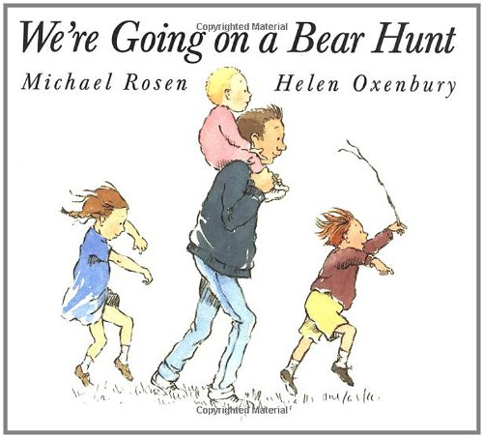 | Let’s Get Active!  Why don’t you join in with cosmic yoga adventure on all about going on a bear hunt!  https://www.youtube.com/watch?v=KAT5NiWHFIU
Let’s Discover  Make a sensory box using materials you have at home and create some of the scenes in the book.  You could use grass, water, brown paper, twigs, leaves, cotton wool and a cardboard box. | Let’s Pretend  Can you remember the sounds in the story?  Why don’t you try to make sound bottles to create the sound of the swishy grass, cold river, oozing mud and the forest? | Let’s Create  Can you make a bear cave using items and objects in your house?  You could use a cardboard box, tent, or blankets. You can make it cosy by adding pillows, teddy bears and fairy lights.

