“Stickman” by Julia Donaldson

Clink on the link below to listen to the story:  https://youtu.be/o3lCfKhsOsY | The Stickman stays with his family in a tree. Who is in your family? Can you draw a picture or make puppets of your family?  You can use whatever materials or resources you have at home. | The Stickman goes on lots of adventures. Can you go on a ‘stick hunt’ and collect sticks, leaves, pine- cones, etc to make your own stickman or family?  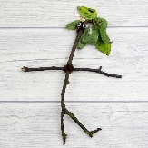
Let’s Talk  How many children did the Stickman have?  What did the Stickman get mistaken for?  How many different animals were in the story? | 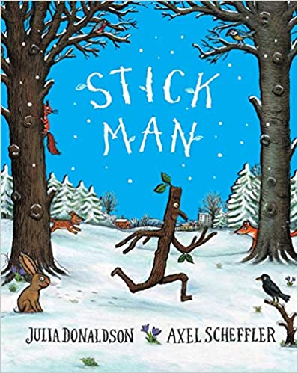 | Let’s Get Active!  Make up your own Stickman moves and join in with a range of twigtastic games. Jump, hop, skip, run or even do some star jumps.  The Sticky kids love to be active.  https://youtu.be/cj-ouBZXd00
Let’s Discover  With some of the sticks that you have collected can you guess how many sticks tall you are.  Which stick is the shortest?  Which stick is the longest? | Let’s Pretend  If you were the Stickman who would you like to be found by?  Make a fancy stick crown and pretend to be the king or queen of your family. | Let’s Create  Can you make a treehouse using your sticks and other objects you found on your stick hunt?  What about making some numbers, letter’s, or shapes with your sticks.

