The Smartest Giant in Town by Julia Donaldson

Clink on the link below to listen to the story:  https://www.youtube.com/watch?v=hc-n1B6RscY | Can you make a picture or model of George the Giant?  You can use pens, pencils, crayons, collage, junk or playdough. | Can you join the author and her husband to sing along to the Giant’s song? If you have an instrument see if you can keep the beat.  https://www.youtube.com/watch?v=iJ4CHVIIv78
What part of the story was your favourite?  Did you think the story was funny? | 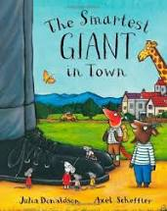 | Can you remember all the animals that George the Giant helped?  This is tricky but can you remember the order that the Giant helped each animal?
In the story George the Giant has some shapes and patterns on his clothes, can you find any of them when watching the video? | George the Giant is very kind to the animals in the story. Can you help someone in your house and do something kind for them? | Can you pretend to be George the Giant, by finding some of the clothes that George shares with the animals and role play the story at home?

