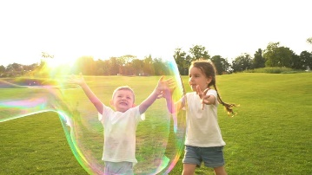Home Learning 15th of June

Hi Boys and Girls , we hope you are well. It is nearly the summer holidays so this will be the last week of home learning that Mrs Prunty and I will be sending you. We hope you have a lovely summer and can’t wait to see you all when you come back in August. Over the holidays you will still be able to read books on Scholastic and should still be able to go on to Education City and Top Marks if you are looking for something to do.

**Monday**

*Chilli Challenge*

|  |  |  |
| --- | --- | --- |
| [This Photo](https://de.wikipedia.org/wiki/Datei:Chilli_pepper_4.svg) by Unknown Author is licensed under [CC BY-SA](https://creativecommons.org/licenses/by-sa/3.0/) | [This Photo](https://de.wikipedia.org/wiki/Datei:Chilli_pepper_4.svg) by Unknown Author is licensed under [CC BY-SA](https://creativecommons.org/licenses/by-sa/3.0/)  [This Photo](https://de.wikipedia.org/wiki/Datei:Chilli_pepper_4.svg) by Unknown Author is licensed under [CC BY-SA](https://creativecommons.org/licenses/by-sa/3.0/) | [This Photo](https://de.wikipedia.org/wiki/Datei:Chilli_pepper_4.svg) by Unknown Author is licensed under [CC BY-SA](https://creativecommons.org/licenses/by-sa/3.0/)  [This Photo](https://de.wikipedia.org/wiki/Datei:Chilli_pepper_4.svg) by Unknown Author is licensed under [CC BY-SA](https://creativecommons.org/licenses/by-sa/3.0/)  [This Photo](https://de.wikipedia.org/wiki/Datei:Chilli_pepper_4.svg) by Unknown Author is licensed under [CC BY-SA](https://creativecommons.org/licenses/by-sa/3.0/) |
| 36890÷10= | 43÷100= | 33, 499÷1000= |

Here is a word problem. Think about which calculation you should use to find the answer. It is quite tricky so take your time. Check your answers with a calculator.

Pokémon maths problem

Read the following Pokémon problem carefully and highlight the relevant information.

|  |  |
| --- | --- |
| Peter was 27 years old and opened a shop selling Pokémon soft toys at number 38 High Street. He spent money buying soft toys for the shop. He bought 14 Pikachus which cost him £5.70 each and he sold them for £11.99 each and 8 Charmanders which he bought for £5.12 each and sold for £10.79 each. He wanted to buy 17 Bulbasaurs for his shop but they weren’t available.   1. How much money did he spend buying Pikachus ? 2. How much money did he make selling them ? (you could round £11.99 to £12 to make it easier then take the extra 1ps off at the end ) 3. How much profit did he make ? 4. How much did he spend buying Charmanders ? 5. How much did he make selling them all ? | [This Photo](http://dnd-wiki.org/wiki/Charmander_(3.5e_Monster)) by Unknown Author is licensed under [CC BY-SA](https://creativecommons.org/licenses/by-sa/3.0/) |

Last week we looked at data handling, especially using bar graphs. Let’s practise some more.

Summer Olympics medal winners

| **National Team** | | | Number of Summer Olympics taken part in: | Gold  medals: | Silver  medals: | Bronze  medals: | Total  medals: |
| --- | --- | --- | --- | --- | --- | --- | --- |
| MC900001022[1] | | United States (USA) | 26 | 976 | 757 | 666 | 2399 |
|  | | *Soviet Union (USSR)\**  *\*The Soviet Union was dissolved in 1991. Its equivalent today is the Russian Federation.* | 9 | 395 | 319 | 296 | 1010 |
| MC900024350[1] | | Germany (GER) | 15 | 174 | 182 | 217 | 573 |
| MC900025615[1] | Great Britain (GBR) | | 27 | 236 | 272 | 272 | 780 |
| MC900025619[1] | France (FRA) | | 27 | 202 | 223 | 246 | 671 |
| MC900025638[1] | Italy (ITA) | | 26 | 198 | 166 | 185 | 549 |
| MC900024347[1] | China (CHN) | | 9 | 201 | 145 | 127 | 473 |
| MC900001214[1] | Hungary (HUN) | | 25 | 167 | 144 | 165 | 476 |
|  | *East Germany (GDR)*\*\*  *\*\*East and West Germany were reunified as Germany in 1990.* | | 5 | 153 | 129 | 127 | 409 |

Select one graph activity or work your way through them all!

|  |
| --- |
| **The Apprentice**  Create a bar graph to show the gold medal count for these nations:  Soviet Union, Germany, Great Britain, France, Italy, China, Hungary. |
| **Master Mathematician**  Create a bar graph to show the gold, silver and bronze medal count for the 6 nations with the highest total medal scores. |
| **­Mega-Challenge**  Create a bar graph to show the total, gold, silver and bronze medal count for the 8 nations with the highest total medal scores. |

Spelling- New Learning   

Last week we looked at prefixes. Remember a prefix is a word or group of letters that can be put in front of a word that can change the meaning e.g. tidy and untidy.

Today we are going to look at suffixes which go after the root word.

Watch this video where suffixes are explained in more detail.

<https://www.bbc.co.uk/teach/class-clips-video/english-ks2-wonderful-words-suffixes-part-1/zdnd7nb>

**Rule 1 is to add the suffix to any word that ends in two consonants, which is demonstrated by adding the suffix 'er' to 'walk' giving us 'walker', and adding 'est' to 'fast' giving us 'fastest'.**

Rule 2 explains how any words with a short vowel sound followed by a consonant, such as 'hop', should have the last letter doubled before adding the suffix. Shown by adding the suffix 'ing' to 'hop' and giving us 'hopping'.

Rule 3 concerns words that end in a consonant followed by an 'e', such as 'hope'. With these words the 'e' must be removed before adding the suffix, making 'hope' into 'hoped, and 'hoping'.

The final rule reminds us that if the word ends in a consonant followed by a 'y', then you change the 'y' into an 'i'. For example, adding the suffix 'er' to 'cry' gives us 'crier'. The exception to this rule is to avoid double 'i', when adding the suffix 'ing', keep using the 'y', so 'cry' becomes 'crying'.

|  |  |  |  |  |  |
| --- | --- | --- | --- | --- | --- |
|  | er | ing | able | ed |  |
| 1. like 2. drive 3. excite 4. safe | | | 1. time …………………………….. 2. knowledge…………………………… 3. manage ………………………………….. 4. agree ………………………………… | | |

**Look at the following root words and suffixes.**

**What do you notice about the spelling of the new words?**

|  |  |  |  |
| --- | --- | --- | --- |
| care + less = careless | care + full = careful | move + ment = movement | late +ly = lately |

**Choose one of the consonant suffixes from the box to add to each word below.**

|  |  |  |  |  |  |
| --- | --- | --- | --- | --- | --- |
|  | less | ful | ment | ly |  |
| 1. like …………………………………………. 2. excite 3. time 4. achieve | | | 1. safe …………………………………… 2. sense……………………………….. 3. complete…………………………….. 4. fulfil …………………………………. | | |

How many words can you make y adding a suffix ?

|  |  |
| --- | --- |
| root word |  |
| harm |  |
| quick |  |
| employ |  |
| develop |  |
| exception |  |
| inform |  |
| pain |  |

Tuesday

|  |  |  |
| --- | --- | --- |
| [This Photo](https://de.wikipedia.org/wiki/Datei:Chilli_pepper_4.svg) by Unknown Author is licensed under [CC BY-SA](https://creativecommons.org/licenses/by-sa/3.0/) | [This Photo](https://de.wikipedia.org/wiki/Datei:Chilli_pepper_4.svg) by Unknown Author is licensed under [CC BY-SA](https://creativecommons.org/licenses/by-sa/3.0/)  [This Photo](https://de.wikipedia.org/wiki/Datei:Chilli_pepper_4.svg) by Unknown Author is licensed under [CC BY-SA](https://creativecommons.org/licenses/by-sa/3.0/) | [This Photo](https://de.wikipedia.org/wiki/Datei:Chilli_pepper_4.svg) by Unknown Author is licensed under [CC BY-SA](https://creativecommons.org/licenses/by-sa/3.0/)  [This Photo](https://de.wikipedia.org/wiki/Datei:Chilli_pepper_4.svg) by Unknown Author is licensed under [CC BY-SA](https://creativecommons.org/licenses/by-sa/3.0/)  [This Photo](https://de.wikipedia.org/wiki/Datei:Chilli_pepper_4.svg) by Unknown Author is licensed under [CC BY-SA](https://creativecommons.org/licenses/by-sa/3.0/) |
| 768x10= | 4.3 x100= | 0.02 x 1000= |

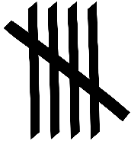

[This Photo](http://commons.wikimedia.org/wiki/File:Tally_marks-Five-bar_Gate.svg) by Unknown Author is licensed under [CC BY-SA](https://creativecommons.org/licenses/by-sa/3.0/)

**Tally Marks**

Here is a table that shows how children travel to school each day. Remember we count in bundles of 5 with tally marks.

|  |  |
| --- | --- |
| **Transport** | **How many children** |
| Bicycle |  |
| Car |  |
| Scooter |  |
| Bus |  |
| Walking |  |

How many children travelled by bicycle?

How many travelled by car and bus?

Which type of transport had the least number of pupils?

Which type of transport had the most number of pupils?

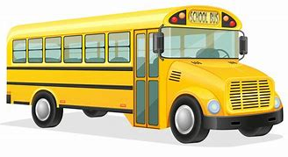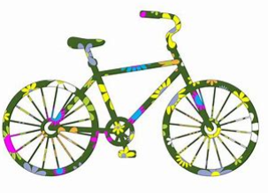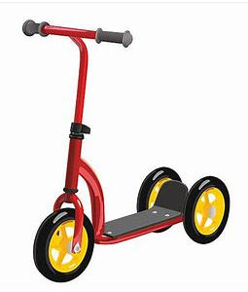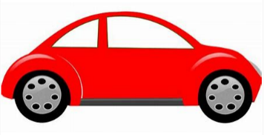How many children took part in the survey?

Word Problems

These are 2 step problems . Read the question very carefully before you answer.

|  |  |  |
| --- | --- | --- |
| 120 boys and 130 girls go on a school trip. They travel on 5 coaches. How many children are there on each coach? | A theatre can seat 360 people in the stalls and 270 people in the balcony. Each row can seat 9 people. How many rows are there? | Mr Brandrick had 640 chickens, he sold 320 and now keeps the rest in 4 identical chicken sheds. How many chickens are in each shed? |
| I mix together 1000ml of lemonade and 680ml of orange juice. I divide the drink equally between 8 glasses. How much drink is in each glass? | Mrs Jones wins £8600 on the lottery one week and £1030 on the lottery the following week. She shares the winnings equally between her 3 children. How much money do they get each? | Mrs Higgins bakes 1200 chocolate cakes and 1032 sponge cakes. She puts them in boxes for a cake sale. Each box can hold 4 cakes. How many boxes will Mrs Higgins need? |
| Joe had 3934 lego bricks - he sold 1324. He split the remaining bricks equally into 9 boxes. how many bricks were in each box? | I have 612 stamps in one book and 454 stamps in another. Each letter needs 2 stamps. How many letters can I post? | Mrs Jones had 36 boxes of 6 eggs. She shared the eggs equally between 4 people. How many eggs did each person get? |

Spelling

Here are some more suffixes for you to try. Think about the rules.

Choose 4 of the words you make in the grid and write interesting sentences.

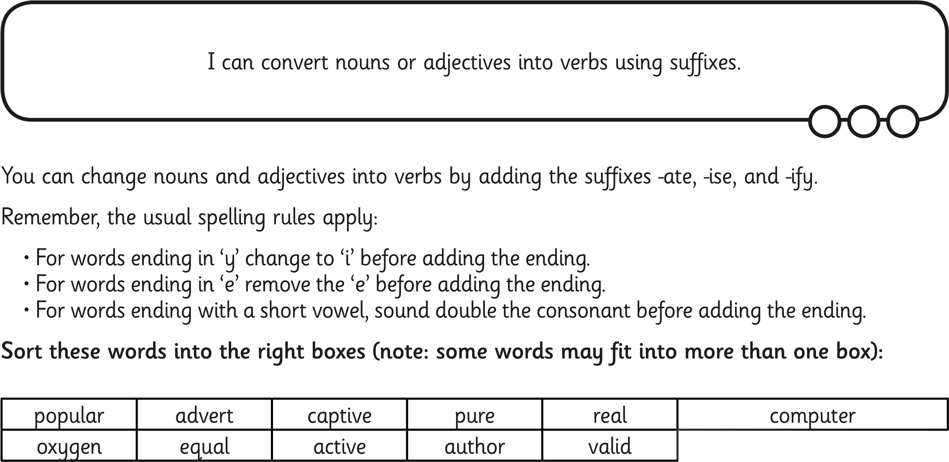

|  |  |  |
| --- | --- | --- |
| **ate** | **ise** | **ify** |
|  |  |  |
|  |  |  |
|  |  |  |
|  |  |  |
|  |  |  |
|  |  |  |

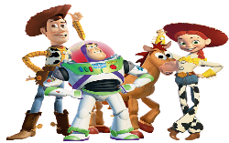

[This Photo](https://order.uprintinvitations.com/Invitations-Boys/Toy-Story-Stripes-Birthday-Invitations-ALL-COLORS-ALL-CHARACTERS.htm) by Unknown Author is licensed under [CC BY](https://creativecommons.org/licenses/by/3.0/)

Film Quiz

1. Which Disney film does the song 'When You Wish Upon a Star' come from?
2. What was the name of Dorothy's dog in the Wizard of Oz?
3. Which movie features two characters called Simba and Mufasa?
4. Which fairy tale character slept for 100 years?
5. In the movie Polar Express, where does the young boy travel to by train?
6. Who wrote Willy Wonka and the Chocolate Factory?
7. What is the name of the Disney character who plays the Little Mermaid?
8. Who is the author of the famous collection of Harry Potter books?
9. Which Disney movie features a song called 'The Bare Necessities'?
10. What is the name of the newspaper where Peter Parker works in Spiderman?

Wednesday

|  |  |  |
| --- | --- | --- |
| [This Photo](https://de.wikipedia.org/wiki/Datei:Chilli_pepper_4.svg) by Unknown Author is licensed under [CC BY-SA](https://creativecommons.org/licenses/by-sa/3.0/) | [This Photo](https://de.wikipedia.org/wiki/Datei:Chilli_pepper_4.svg) by Unknown Author is licensed under [CC BY-SA](https://creativecommons.org/licenses/by-sa/3.0/)  [This Photo](https://de.wikipedia.org/wiki/Datei:Chilli_pepper_4.svg) by Unknown Author is licensed under [CC BY-SA](https://creativecommons.org/licenses/by-sa/3.0/) | [This Photo](https://de.wikipedia.org/wiki/Datei:Chilli_pepper_4.svg) by Unknown Author is licensed under [CC BY-SA](https://creativecommons.org/licenses/by-sa/3.0/)  [This Photo](https://de.wikipedia.org/wiki/Datei:Chilli_pepper_4.svg) by Unknown Author is licensed under [CC BY-SA](https://creativecommons.org/licenses/by-sa/3.0/)  [This Photo](https://de.wikipedia.org/wiki/Datei:Chilli_pepper_4.svg) by Unknown Author is licensed under [CC BY-SA](https://creativecommons.org/licenses/by-sa/3.0/) |
| 768x10= | 4.3 x100= | 0.02 x 1000= |

The graph below shows how many times people visited the ice rink.

1. 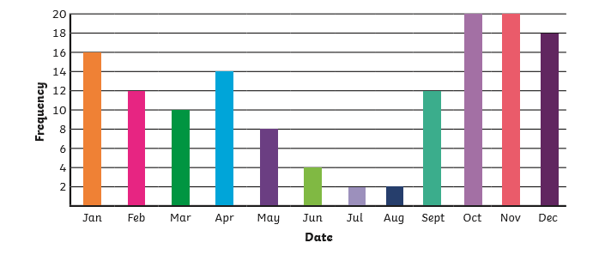
2. What month did the ice rink have the most visitors?

What months did the ice rink have the least visitors?

Which months had the most ?

Which were the 3 most popular months and how many people visited in these months altogether ?

How many visitors did the ice rink have altogether over the whole year?

If it cost £3 to ice skate how much money did they make in a year ?

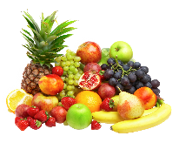

[This Photo](http://www.pngall.com/fruit-png) by Unknown Author is licensed under [CC BY-NC](https://creativecommons.org/licenses/by-nc/3.0/)

Mixed Bunch

Write these as chimney sums or bus stop sums. Be careful to line the numbers up correctly in the place value

23846 + 345 = 45009 + 56789= 49665-379=

6000 – 2687 = 8234 x 4= 4958 x6 =

48596 ÷ 4 = 58493 ÷ 6 = 38493 ÷ 8 =

483932 ÷ 100 = 38492 ÷ 100= 45 ÷ 10 =

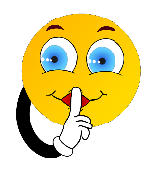**Spelling**

**Silent Letters**

**Put each of these words in the right column according to the silent letter.**

**Remember that silent letters have no sound in a word.**

knight write gnome hour lamb wriggle honest knife numb ghost climb wreck knit wren muscle knee comb scissors wrong right bomb whale wrist sword knock wrap crumb doubt what knot

|  |  |  |  |  |  |
| --- | --- | --- | --- | --- | --- |
| **Silent k** | **Silent w** | **Silent b** | **Silent h** | **Silent g** | **Silent c** |
|  |  |  |  |  |  |
|  |  |  |  |  |  |
|  |  |  |  |  |  |
|  |  |  |  |  |  |
|  |  |  |  |  |  |
|  |  |  |  |  |  |
|  |  |  |  |  |  |
|  |  |  |  |  |  |

Underline or identify the silent letters in this passage.

Sir Bob , the honest Knight , climbed the castle stairs slowly as his knees were sore. On reaching the top , he knocked loudly on a door.

“ Do you know what hour it is ?” demanded the King. “You knock on my door , sword in hand? You wrecked my dream. I was dreaming that I was chasing a lamb through the fields and it was so cold my hands were numb. I caught it and it was wriggling then you woke me up !”

Sir Bob went so pale, he looked as if he had seen a ghost.

“I am sorry Your Majesty I knocked on the wrong door. “ The muscles in his face twitched and his stomach felt as if it were in a knot.

Sir Bob left quickly to write a letter of apology. The letter was so long his wrist ached and his fingers felt numb.

Guess the cartoon characters

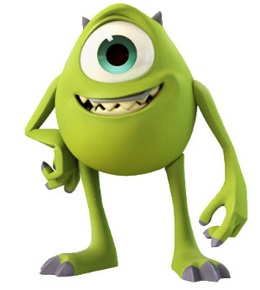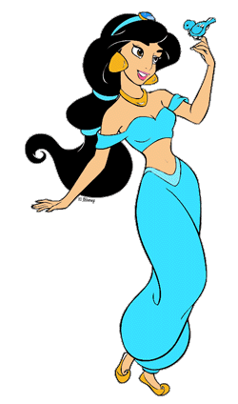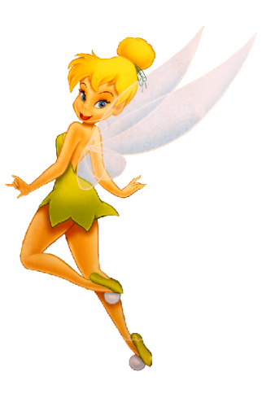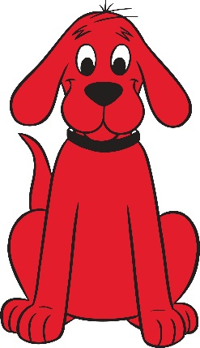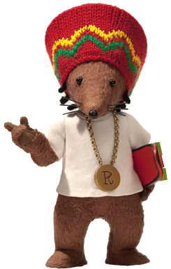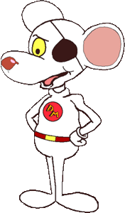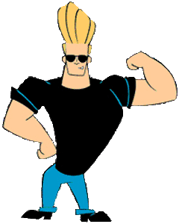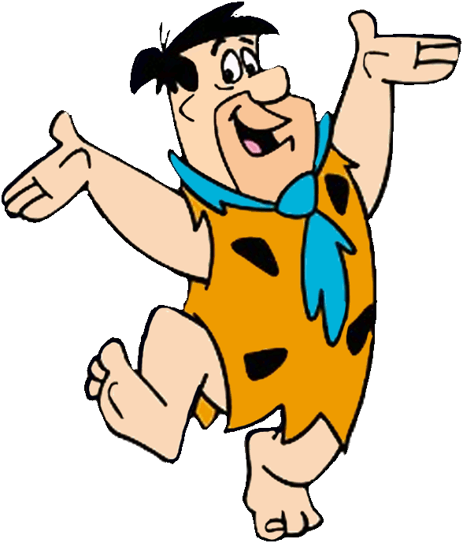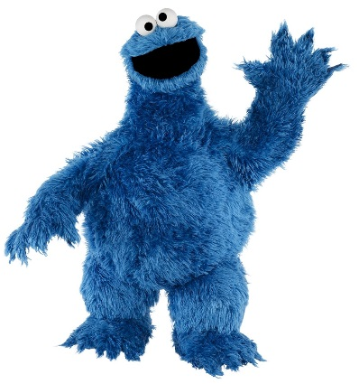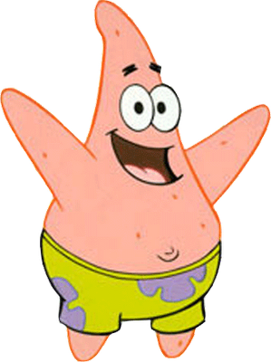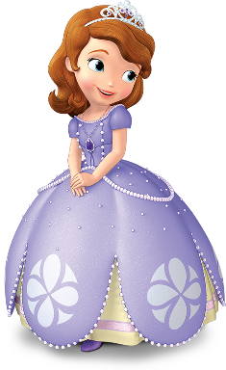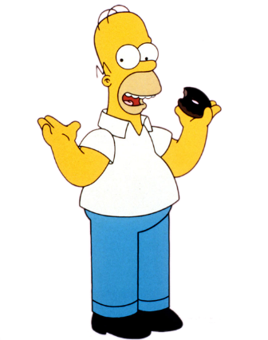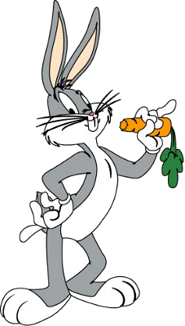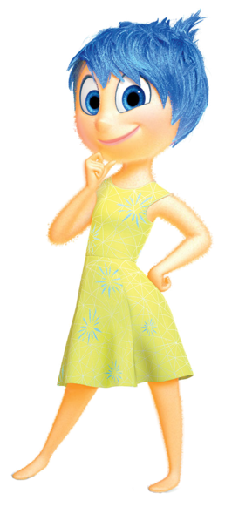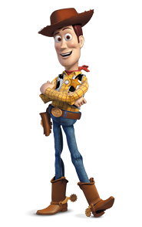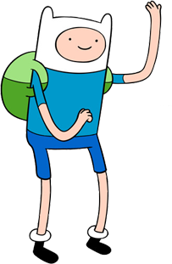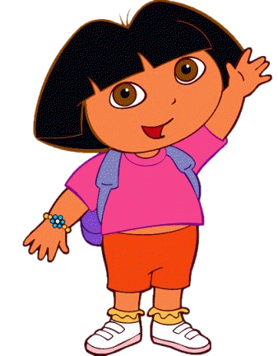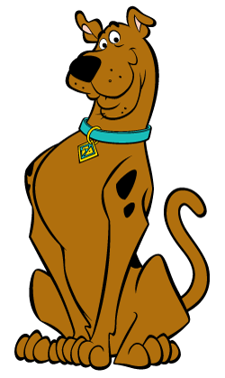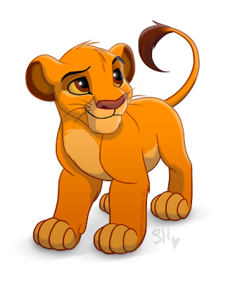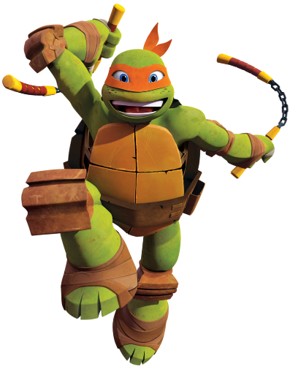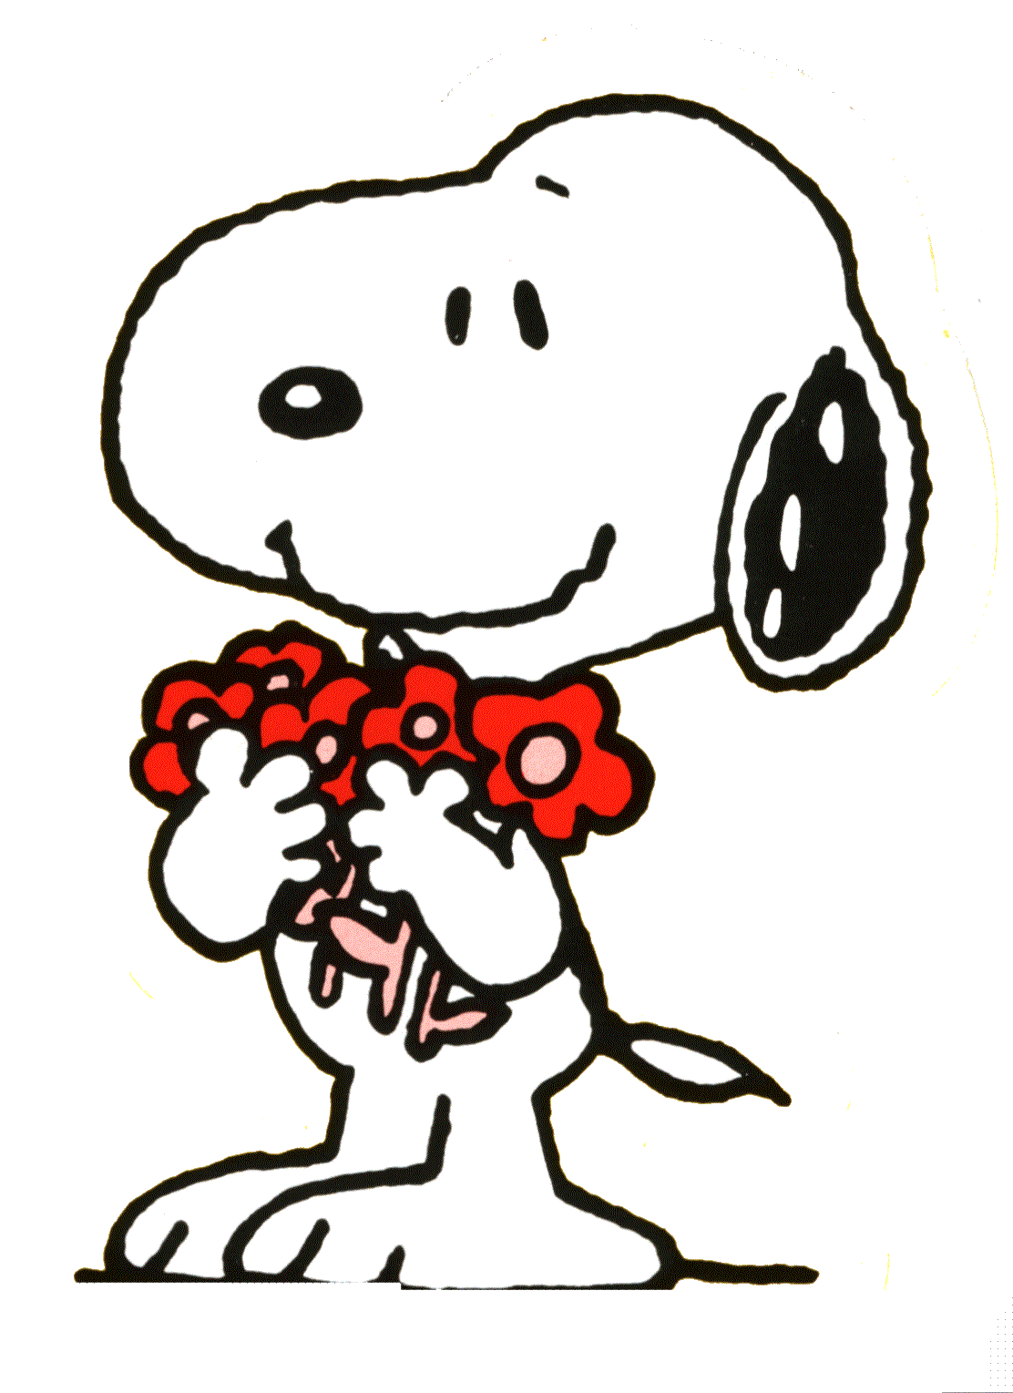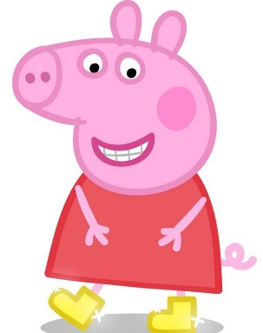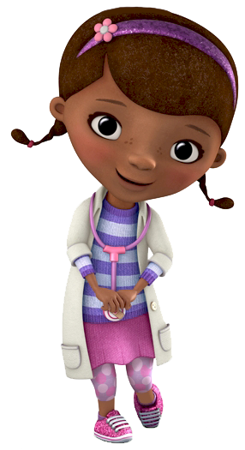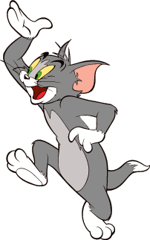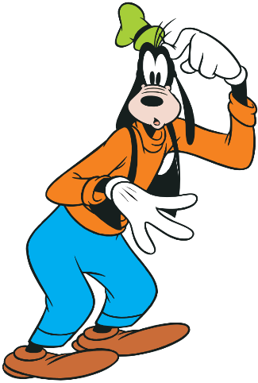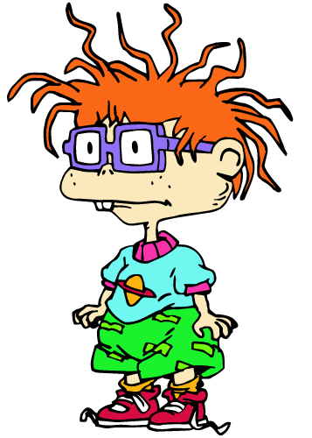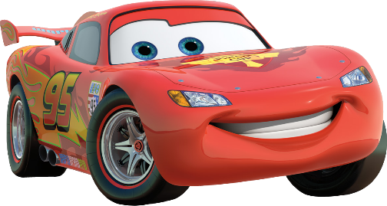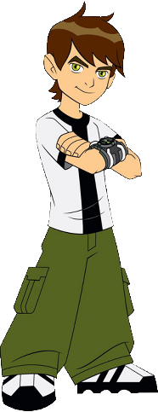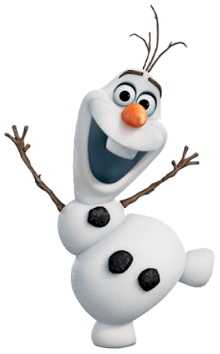

**34**

**32**

**31**

**30**

**28**

**27**

**25**

**24**

**23**

**22**

**21**

**20**

**19**

**17**

**16**

**15**

**14**

**13**

**12**

**11**

**10**

**9**

**8**

**7**

**6**

**5**

**4**

**3**

**2**

**1**

**18**

**26**

**33**

**29**

Thursday

|  |  |  |
| --- | --- | --- |
| [This Photo](https://de.wikipedia.org/wiki/Datei:Chilli_pepper_4.svg) by Unknown Author is licensed under [CC BY-SA](https://creativecommons.org/licenses/by-sa/3.0/) | [This Photo](https://de.wikipedia.org/wiki/Datei:Chilli_pepper_4.svg) by Unknown Author is licensed under [CC BY-SA](https://creativecommons.org/licenses/by-sa/3.0/)  [This Photo](https://de.wikipedia.org/wiki/Datei:Chilli_pepper_4.svg) by Unknown Author is licensed under [CC BY-SA](https://creativecommons.org/licenses/by-sa/3.0/) | [This Photo](https://de.wikipedia.org/wiki/Datei:Chilli_pepper_4.svg) by Unknown Author is licensed under [CC BY-SA](https://creativecommons.org/licenses/by-sa/3.0/)  [This Photo](https://de.wikipedia.org/wiki/Datei:Chilli_pepper_4.svg) by Unknown Author is licensed under [CC BY-SA](https://creativecommons.org/licenses/by-sa/3.0/)  [This Photo](https://de.wikipedia.org/wiki/Datei:Chilli_pepper_4.svg) by Unknown Author is licensed under [CC BY-SA](https://creativecommons.org/licenses/by-sa/3.0/) |
| 32x6= | 245x8= | 5674 x 5 = |

Look at this bar graph and answer the questions below.

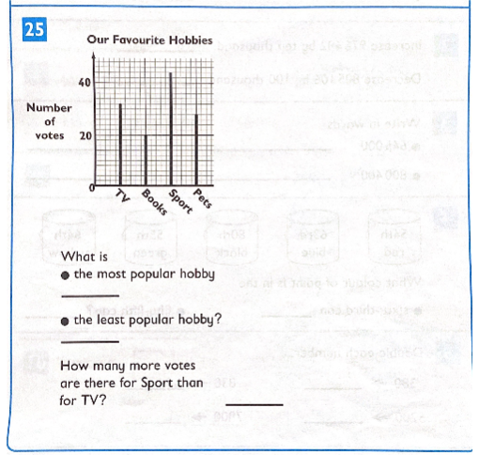

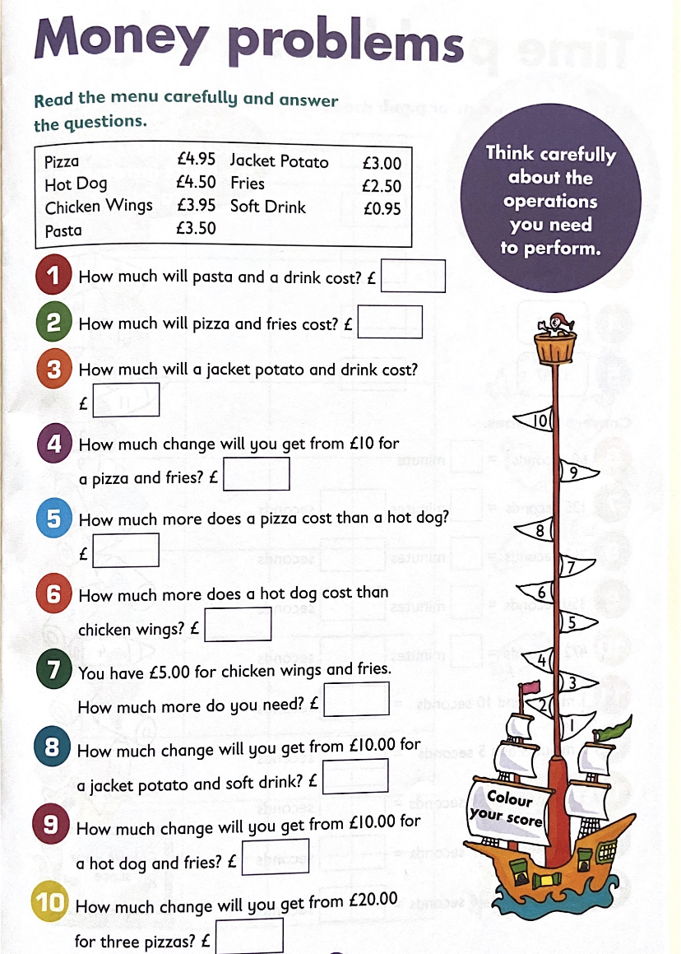

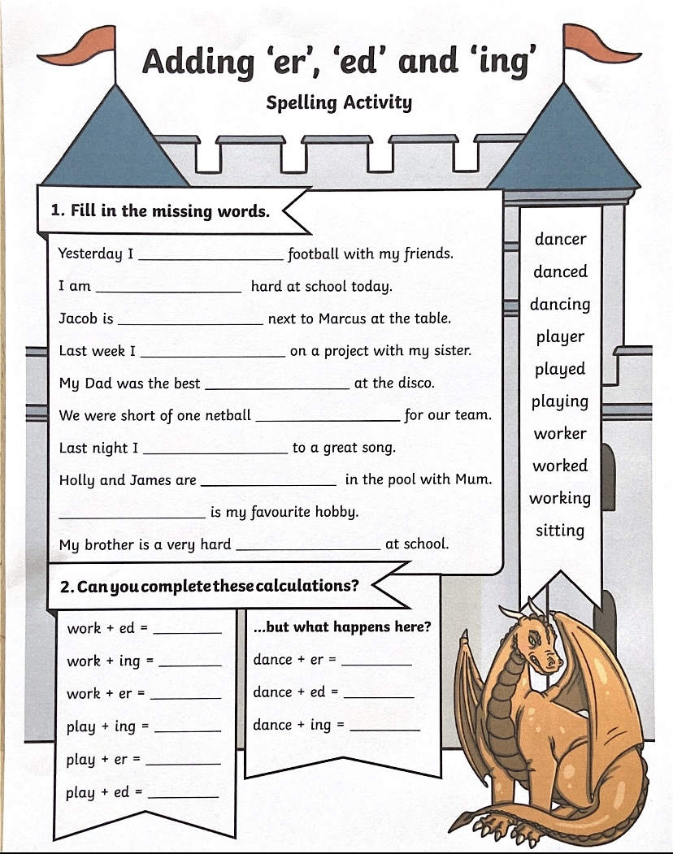

Film Quiz

1. Which of the following names is one of the leading characters in Smurfs 2:  
   a. Papa Smurf, b, Dada Smurf, c. Father Smurf?
2. Complete the movie title: Nativity 3...:   
   a. Danger in the Manger, b. Dude, Where's My Donkey, c. Star Going Far?
3. Which of the following names is one of the main minion characters:   
    a. Liam, b. Robert, c. Dave?
4. What are the small orange men in Charlie and the Chocolate Factory known as:   
    a. Oompa Fumpas, b. Oompa Loompas, c. Oompa Dumpas?
5. What is the name of the cowgirl from The Toy Story:   
    a. Jessie, b. Holly, c. Daisy?
6. Complete the title of this famous children's movie: Beauty and the ...?
7. Which of the following songs features in The Lion King:  
    a. Let It Go, b. Circle of Life, c. Circle of Love?
8. How many dwarfs did Snow White have? Can you name them
9. What does Paddington Bear keep underneath his hat in case of emergency
10. What is the name of Kristoff's reindeer in the film Frozen?
11. What 'C' is a fairytale character who meets her prince at a ball?
12. Which of the following movies is about an orphan:   
    a. Tangled, b. Frozen, c. Annie

FRIDAY

|  |  |  |
| --- | --- | --- |
| [This Photo](https://de.wikipedia.org/wiki/Datei:Chilli_pepper_4.svg) by Unknown Author is licensed under [CC BY-SA](https://creativecommons.org/licenses/by-sa/3.0/) | [This Photo](https://de.wikipedia.org/wiki/Datei:Chilli_pepper_4.svg) by Unknown Author is licensed under [CC BY-SA](https://creativecommons.org/licenses/by-sa/3.0/)  [This Photo](https://de.wikipedia.org/wiki/Datei:Chilli_pepper_4.svg) by Unknown Author is licensed under [CC BY-SA](https://creativecommons.org/licenses/by-sa/3.0/) | [This Photo](https://de.wikipedia.org/wiki/Datei:Chilli_pepper_4.svg) by Unknown Author is licensed under [CC BY-SA](https://creativecommons.org/licenses/by-sa/3.0/)  [This Photo](https://de.wikipedia.org/wiki/Datei:Chilli_pepper_4.svg) by Unknown Author is licensed under [CC BY-SA](https://creativecommons.org/licenses/by-sa/3.0/)  [This Photo](https://de.wikipedia.org/wiki/Datei:Chilli_pepper_4.svg) by Unknown Author is licensed under [CC BY-SA](https://creativecommons.org/licenses/by-sa/3.0/) |
| 32÷2 | 245÷ 5== | 5674 ÷ 2 = |

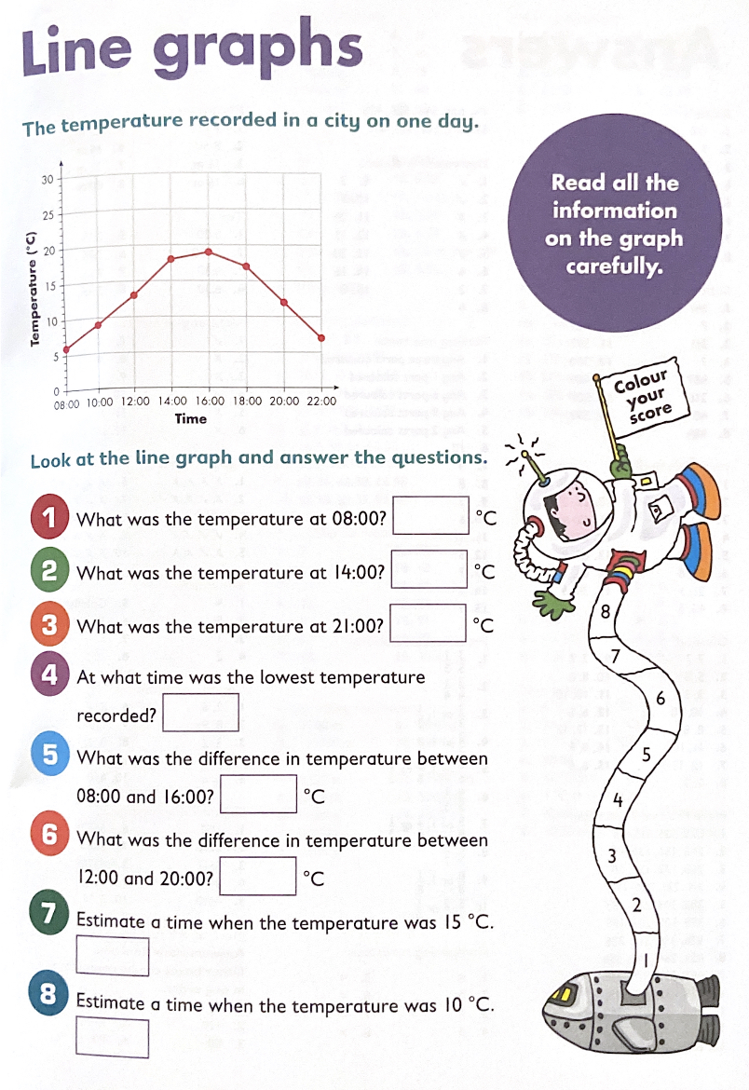

Guess the Disney Character

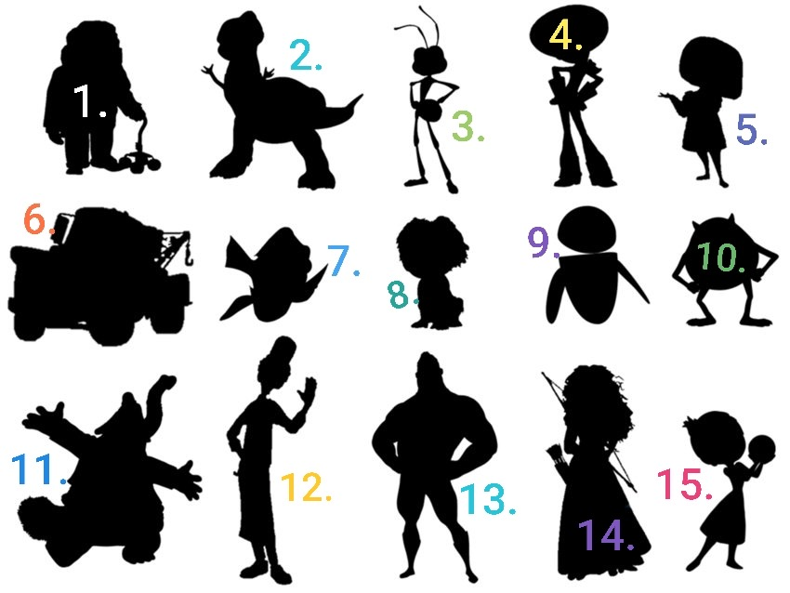

QUIZ

1. How many months of the year have 30 days?
2. In which street does the British Prime Minister live?
3. Name the most famous nurse of Victorian Times who improved care for wounded soldiers?
4. What is the name of the toy cowboy in Toy Story?
5. Pharaoh is the title given to the rulers of which ancient country?
6. Which Italian city is famous for its leaning tower?
7. What is the nickname for the bell of the clock at the Palace of Westminster in London?
8. How many years are there in a millennium?
9. What sweet food made by bees using nectar from flowers?
10. Name the school that Harry Potter attended?
11. In the nursery rhyme, who sat on a wall before having a great fall?
12. Which big country is closest to New Zealand?

