Boisterous
Disappear
Persuade
Technique
Primate
Responsible
Audible
Breakable
Visible
Discipline
Inference
Possession
Brilliant
Potential
Through
Interrupt
Preparation
Business
Beautiful
Wonderful
Automobile
Bicycle
Tomorrow
Jealous
Unanimous
Embarrass
Knowledge
Ceiling
Proportion
Unfortunately

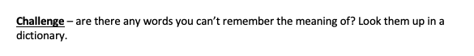

Library
Vaccine
Finite
Capture
Disinterested
Exhibition
Illusion
Alliteration
Apostrophe
Metaphor
Atmosphere
Consonant
Exclamation
Grammar
Country
Infrastructure
International
Adjacent
Approximately
Centimetre
Circumference
Denominator
Diameter
Equilateral
Estimate
Equation
Musician
Gymnastic
League
Qualify

