Numeracy-
Online Task
- Log on to Education City for more games linked to money through glow.
- You can also use sum-dog at any point with regular challenges being placed.
- Hit the button
- Mental maths train
- Rocket rounding
Part A
Complete the following table by rounding to the nearest 10 and 100.
Starting Number | Nearest 10 | Nearest 100
292
906
289
282
555
919
3832

Mental Sums
Complete the following sums mentally.
- 29+93=
- 87-48=
- 4x9=
- 27÷3=
- 58+15=
- 45-29=
- 5x13=
- 52÷4=
- 83+84=
- 148-81=
Information Handling
Complete the following questions based on the table below.
 | IIII IIII IIII
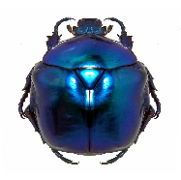 | IIII IIII IIII IIII IIII I
 | IIII III
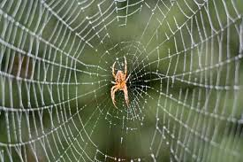 | IIII IIII IIII IIII
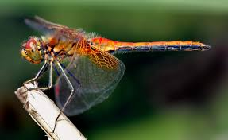 | IIII IIII IIII II
- How many of each kind of insect were seen?
- b) c) d)
e)
2) How many insects altogether were seen?
3)How Many insects had (a) spots (b) a web or branch?
4) How many more insects were
a) and b) and
c) and and

Shoe Sizes
Size 5 | IIII IIII IIII
Size 9 | IIII IIII IIII IIII
Size 7 | III
Size 1 | IIII IIII IIII IIII IIII IIII
Create a series of questions for someone to answer based on the table above!

Looking out the window if you can see any traffic going past mark what colour you can see.
Red
Black
White
Blue
Silver
Other

