Writing- Recount - Title : Going to a special place
A recount has three main parts a beginning, middle and end. Remember to describe the events in sequence, use linking words- first, then, next, finally.

Reading
- Log onto the Scholastic website using the log in details emailed to you from Mrs Rigg.
Reading Book
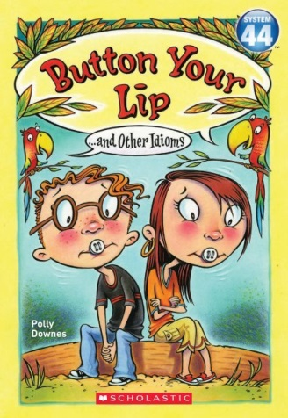

Reading- Read pages 1-16 this week.
Literacy Here are some suggested activities. Choose one a day and do more if you wish.

MTV (Making Thinking Visible)  PRE-READING :See Think Wonder – Look at the front cover. See - Can you write what you see? Think- Can you write what you think is happening in the picture? Wonder What questions do you have about this image? | Make a list of any words you are unsure of, look them up in a dictionary or online once you have had a sensible guess. | Make up three good questions you could ask someone about this book to test that they have read it carefully. Write down the answers you would expect them to give. | Read your book to a family member and try and read with expression to make it come alive for them.
Create a new front cover and possible title for your book. | Draw a large picture of one of the settings used in the picture frame for page 15. Label everything in your picture. | Copy your favourite sentence from page 14 in bold, colourful letters. Say why you chose it underneath. | Make a table or tally of all the nouns in page 5.
MTV (Making Thinking Visible)  Headline - Can you think of a title for page 12 What else could be the name for the idiom ? Write why you chose the headline. | Write down all the verbs you can find in the book. | Read your book with a family member and ask them some questions about the text. | Draw a picture of your favourite idiom in the book. Write a few sentences or more about why this was your favourite part.

MTV (Making Thinking Visible)

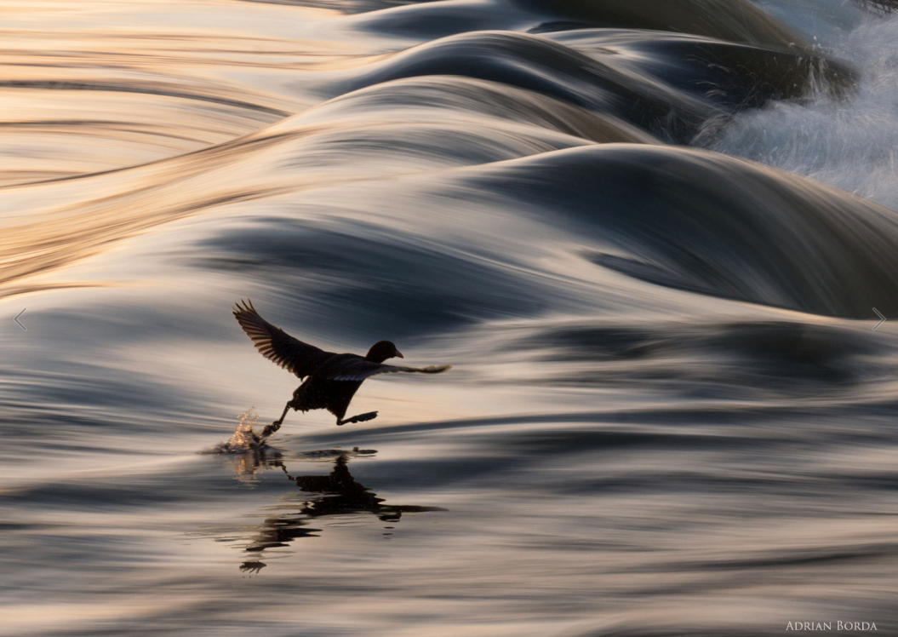

Take your time to look at the picture above -
1. What do you see in the picture above?
2. What do you think is happening in the picture?
3. What are some questions you would like to ask (What do you wonder?)

Challenge Questions
• Is the bird walking on the water? How? Why?
- Is this bird special? Can it fly?

