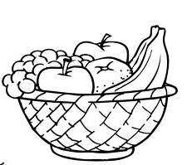
Favourite Fruit

Shoppers in the supermarket were asked in a survey which was their favourite fruit. Here is a list of their responses.

Banana Apple Banana Banana Grape Orange
Apple Apple Strawberry Orange Apple Banana
Orange Orange Strawberry Banana Grape Apple
Apple Apple Orange Strawberry Strawberry Apple

Complete this Tally Chart and use this information about favourite fruits to fill it in. Then create three questions below
FRUIT | TALLY | TOTAL
Apple
Banana
Grape
Orange
Strawberry

Questions
1.

2.

3.

