Monday 15th June 2020
These are suggested activities for Primary 2. Feel free to do them in any order you wish.

Literacy
This week’s phoneme is: mb (lamb)
Can you find things in your house or garden that have this mb phoneme sound? I have found something in my house: comb
Make a list of mb words you find around the house or in a book you are reading at home.

Common words:
green, people, which, another
- Read each word aloud, talk about the word and spelling strategies that help you to spell each word.
- Can you cover the word and write it 3 times?
- Can you use each word in a sentence?

Phoneme Spotter mb

In the morning Mrs Priesty would wake up at five minutes past 8, climb out of bed and go to comb her hair. However today Mrs Priesty was in such a rush to go to the farm to see the new baby lamb that she banged her thumb- she couldn’t pick up the comb as her thumb was numb!

How many did you find? ____

Can you draw a picture to go with this phoneme story?

Elkonin Boxes- mb phoneme
Can you put these words into elkonin boxes, can you spot single sounds and phonemes?
Lamb
Climb
Crumb
Thumb
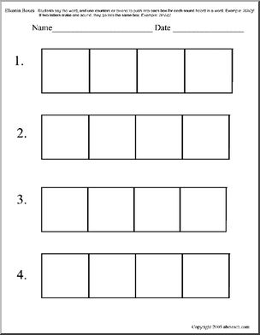
Literacy Assignment
Writing

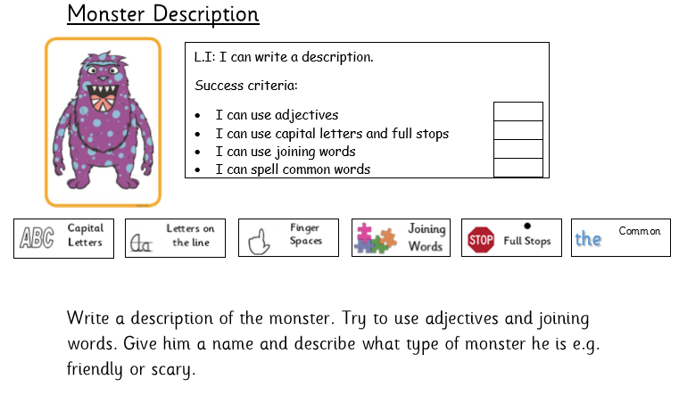

Maths Assignment
Say 2, 5 and 10 times tables out loud.
Count in 2’s, 5’s and 10’s up to 50 or beyond if you can.
First Level: Number and Number Processes
Multiplication/Division Activities
There are 10 sweets in one packet. How many sweets in two packets? | There are 6 lollipops in a pack. I share them with 3 friends? How many lollipops do they each get?
Know 1 know 4.  2 x 5=10  5 x 2=10  10 ÷ 2= 5  10 ÷ 5 = 2  Try this for: 4 8 2  12 6 2 | How do we use multiplication in everyday life? Plan a menu for 2, 3, 4 or 5 people. How many slices of pizza will you need if everyone wants two? How many strawberries will you need if everyone wants five?
Mary has 24 pairs of shoes. How many shoes does she have altogether? | John spends 90p on 10 party bags. How much does each bag cost?
Create a game to help you practice your tables. Write down the rules and play the game with someone in your family. | Choose as many times table as you like. Use sweets, pasta shapes, Lego bricks etc. to create each fact.
There are 20 children in P2. Their teacher needs them to sit in groups of 5. How many groups will she have? | A car can seat 5 passengers. How many cars would you need to take 25 people to the shops?
Maths
First Level: Number and Number Processes

Start at the following numbers then follow the instructions in the stars.

67 | 89 | 10 | 100
24 | 20 | 39 | 30
43 | 14 | 57 | 50
64 | 70 | 83 | 92
Count backwards in jumps of 2
Say the number before and after

Count backwards

Count forwards in jumps of 10
Count forwards in jumps of 2
Count backwards in jumps of 10
Count forwards

Maths- Shape
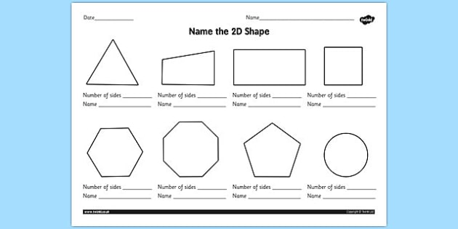

Can you find any shapes at home? Go on a shape hunt and make a list of the shapes you find!

Reading

Log into Oxford Owl using our class login details:
Username: Sttims1
Password: class
Search for the book The Magic Paintbrush. Click on the play button to listen to the book, then try to read this by yourself or to an adult at home.
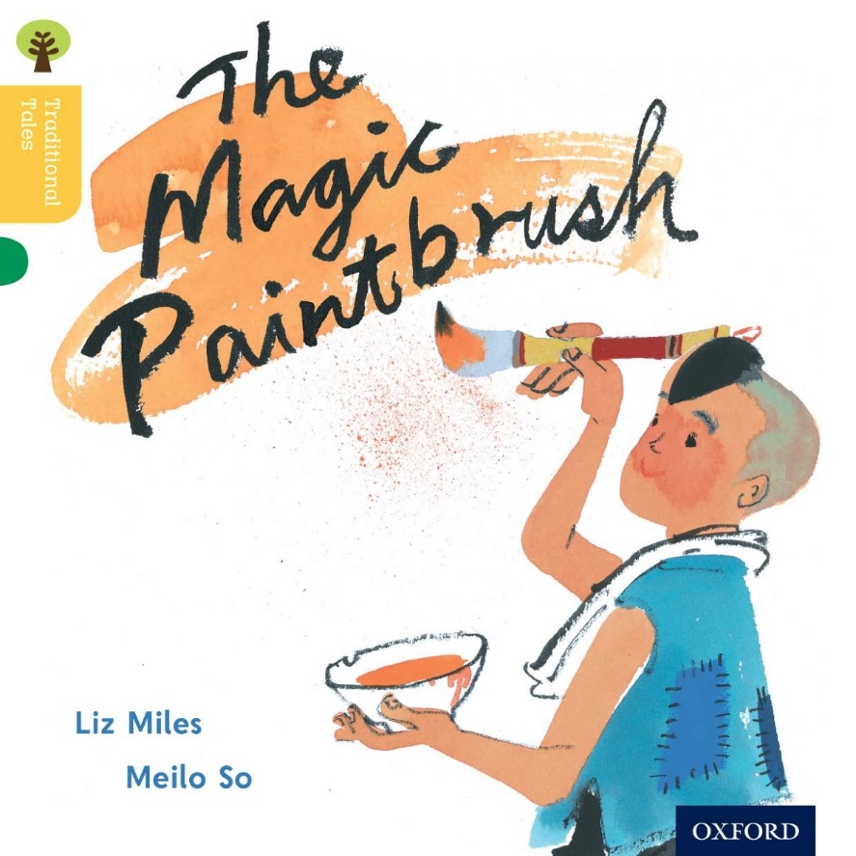

Once you have read the book try the activities that go along with the book.

Comprehension-The Magic Paintbrush

- Who was in the story?
- Go to Page 10. Have a look at the farmer. What do you think he was thinking about?
- Find 3 or 4 things that Ho did to help people?
- Why did the farmer put Ho in jail? Pg 14
- What did Ho paint to get rid of the farmer? Pg. 22
- Retell the story in your own words-use the story map to help you.
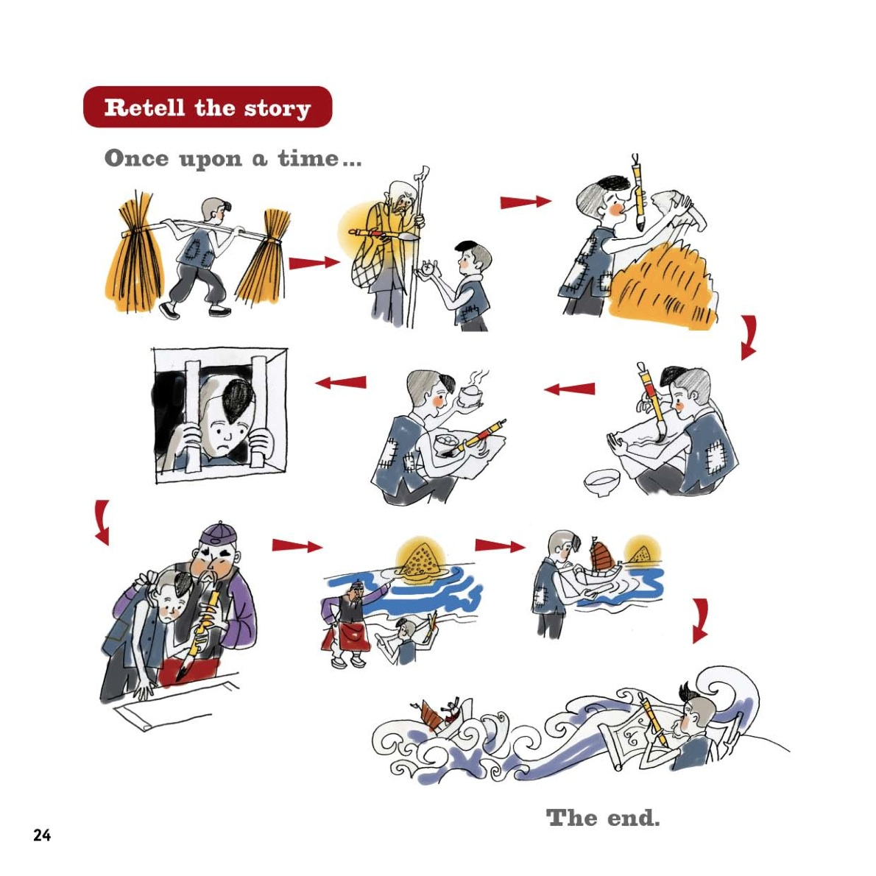
NLC Maths and Numeracy Learning at Home First Level: Number and Number Processes

Use the number lines to help you work out these addition and subtraction questions.
14 + 5 =
18 – 6 =
12 + 7 =
20 – 4 =
16 + 3 =
19 – 9 =
15 + 3 =
17 – 8=
3 + 11=
20 – 14 =
1 + 18 =
14 – 7 =

Fun Activities
Sumdog
Log into your Sumdog and have a go at some games! Have Fun!

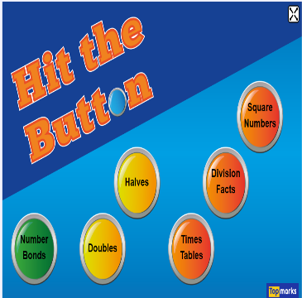
www.topmarks.co.uk

Click on topmarks website (no login needed) search for Hit the Button and try some games! Have Fun!
www.phonicsplay.co.uk

Username: march20
Password: home

Try some phoneme games

Health and Wellbeing

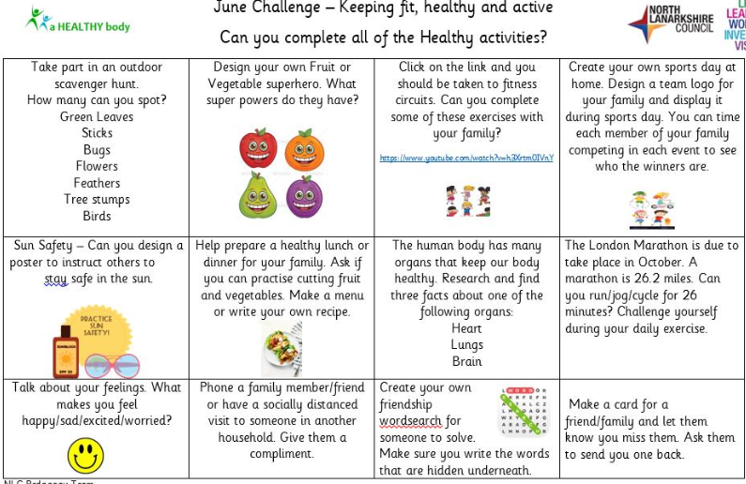
Maths-Find ½ and ¼
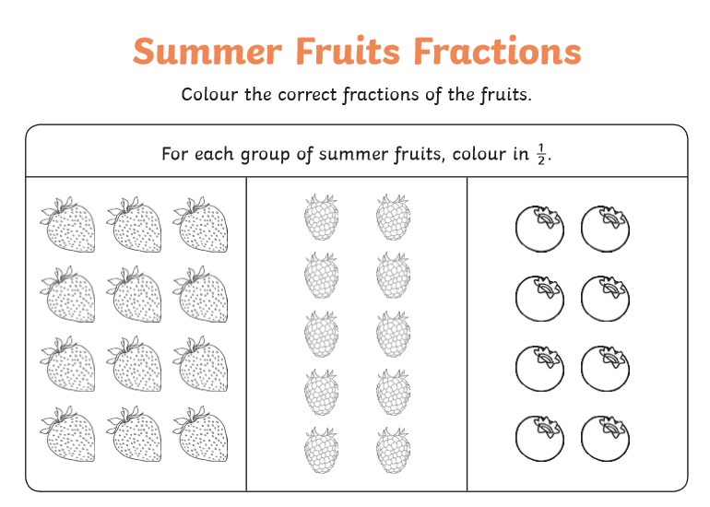
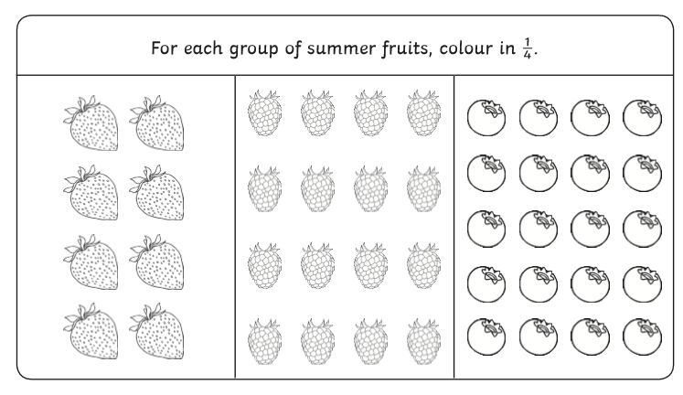

Literacy Check up day!!!!!!
Spell check and Phoneme check

Get someone in your house to check if you can spell these words.
- comb
- crumb
- thumb
- lamb
- green
- people
- Which
- Another

Well how did you do?

Maths Check
- 21+9=
- 24-3=
- 5+18=
- Double 12
- Double 14
- 16+5=
- 25-12=
- 41= __ tens and __ units
- 27= __ tens and __ units
- 5, 10, __, 20, 25, __, 35
- __, 40, 50, __, 70, 80, __
- 10 more than 26 =_____
- 10 more than 90 =_____
- 10 more than 58= _____
- 1 less than 26 = _____
- 1 less than 23 = ____
- 16 ÷2 =
- 5x5=
- 5x ___=35
- 2x ___=18
- ___ ÷2=10
- ___ ÷2=8

