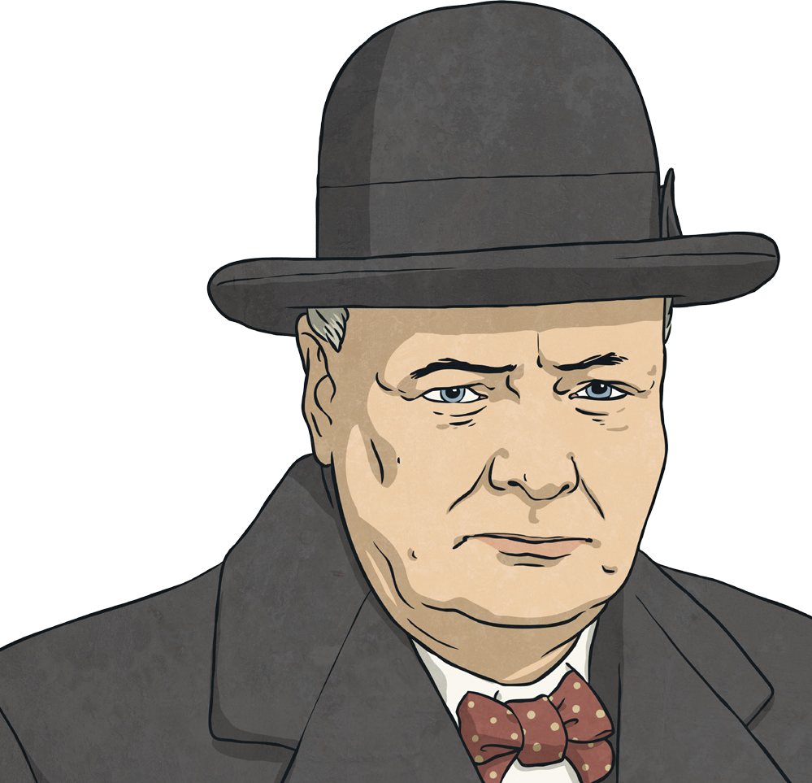
Winston Churchill Fact File

Winston Churchill is one of Great Britain’s most famous statesmen and prime ministers because he was the British leader twice and he also led Britain to victory in the Second World War.

Early Life
He was born Winston Leonard Spencer-Churchill on 30th November 1874 at Blenheim Palace (the seat of his grandfather, the 7th Duke of Marlborough) in Oxfordshire. His father was Lord Randolph, a Conservative politician, and his mother was Jeanette, Lady Randolph Churchill. When he was 13, he only managed to make the lowest class at
Harrow school, so his father put him in the army class to prepare for a career in the armed forces.

Early Career
Churchill began his army career as a cadet in 1893 at Sandhurst, after having three attempts to pass the entrance exam. He eventually became a cavalry officer and war reporter, spending his 21st birthday working in Cuba. In 1898, he went to fight in the Sudan but he knew that politics was his first love. He, therefore, spent time following the news from home and doing lots of reading.

Famous Churchill Quotes:
“Success is not final, failure is not fatal: it is the courage to continue that
counts.”
“Success consists of going from failure to failure without loss of enthusiasm.” “Never in the field of human conflict was so much owed by so many to so
few.”

“We shall defend our island, whatever the cost may be, we shall fight on the beaches, we shall fight on the landing grounds, we shall fight in the fields and in the streets, we shall fight in the hills; we shall never surrender.”

Into Politics
At the 1900 general election, he became MP for Oldham and he made his first speech in Parliament in 1901. He always prepared well and used notes as part of his method to overcome his lisp. Meanwhile, in his private life, he was married to Clementine in 1908 and they went on to have five children.

Rising to the Top
By 1910, Churchill had become home secretary and was in charge of the Royal Navy. He then spent a short amount of time as chancellor of the exchequer, in charge of the country’s taxes and money. The first part of the Second World War in 1939 did not go well for Britain and in 1940, Britain needed a new prime minister. That was to be Winston Churchill.

Later Life
Churchill led Britain through the Second World War with his direction and his many famous speeches. However, not long after the war, Britain needed a change and the Conservatives lost power. Churchill kept up with his writing. A second chance to lead the country came round when the Conservatives were re-elected to power and Churchill was prime minister once more from 1951 to 1955. Even after that, he continued to be an MP until 1964. In 1965, he died aged 90. He is buried in a small churchyard in Oxford and his headstone reads: ‘Remember Winston Churchill’.

Winston Churchill Questions

What was Churchill’s career before he went into politics?

- What was the name of his wife?

- Which political party was he part of?

- In what year did he officially get a job in politics?

- Why has the author used the subheading ‘Rising to the Top’ for that paragraph?

- Find an example of a fronted adverbial in the text.

- In what month was he in Cuba?

- In the Famous Churchill Quotes section, what does the word ‘conflict’ mean?

- What does the word ‘victory’ mean?

- Churchill is famous for his quotes; what do you think about the ones here? Have any of them made you think, and why? Which do you like best?

