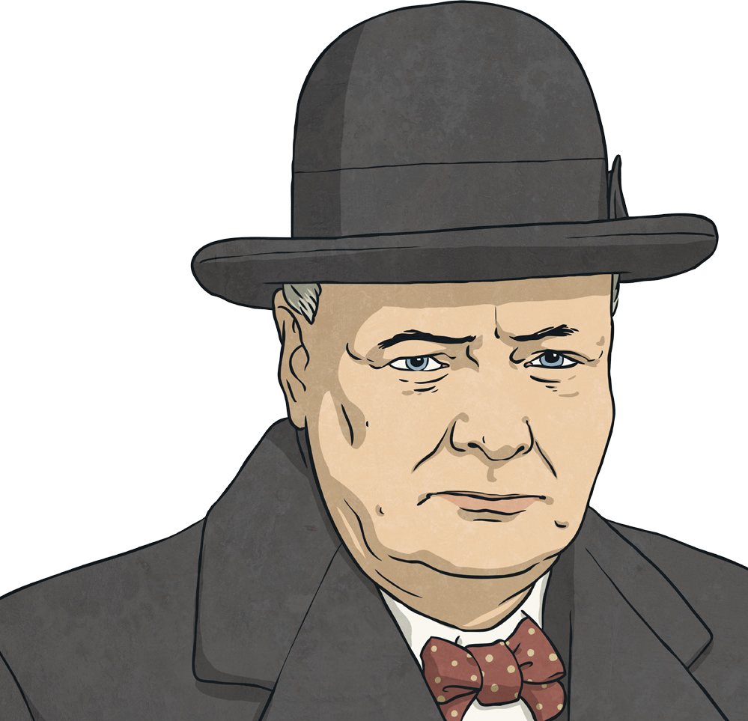
Winston Churchill Fact File

Winston Churchill is a very famous British prime minister. He is famous because he was prime minister twice and because he led Britain to win the Second World War.

Childhood
He was born Winston Leonard Spencer-Churchill on 30th November 1874 at Blenheim Palace near Oxford. His father was Lord Randolph, a Conservative politician, and his mother was called Jeanette. When he was 13, he wasn’t doing very well at Harrow school and only just got into the lowest class, so his father put in the army class.

Early Career
He started his army career as a cadet in 1893 at Sandhurst army training centre, after having three tries to pass the entrance exam. He eventually became an officer and war reporter. In 1898, he fought in the Sudan in North East Africa, but he knew that politics was his goal. He spent time following the news from home and doing lots of reading.

Famous Churchill Quotes:
“Success is not final, failure is not fatal: it is the courage to continue that
counts.”
“Success consists of going from failure to failure without loss of enthusiasm.” “Never in the field of human conflict was so much owed by so many to so
few.”

“We shall defend our island, whatever the cost may be, we shall fight on the beaches, we shall fight on the landing grounds, we shall fight in the fields and in the streets, we shall fight in the hills; we shall never surrender.”

Politics
At the 1900 general election, people voted for him to become the MP (Member of Parliament) for Oldham in Lancashire. He always prepared well for his speeches and used notes because he had a lisp. Meanwhile, in his home life, he married Clementine in 1908 and they went on to have five children.

Rising to the Top
By 1910, his job was home secretary for the government and that meant he was in charge of the Royal Navy. After that, he was chancellor, which meant he was in charge of the country’s taxes and money. The first part of the Second World War in 1939 had not gone well for Britain so in 1940, Britain needed a new prime minister. That was to be Winston Churchill.

Later Life
Churchill led Britain through the Second World War and made many famous speeches. However, not long after the war Britain needed a change and the Conservatives lost power. Churchill kept up with his writing. When the Conservatives were re-elected to power, he became prime minister again, from 1951 to 1955. Even after that, he stayed an MP until 1964. In 1965, he died aged 90. His gravestone reads: ‘Remember Winston Churchill’.

Winston Churchill Questions

Find two conjunctions in the introduction paragraph.

- How many children did Churchill have?

- Find two verbs in the last paragraph.

- In what year did he first get a job in politics?

- Why has the author put (Member of Parliament) in brackets in the ‘Politics’ section?

- What is a quote?

- What does it say on Churchill’s gravestone?

- In the Famous Churchill Quotes section, what does the word ‘defend’ mean?

- What was the name of Churchill’s wife?

- Churchill is famous for his quotes; what do you think about the ones here? Have any of them made you think, and why? Which do you like best?

