|  |  |
| --- | --- |
| Question | Answer |
| 1 |  |
| 2 |  |
| 3 |  |
| 4 |  |
| 5 |  |
| 6 |  |
| 7 |  |

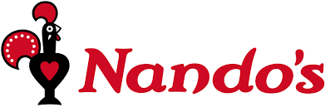

**HOT Challenge**

1. Hello, can I book a table please for a large group? Well there’s Maureen and Bill with their twins. Then there’s Sheila and Pete with their twins. There’s also myself, my wife and our respective parents. **So how many people are you going to reserve the table for?**

2. We’re all going to leave the house at about 6.52pm and it will take 43 minutes to get to you. **What time will you reserve the table for? (Restaurants normally round their bookings to the nearest 15 minute interval)**

3. We’d like to order 2x Halloumi sticks & dip as starters please but we also have a £1.50 off all starters voucher**.** **How much will our starters be in total?**

4. What will be cheaper; What will be cheaper; 4 x cloudy lemonade, 4 x pressed apple juice and 6 x Rubro or for everyone to have a Bottomless Coca Cola Classic? **What is the difference in price between the two options?** We will have the cheapest option please.

5. For our Mains we would like to order the following: 1x Family Platter, 1x Chicken Butterfly with 2+ Reg Sides, 1x Large Peri-Salted Chips, 1x Corn on the cob and 2x Garlic Bread. **How much will our Mains be in total?**

6. We don’t want any pudding thank you. Just the bill please. **How much is the meal altogether?**

7. We would like to leave a 15% tip. **How much is that?**