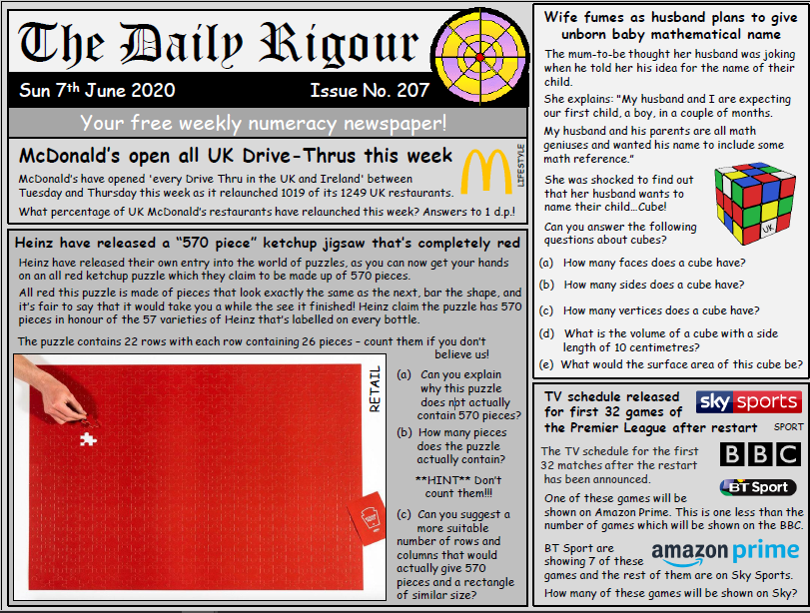
How many answers can you get? If you are stuck
with some then just miss it out or ask in Teams
Materials taken from Rigour website found at https://www.cdmasterworks.co.uk/
or by e-mail for some help.
Q. | Answer
McDonalds
Jigsaw a)
Jigsaw b)
Jigsaw c)
Rubix Cube a)
Rubix Cube b)
Rubix Cube c)
Rubix Cube d)
Rubix Cube e)
Football on TV

