Home Learning Week Beginning 8.6.20

Good morning Boys and Girls. We hope you have had a lovely, restful weekend. Here is your tasks for the week ahead. Try your best to complete them. Mrs Simpson and I will be on for a live chat on Friday only this week, as we are back in school to prepare the classes for August. I will be on the live chat from 2:00 until 2:30 and Mrs Simpson will be available from 2:30 to 3:00.
Remember, you can contact us through Glow, but we may be a little slower getting back to you than usual because we are back in school.

Monday
Chilli Challenge
This Photo by Unknown Author is licensed under CC BY-SA | This Photo by Unknown Author is licensed under CC BY-SA  This Photo by Unknown Author is licensed under CC BY-SA | This Photo by Unknown Author is licensed under CC BY-SA  This Photo by Unknown Author is licensed under CC BY-SA  This Photo by Unknown Author is licensed under CC BY-SA
250÷10= | 2953÷100= | 23, 409÷1000=

New Learning Alert!!! Data Handling!!!
We now need to move onto a topic within Maths that we did not get the chance to go over. It is called Data Handling. We use Data Handling to gather, record and present information in a way that is helpful to others.
This information can be recorded using tally marks, graphs, and charts. Watch this clip from YouTube where it shows you how to record information using tally marks and a bar chart.

https://www.youtube.com/watch?v=ZWvp2TQ428Q

Bar Chart
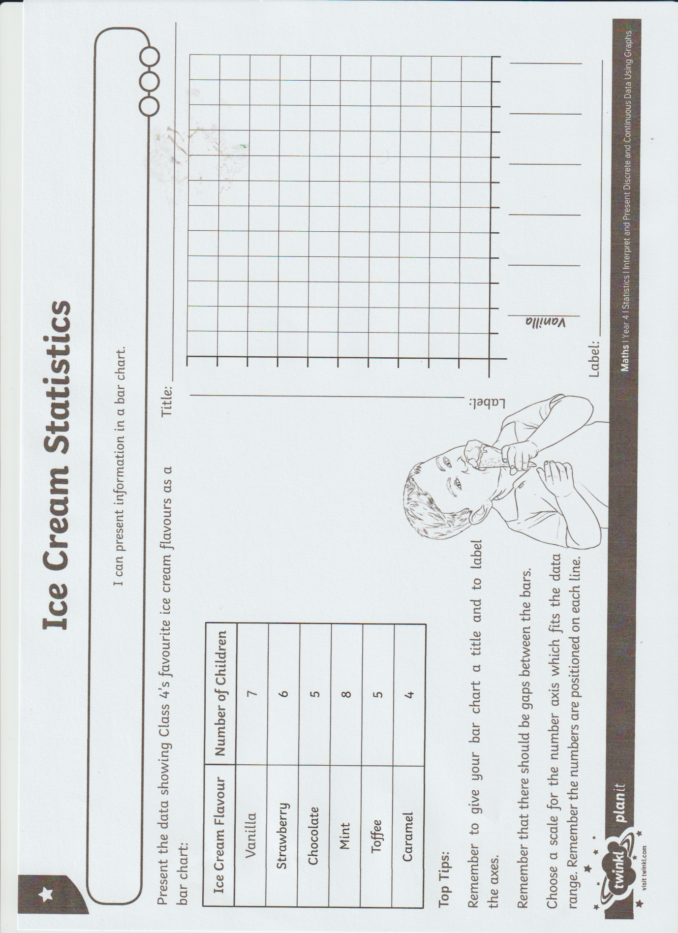
Read the information and complete the graph to show the data.
Spelling
Last week we looked at the different representations for the phoneme ‘au’ a, o, aw. Use the words with all the different representations that you came up with and practise the spelling of these words using the elkonin boxes below.

.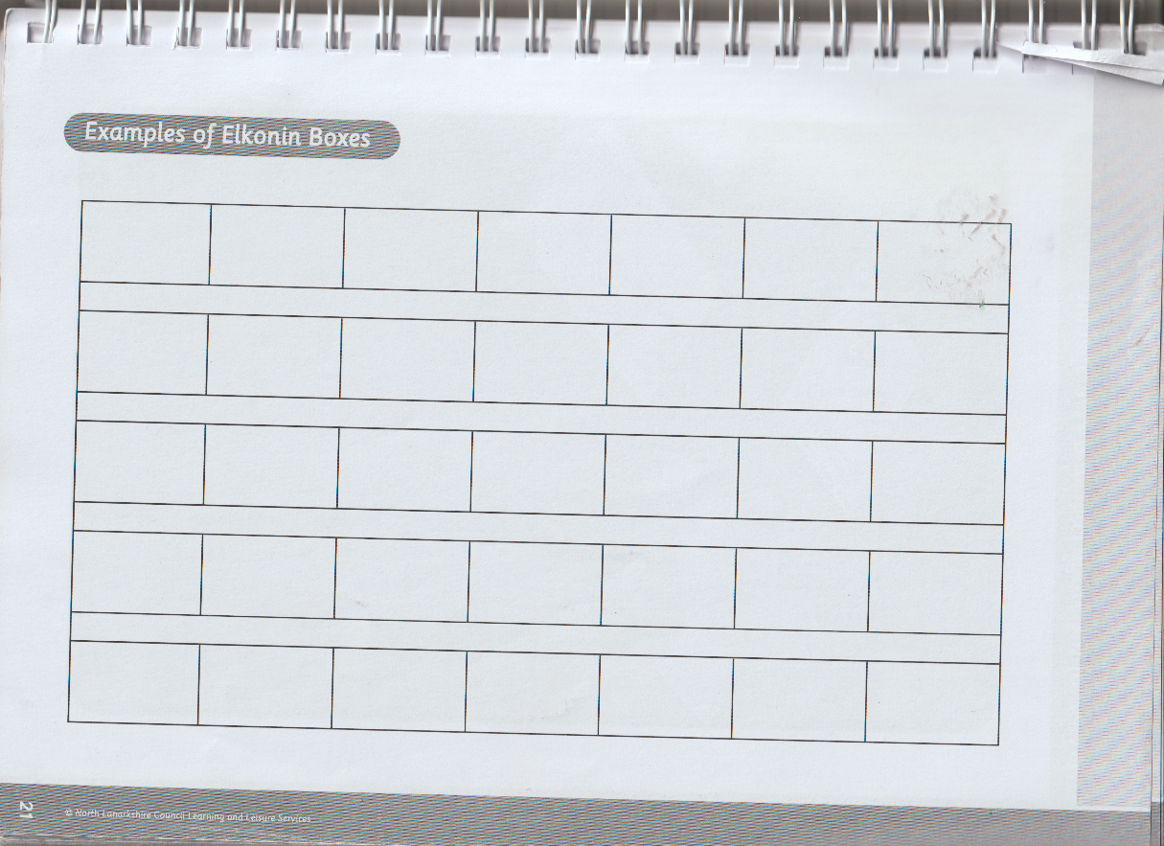

Tuesday
Chilli Challenge
This Photo by Unknown Author is licensed under CC BY-SA | This Photo by Unknown Author is licensed under CC BY-SA  This Photo by Unknown Author is licensed under CC BY-SA | This Photo by Unknown Author is licensed under CC BY-SA  This Photo by Unknown Author is licensed under CC BY-SA  This Photo by Unknown Author is licensed under CC BY-SA
24x2= | 1236x11= | 2200x15=

Read the Bar Graph and try to interpret the data.

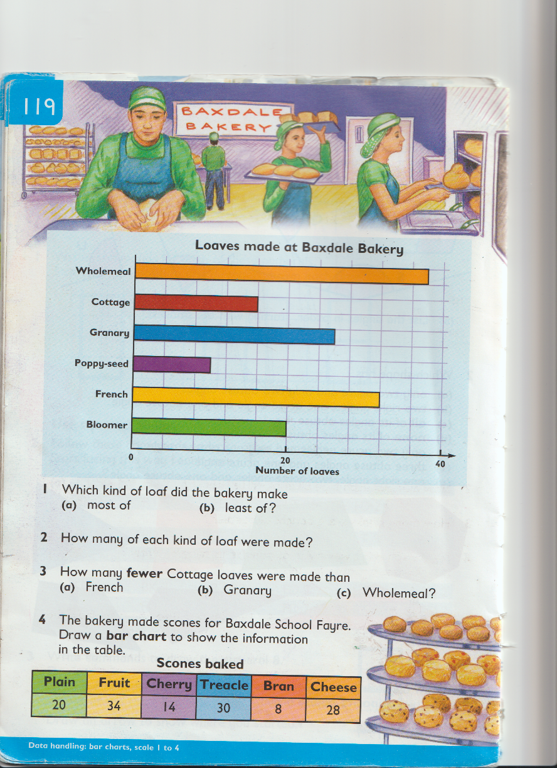

We have looked at contractions before – these are when two words are shortened with the use of an apostrophe. For example do not can be shortened to don’t. Have a go at the following activity.

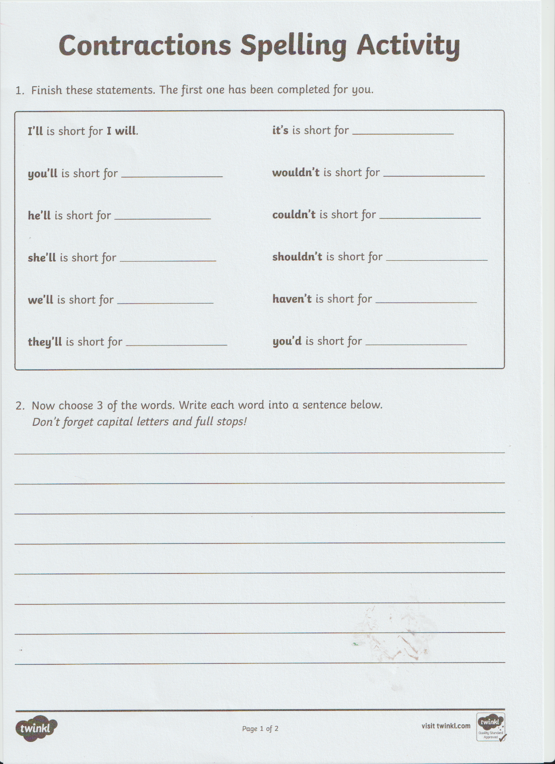

Wednesday
Chilli Challenge
This Photo by Unknown Author is licensed under CC BY-SA | This Photo by Unknown Author is licensed under CC BY-SA  This Photo by Unknown Author is licensed under CC BY-SA | This Photo by Unknown Author is licensed under CC BY-SA  This Photo by Unknown Author is licensed under CC BY-SA  This Photo by Unknown Author is licensed under CC BY-SA
79-23= | 275-103= | 2532-871=

Division – try these division sums, there are some missing numbers that you have to find.
Simon Smith orders 300 address labels in strips of 10.
How many strips does he order?

- How many strips of 10 can be made with
- 500 labels (b) 2000 labels
- 4600 labels (d) 7300 labels

- (a) ÷10= 80 (b) ÷10= 600 (c) ÷10=250 (d) ÷10=940

- Amy Arnott orders 600 address labels in sheets of 100.
How many sheets does she order?

- How many Sheets of 100 can be made with
- 400 labels (b) 9000 labels
(c) 1800 labels (d) 8700 labels

- (a) 200 ÷ 10= (b) 4000 ÷ 1000= (c) 700 ÷ 100=
(d) 1700 ÷ 10= (e) 3000 ÷ 100= (d) 1000 ÷ 1000=
Taught Writing
This week Boys and Girls we are going to write about what we would like to do after lockdown. This was a suggestion from some of the boys and girls in Room 12.
So what is your story going to be about? It is an imaginative story so feel free to let your imagination go.
Are you going to go to McDonalds, TGIF’s or another restaurant?
Or it could be that you are desperate to go to the cinema or swimming?
Who are you going to see there- someone you haven’t seen in a long time?
How are you going to feel? Are you going to be excited?
It is your story, but make sure you include, feelings, what you see, hear, taste, touch and smell.

Thursday
Spelling Rule – New learning New Learning
We are going to be learning about Prefixes this week. A prefix is a word or group of letters that can be put at the front of another word. These words or groups of letters change the meaning of the word. For example almost, already and always. So in these words, most, ready and ways are called the ‘root’ words. This means that they are the main word and a prefix can be added to the root words to change their meanings. You will notice that in the words almost, already and always, we drop one of the ‘l’s’ so we put al at the front. This is called the prefix. There are other examples of prefixes; un -unwrap, re-rewrite and de-detail.
Watch this You tube clip where prefixes are explained in more detail.
https://www.youtube.com/watch?v=w7oGNyHX81I
Now that you have watched the clip, try to sort the prefixes into the correct column.
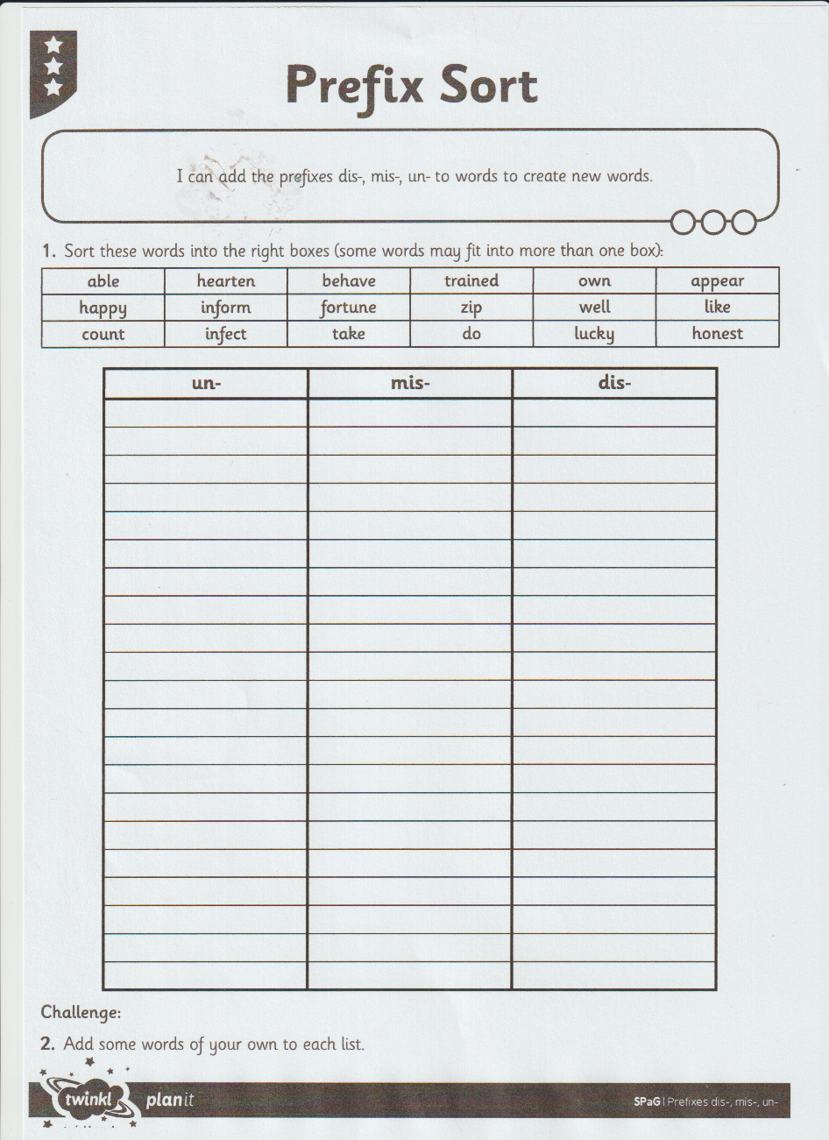

Chilli Challenge
This Photo by Unknown Author is licensed under CC BY-SA | This Photo by Unknown Author is licensed under CC BY-SA  This Photo by Unknown Author is licensed under CC BY-SA | This Photo by Unknown Author is licensed under CC BY-SA  This Photo by Unknown Author is licensed under CC BY-SA  This Photo by Unknown Author is licensed under CC BY-SA
91+13= | 271+97= | 2842+901=

Revision of Time – Look at the clocks – the small hand and the big hand and write the times.
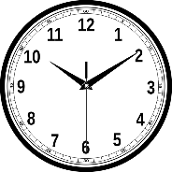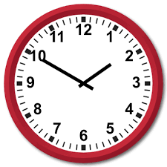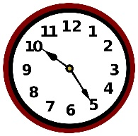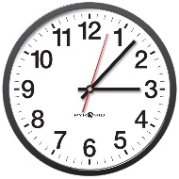
- Write these times in order.
- Start with the latest time.
3:29 3:58 3:42 3:27
- Start with the earliest time.
10:55 10:49 11:00 11:04
- Write the time
- 50 minutes after 2:35 (b) 65 minutes after 06:40 (c) 1 hour and 30 minutes after 11:15.
(d) 45 minutes after 04:25 (e) 70 minutes after 12:10

Try these Time word problems.
- The Jacksons left Mandalay Bay at 7:15am. The Journey to Pyramid Lake took 1 hour and 20 minutes. At what time did they arrive?
- They arrived at French Towers at 10:10am. The journey took 90 minutes. When did they leave Pyramid Lake?
- (a) They left French Towers at noon.
How long did they stay?
- The Journey to Wild West City took 115 minutes.
At what time did they arrive?

Spelling
Pick some of your spelling or phoneme words from last week and try this new spelling task. It is called Picture and a Story. For example, you choose a word, so I will choose the word ‘morning.’

Firstly, I will write a sentence using this word. I love to get up early every morning to see the sunrise and to have a lovely breakfast.

Next, I will then draw a picture to show this.

Our next task is to read the following paragraph and try to find the author’s hidden meaning. Remember! This is called ‘inference.’ See if you can answer the questions correctly.

A Busy Morning
“Ouchhhh!” screamed Toby. I ran into the living room to see Toby lying on the hard, wooden floor, tears rolling down his chubby, little cheeks. Behind me, I heard my mum walk into the room.
“What have you been doing to Toby?” she shouted, her face turning a deep red. “Go upstairs; I haven’t got time for this today.”
“But-“I started to explain.
“Upstairs. NOW!” Mum ordered. “And finish your packing, we need to leave for the airport in 20 minutes.”
I stomped up the stairs to my room. It wasn’t fair! Angrily, I started throwing things into my suitcase: sunglasses, a swimming costume, shorts and flip-flops.
- How is Mum feeling when she walks into the room? How can you tell?
- What does Mum think has happened and why?
- What do you think the relationship is between Toby and the narrator (the person who is telling the story)?
- Why do you think Mum says, “I haven’t got time for this today”? What is she getting ready for?
- Where do you think the family might be going?
- Explain what clues there are to where the family are going.

Friday
Spelling and Phoneme Check Up. Get someone to read out your phoneme words and spelling words from last week and see if you can spell them correctly.

Maths Check Up
Multiplication and Division.
- 23x15= 2. 96x24= 3. 108x14= 4. 210x25=
5. 98÷3= 6. 425÷4= 7. 248÷6= 8. 1255÷5=

Round these numbers to the nearest tens of thousands.
24,309 12,389 245,612 98,321 109,342

Adding and Subtracting.
- 23,145+16,093= 2. 45,719+26,098= 3. 108,234+79,515=
- 19,316-11,212= 5. 78,206-16,390= 6. 187,730-29,534=
Remember to log in to Sumdog and Education City to see new tasks. 